Keeney Update
VOL III, Number 4 Roscoe C. Keeney, Jr. SEPT 1986

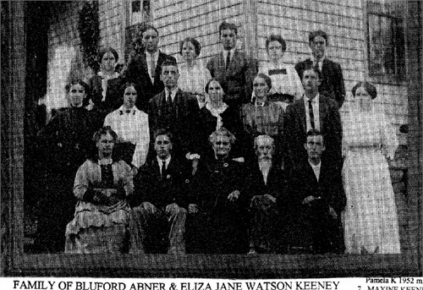
FAMILY OF BLUFORD KEENEY (850-191), TEXAS CO., MO
ABNER KEENEY OF MISSOURI (father of Bluford)

THE CYCLONE OF 1879
The terrifying tornado which Carl Carlson and seven others witnessed on their arrival at Randolph (see page 45) was chronicled in the Manhattan Nationalist of Friday, June 8, 1879.
TERRIBLE CYCLONES
On Friday last, a portion of Kansas and Missouri was devastated by a terrific cyclone (or cyclones. A large number of people were killed or injured, and a great amount of property destroyed. S. M. Fox, of this city, visited Irving, in Marshall Co. immediately after the disaster and returned along the track of the destroyer to Fancy Creek, in the northern most part of Riley Co., and has kindly furnished us the following account:
The storm, after passing the town, crossed the Blue River. It lifted the long iron bridge from its piers and carried the twisted and shapeless mass some thirty feet up the river. It than continued its course to the northeast in the direction of Frankfort.
The second tornado came from the west, and many say it was even more terrible. It swept over part of the track of the former one, but lapped to the north, and destroyed many buildings, among others, the church and elevator. There were in all twenty-seven buildings destroyed. Thirteen persons were killed in std about Irving, and fifty-three seriously wounded. The following is the list of the dead: Mrs. W. J. Williams; Mrs. Susan Buckmaster and four children; Fannie Schwaka; W. R. Keeney; John Keeney and wife; Miss Emma Sheldon; Mrs. Fred Nowk; Mrs. Geo. Martin.
Many strange incidents are related illustrating the freaks the tornado indulged in. Arthur Taylor was picked up and carried eighty rods through the air, and mildly set down at the end of his aerial journey in a wheat field. Frank Fitch, a little fellow, eight years old, was carried half a mile, over tree tops, and left on the ground unharmed. A horse belonging to Mr. Williams was borne over a lumber yard, along the edge of the storm, and then gently set down in the river bottom, some distance beyond. And so on, instances innumerable -- and vouched for by men of undoubted veracity.
It seems impossible for anyone to depict what the horrors of those few minutes must have been. The bodies of many of the dead and wounded were entirely stripped of clothing. Mrs. Keeney was fairly driven in the earth so that her hair had to be cut away that the body might be removed. Mr. Armstrong's house, said to be the finest house in Irving, was literally wiped off the face of the earth - a portion of a lounge and a few pieces of lumber slivered and shapeless, are every vestige that has been found of it or its contents.
In the Light of this, it seems odd enough to be in a direct line between the elevator and church
a dilapidated building that a boy could see over, standing unharmed. The schoolhouse was carried,
together with its frame, some ten rods, and left standing upright on the ground.
Most persons in describing the cyclone say it was of an ashen color, and seemed to be trailed
behind a terrible looking cloud, and swayed from side to side like the trunk of a huge elephant
rending and crushing everything !n its track.
PRAYER FOR GENEALOGISTS
By Curtis Woods
Lord, help me dig into the past
And sift the sands of time
That I might find the roots that made
This family tree of mine.
Lord, help me trace the ancient roads
On which my father’s trod
And led them through so many lands
To find our present sod.
Lord, help me find an ancient book
Or dusty manuscript -
That's safely hidden now away
In some forgotten crypt;
Lord, let it bridge gap that haunts
My soul when I can't find
The missing link between same name
That ends the same as mine.

NEBRASKA KEENEYS
1880
SUPHRONIA KEENEY 68 (widow) - Clay County, born in Mass.
MERIAH H. KEENEY 31, housekeeper, married, born in PA.,
DAUGHTER, FLORA KEENEY, age 7, born in Nebraska
D.A. KEENEY, 33, farmer; Addie 28, Nellie 10, Laura 8, Ernest 5, Edward 2; D. A., born IL, Addie, b. NY; parents of D. A, Keeney born in Connecticut
E. H. KEENEY, 39, b. IL, parents b. NY, farmer; Alice 29 (b.IL), Alma 10, b. IL, Henry 8, & Albert 3, b. NE, Bertha 5 mos., b.NE
S. F. KEENEY, 40, b. NY, parents b. NY & MA, farmer; Julia 26, b. NY, Ida M. 15, b. NY, Minnesota 7, dau., b. MN, Edna E. 1, b. NE
WASHINGTON KEENEY 45, b. M0, parents b. OH & MO., Surrena 46, b. IL, parents b. KY & IN Frances J. 14, b. M0, William A. 10, Liddie (dau.) 7, Wynona 4, all b. Iowa, Sarah E. l, b. Iowa
WILLIAM KEENEY 53, b. IN, parents b. VA, farmer; Philena 41, b. IN, parents b.08 & ED, John- 1B and Ross 14 b. Iowa, Benjamin 8, b. NE
ADA E. KEENEY, 18, b. IL, parents b. OH, boarder
1900
ALICE KEENEY 43, b.9-1856 in IN, parents b. IN, farmer, Glenn 21, b.5-1879 in NE, Earnest 18, b.4-1881 in IA, Edna 15, b. 9-1884, b.IA, Bessie 13, b.7-1886 in IA, Minnie 11, b.4-1889 in NE, Frank T, b.2-1893 in NE, Doris 2, b.5-1898 in NE (granddaughter)
JESSIE KEENEY 25, b.4-1875 in IA, parents b. IA & IL, Madge 22, b.10-1877, b. NE, parents b. IN,
Harold 1, b. NE, William (father) 41, b. 2-1854 in IA(parents b. in TN & KY - ....
WALTER KEENEY 42, b.3-1858, b. PA, parents b. PA, farmer, Lucy 29, b.3-1871, b. MN, parents b. NH & OH, Henry 8, b.4-1892 in NE, Vera 2, b.10-1897 in NE
DON A. KEENEY 56, b.7-1843 in IL, parents b. CT, Addie 50, b.l1-1849 in NY, parents b. NY, Eddie F. 21, Mett ie G. 19, b.8-1880, Arthur E. 16, b.7-1883, Katie L. 12, b.8-1887, Albert B. 7, b. 10-1893 all in NE
JAMES KEENEY 19, b.6-1861 in Ireland, Alice 30, B. 12-1869 in Ireland, Annie 6, b.1-1894, Nellie 4, b.3-1896, Michael 2, b.8-1897, Marie F.6 mos., all NE
SAMUEL F. KEENEY 60, b 5-1840 in NY, parents b. NY, insurance agent; Julia S. 56, b.8-1843 in NY
JASON KEENEY 58, b.l1-1841 in NY, parents b. PA & NY, Mary E. 60, b.8-1839 in NY, parents b. NY
JOHN KEENEY 36, b.5-1864 in Iowa, parents b. IN; Rosa 28, b.5-1872 in NE, parents b. Ohio, William 13, b. NE, Grace 8, b.12-1891, William W.(father), 73, b.5-1827 in IN, parents b. TN and NC
PAT KEENEY 48, widower b.1852 in Ireland, saloon keeper, Ann McAulley 73 (ML), widow, b. Ireland, Pat (son) 17, b.6-1882, Anna 12, b.4-1888, Mary 10, b.8-1889, Nellie 7, b.2-1893, Katie 5, b.9-1894
PATRICK KEENEY 18, b.10-1881 in NE, parents born in Ireland, boarder
WILLIAM KEENEY 49, b.6-1850 in IN, parents b. IN, Mary C. 40, b.2-1860 in Iowa, parents b. Iowa
JOSEPH KEENEY 58, b.9-1841, in IN, parents b. KY, carpenter; Rosa 55, b.7-1844 in Ohio, parents b. NH & NY, Robert F. 28, b.10-1871 in NE, Fred L. 26, b.6-1873 in NE; Merrick Co., NE

A Day on New River
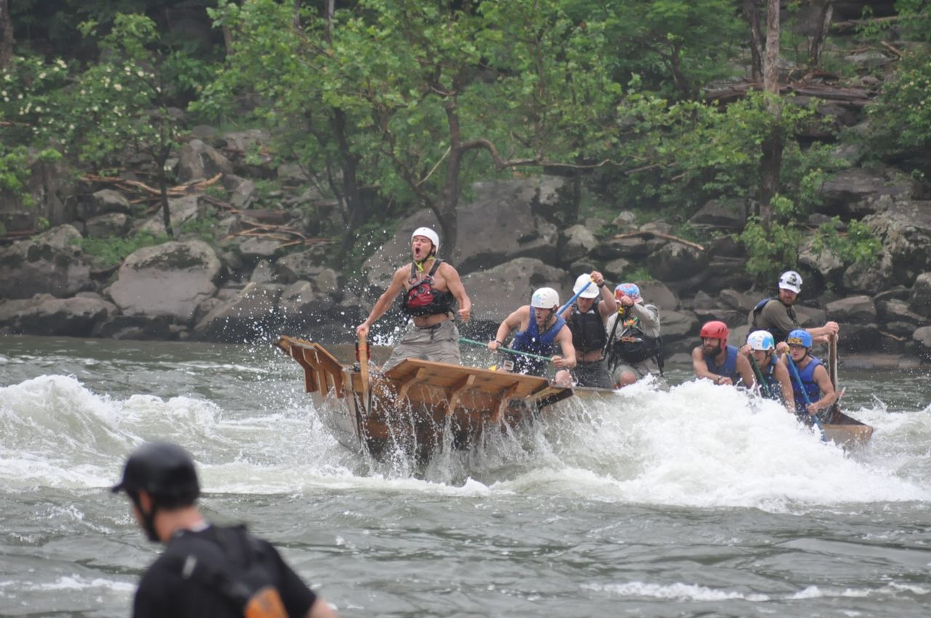
SUPPORT
This issue of KEENEY UPDATE is being paid for by a $25 donation from (names removed per request of R. Keeney).
No names have ever been omitted from the circulation list except for the deceased, and this policy will continue long as the bills are paid.
NEEDED: Pictures, clippings, obituaries, charts for future issues; prefer pictures of Keeney descendants born prior to 1900.
Supporters could help greatly by going to state archives in their capital city and copy census records of KEENEYS, especially those 1900 and before.

Down the rapids
(Original picture missing)
The gorge offers 18 major rapids like Lower Keeney, shown here. Rafters brace themselves and dig the paddle blades deep to keep from capsizing. The trips attract more than 80,000 rafters from around the country every summer.

From NUTMEGGER
from THE NUTMEGGER, December 1980
KEENEY, Ezra, b. Lucasville. PA, 15 August 1806 m. (2) Almira Dexter 15 March 1848 (born in Bradford or Wyoming Co., PA 4 July 1824
MARGARET (Mary) KEENEY, b.1786, d.28 Aug 1825, daughter of Alexander Keeney, m. Jeremiah
Woodruff (b.1785 Farmington, CT, d.1826 Berlin, CT, married 30 September 1805
ASAHEL KEENEY, b. 2 November 1776, d: 12 August 1841 (of New Britain, CT), m. Theodosia Woodruff, (b.7 August 1787, d. 27 June 1869 - St. Clair, MI

DEATH NOTICES
Dennis B. Keeney
Dennis B. Keeney, 64, of 16 132nd St. Chesapeake, died June 26, 1986, in Memorial Division, CAMC, after a long illness.
He was retired from Owens-Illinois bottle plant and was a member of the Church of God, Chesapeake. He was a veteran of World War II.
Surviving: wife, Catherine; daughter, Connie M. Holcomb of Davidson, Conn; son, Larry Lanham of Florida; mother, Mrs. Ruby Keeney of Chesapeake; sisters, Ruby Mooney of Chesapeake and Alma Adkins of Shrewsbury; brothers, James of Titusville, Fla, Edgar of East Bank; five grandchildren; four great grandchildren.
Service will be 2 p.m. Monday at the Church of God, Chesapeake, with the Rev. Ron Wilfong, officiating. Burial will be in Montgomery Memorial Park, London. Friends may call from 5 to 9 p.m. today at Leonard Johnson Funeral Home, Marmet, and at the church one hour before the service.
Dennis B. Keeney (6.302, p.77) was a son of Cassius Clinton & Ruby Massey Keeney; family line of Russell L. Keeney is unsure; Thomas James (6.375, p. 93) is a grandson of Stires Keeney & Mildred Gatewood Keeney; Robert E. Douglass was married to Lillian Mae Keeney, daughter of Flem D. & Ida Keeney (6.417 p. 105)
Russell L. Keeney
Danville, Ind. - Russell Lowell Keeney, 85, Danville, died Thursday in Hendricks County Hospital. A self-employed upholsterer, he had retired from Keeney Upholstery. Born in Pittsboro, he had lived in Danville many years. He was the widower of Lurene Leak Keeney. Services will be at 2 p.m. Saturday in Baker Funeral Home, with calling from 3 p.m. to 9 p.m. today. Survivors: sons, David, Allen and Roy Keeney; daughters, Marjorie Britt, Barbara Ross and Lynann Storm.
Thomas W. James, Sr.
Thomas W. James Sr., 81, of Oak Hill, father of Fayette Tribune employee, Thomas W. James Jr., died July 10 at Beckley Hospital of an apparent heart attack. Service was held July 13, at the Oak Hill Church of the Nazarene with the Rev. Leroy Hostutler in charge. Burial followed in High Lawn Memorial Park.
Born Nov. 16, 1904, at Oak Hill, he was the son of the late William & Goldie Keeney James, a former Fayette County teacher, dairyman and 0ak Hill merchant, a member of the 0ak Hill Church of the Nazarene where he served as the Sunday school superintendent and teacher for over 20 years, treasurer, and member of the local church board. He also served as the state advisor of the Board of the Nazarene Church.
Other survivors include his wife, Elizabeth Shuck James; son, Howard Dale of Woodbridge, Va.; a daughter, Clara Vivian Rushing of Odessa, Tex.; nine grandchildren and three great-grandchildren.
Robert Edwin Douglass
Robert Edwin Douglass, 77, of 1914 Orchard Ave., Bella, died Friday in Memorial Division, CAMC, after a long illness.
He was a member of Witcher Baptist Church and Knights of Pythias. He had lived most of his life in Kanawha County.
Surviving: wife, Lillian; son, Robert E. Jr. of Lilborn, GA; daughter, Mrs. Phyllis Tummelty of Trumbull, Conn; brothers, Richard of Charleston, Frederick of Bell, Glenn of Laling, La, Wayne of Evansville, Ind; four grandchildren.
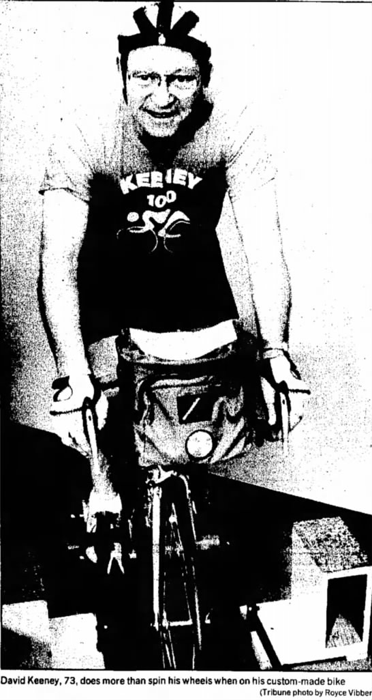
WEST VIRGINIA KEENEYS ORGANIZE
BYLAWS were adopted and a Board of Directors was selected at the 12th annual KEENEY REUNION, held on Sunday, August 3, at Witcher. Almost 200 Keeney descendants and friends registered. Balloting for officers resulted in the election of Mildred Keeney (2000 Orchard Ave., Belle, WV 25015. 949-4579) as president. The Board of Directors will be made up of the officers and one representative from each of the families of children of John S. Keeney and the Rev. Thomas Y. Keeney. All other Keeney families are entitled to name a representative or volunteers can contact the president.
Minutes, financial reports and announcements will be sent to all dues paying members. Dues ($2. for a household, $1 for seniors of 70) should be sent to the treasurer, Rev. James Hill, 330 Sky Dr., Rt. 1, Belle. WV 25015.
(pictures missing)
Herman A. & Elaine J. Nevin Keeney, Nasalle, Washington (6.434, p. 112)
GEORGE W. & GRACE Evelyn KEENEY PRICE, Melbourne, Florida (6.443, p. 113)
MILDRED KEENEY (left) and Hannah M. Keeney (right) reunion organizers, with Linda Harless Bailey (p.100-1)
COUSINS David, George, Herman, Phillip, Thomas Oakes & John Elbert KEENEY (of Galveston, Indiana)
Gordon Palmer, great-grandson of WOODFORD W. KEENEY & Julia Ann Bowles Keeney (4.32, p.53), with his wife, Amelia Walker Palmer.

WILBUR KEENEY FAMILY - Lawrence County, Ohio
The March 1986 KEENEY UPDATE carried a detailed listing of the Michael Keeney/Catherine Lewis family. The following is a listing of the Wilbur Keeney (oldest son of Oran C. & Augusta M. Keeney, page 8, column 2) family.
WILBUR KEENEY, b.3-6-1903, m. Gladys Irene Gibson, b. 3-7-1911, daughter of Miller & Blanche Freeman Gibson; their children: GLENNA AUGUSTA KEENEY, b. 5-11-1933, m. James Tucker, b. 5-28-1922, daughter. EVELYN TUCKER, b. 12-12-1953, m. David Zeurich, B. 12-26-1952. MARGARET LOUISE KEENEY, b & d. 6-11-1936, buried at Tabor Cemetery. WILBUR RAY KEENEY, b. 7-3-1937, d. 2-3-1984, m. Joyce Gilley, daughter of Isaac & Gladys Fouch Gilley; children: Richard Allan Keeney, b.7-27-1959, Pamela Jane Keeney, b. 4-1963. PAULINE FAYE KEENEY, b.2-19-1943, m. Thomas C. Born, b.5-14-1940 on 11-11-1961, son of Daniel T. & Alice Hagg Born, sons: Charles T. 7-12-64, Jeffrey A. 2-15-69, Todd Michael, 9-18-1973. JAMES CREIGHTON KEENEY, b.2-20-1952
(The Kokomo Tribune 11 Feb 1990 Page 25)
(Original picture missing)
May 23, 1986
It's Beltman - Beltman, also known as David Keeney, and a Converse Elementary School third-grader demonstrate a chair in which youngsters can practice buckling a seat belt. Keeney, 66, a Fisher Body retiree, travels around the state presenting a seat-belt safety program to school children. He lobbied for Indiana's seat-belt legislation.

David Keeney & Beltman team up to encourage safety
He's Beltman and he's been delighting and educating elementary pupils since September about the importance of buckling up. Buckling up becomes mandatory in Indiana on July 1, 1987.
Retired General Motors worker, David Keeney, 69, Marion, made his 81st presentation of Beltman to pupils at Boulevard School. He made his 80th presentation in Marilyn Pries' third-grade class at Elwood Haynes School.
(picture missing)
BILL, DENZIL and WARREN KEEENEY, Jr., sons of WARREN McDONALD & Minnie McLaughlin KEENEY, Salem, OR in 1917, the day Bill left for the U. S. Army (p.83, KEENEY RELATIVES)
Keeney presented a similar program on bicycle safety for eight years in the Marion schools. Then he was approached by the state's traffic safety division about doing Beltman on a regular basis.
Most of his programs have been in the state, though he did venture out of state once. Keeney said his presentation is free to any teacher or school that contacts him.
Keeney said he enjoys the presentations, which is evident by the giggles he cannot suppress when he talks about pupils' reactions to Beltman.
Each pupil at the presentation gets a sticker to put on the seat belt. After a card is returned, signed by an adult, certifying that the sticker is on the seat belt, Keeney said he gives the pupil an iron-transfer of Beltman. Each pupil also receives a color autographed poster of Beltman in his bright blue tights, red cape, yellow gloves and white wings.
IN GOD WE TRUST
True patriotism acknowledges the law of God in national affairs. It's not by accident that our coins tell the world: "In God We Trust."
"Blessed is the nation whose God is the Lord." (Ps. 33:12)

Kanawha County births
The following KEENEY births have been recorded in Kanawha County, WV since the publication of 2,597 KEENEY RELATIVES in 1978:
GINA KAYE KEENEY, b.2-27-1978, p-Floyd Randolph and Sherri Kaye Ward Keeney - Hugheston
JENNIFER NICOLE KEENEY, b.9-6-1978, p-Gary Wayne and Deborah Lynn Carter Keeney - Hurricane
STEVEN RAY KEENEY, JR., b.10-4-1978, p-Steven R. and Leslie Ann Stanley Keeney - Cedar Grove
STEVEN VERNON KEENEY, b.l1-11-1978, p-Michael Lane and Melissa Gaye Pyles Keener - Sylvester
COURTNEY ANN KEENEY, b.10-15-1978, p-Terry Lee and Carolyn Sue Phillips Keeney - Eskdale
CRYSTAL GAYLE REENEY, b.1-14-1979 - St. Albans
CRAIG DWAIN KEENEY, b.5-2-1979, p-Kent Dwain & Sherry Ann Payne Keeney - Belle
CHRISTOPHER DAVID KEENEY, b.5-6-19-9, p-David Phillip & Diana Jean Kamm Keeney - Rand
ANDREW WILLIAM K=EY, b.1-3-1980 - p.5teven R. & Leslie Ann Keeney - Cedar Grove
BRIAN LEE KEENEY, b.8-6-1980 - p. Terry Lee and Carolyn Keeney - Eakdale
FLOYD RANDOLPH KEENEY, JR., b.6-11-1980, p. Floyd R. & Sherri Keeney - Hugheston
TIFFANY DAWN KEENEY, b.10-31-1980, p. Don Darrell & Elizabeth Ann Davis Keeney - Spencer
MISTY ANN KEENEY, b.l1-9-1980, p. Michael Lane & Melissa Gaye Keeney - Sylvester
KRISTIN CAROLINE KEENEY, b.6-1--1982, p-Timothy Allen & Terri Lu Hillegass Keeney - Charleston
JESSICA LEE KEENEY and MONICA MARIE KEENEY, b. 12-29-1982 p. John Scott & Ada Irene Plantz Keeney - Charleston
ANDREW DOUGLAS KEENEY, b.3-3-1984, p-Douglas Ross & Anita Dawn Snodgrass Keeney - Boone Co.
ERIN LEIGH KEENEY, b.4-1-1984, p-Charles McDonald & Patricia Dawn Wheeler Keeney - Hurricane
CRYSTAL RENEE KEENEY, b.1-9-1985, p-Johnnie Wayne & Marlene Dona McDougal Keeney - Charleston
DANIELLE KRISTIN KEENEY, b.12-25-1985, p-Dana Edward & Vera Etta Washington Keeney-Charleston
JODI LYNN KEENEY, b.2-16-1985, p-Joseph William & Deborah Lynn Pratt Keeney - Elkview
CYNTHIA JEAN KEENEY, b.3~-23-1985, p-David P. & Diana Keeney - Rand
KIMBERLY LYNN KEENEY, b.4-13-1985, p-Timothy Allen & Terry Keeney - Charleston
SARAH JANE KEENEY, b.5-30-1985, p. Robert Howery & Jennifer Jean Osburn Keeney -Cross Lanes
ASHLEY DAWN KEENEY, b. 7-31-1986, parents - Douglas & Anita Keeney, Glasgow
Mrs. Syble Phillips
Roanoke, VA - Mrs. Syble Keeney Phillips, 80, of Roanoke formerly of Charleston, W.Va. died August 1, 1986, at home.
Surviving: son, B. Michael Phillips of Roanoke; brother, Vincent Keeney of Phoenix, Ariz.; sisters, Mrs. Denver Bird, Mrs. W. W. Moore and Mrs. Jerry Jackson, all of Charleston; three grandchildren.
Service will be 11 a.m. Wednesday at Bucktrout Funeral Home, Williamsburg, VA. Burial will be in Cedar Grove Cemetery, Williamsburg. In lieu of flowers the family suggests memorials to the American Society.
Syble Keeney Phillips was the oldest daughter of Frank Keeney & Bessie Meadows Keeney. Her father was the noted leader of the UMWA, involved in the mining ware in the early years of this century.
His biography was carried in the September 1984 UPDATE.
Syble traveled widely with her husband, Cabell Phillips, who was a member of the staff of the NEW YORK TIMES.

