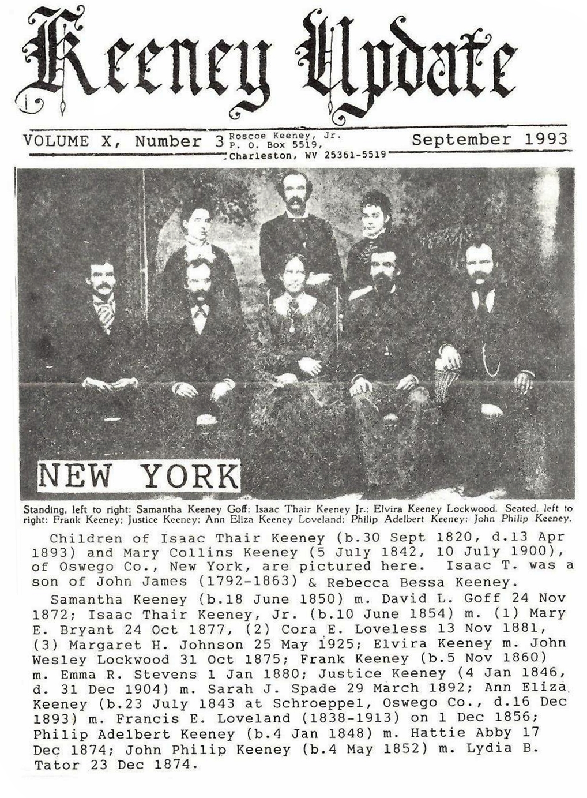
ISSUE #34
This 34th UPDATE is paid for by Hugh Fitch, MI; Edmund Patterson, MA; W. Robert Keeney and Vicie W. Fowler, VA; C. Jeanne Southers, NC; Shirley M. Jett and Anna M. Keeney, MO; Michael Keeney, Joan Soo and Ray W. Keeney, CA; Jerry F. Keeney, FL; James Samples and Ann Keeney Holcomb, OH; Doris Ludwig and George H. Keeney, TX; Helen P. Rushton, IN; Mrs. Monroe Kriegel, OK; Kenneth Keeney, OR; Marjorie K. Adams, KS; and Kenneth Coiner, Lynn Coiner Stover and Russell R. Keeney, WV. PICTURES and FAMILY stories are needed for Dec.
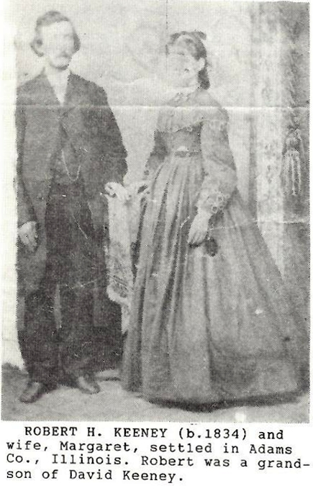

DAVID KEENEY FAMILY OF GREENBRIER COUNTY
DAVID KEENEY, born in 1765 and Greenbrier County, son of the oldest settlers who settled here about 1756; died 1846 (church record), baptized on 24 September 1820 at old Greenbrier Baptist Church, Alderson; married PENINAH HICKLEN BAILES on 24 April 1788 by Reverend John Alderson (Greenbrier County marriage records)
CHILDREN:
I. JOSEPH KEENEY-listed in Fayette County WV 1850 census at age 73; m. Mary Elizabeth McClung on 12 – 30 – 1828
II. JOHN D. KEENEY, b. 1789 in Greenbrier; m. Rachel Burditt (Burdette) 11 November 1812 in Monroe County; Methodist preacher; died 1855; buried at Ripley, Jackson County
III. DAVID KEENEY, Jr., b. 2 June 1790, d. 1 July 1862; m. Jane Hunter (1804 – 1878); old Lewis Presbyterian Cemetery, Blaker’s Mill
IV. MARY KEENEY, b. 1793, d. 6 February 1879 in Greenbrier, death records says age 84; m. John Patterson 19 August 1824
V. ELIZABETH KEENEY, b. c. 1796, died in childbirth in 1827 in Vermillion County, Illinois; m. David Boggess 21 May 1821 in Greenbrier County by Reverend Jacob W. Bromwell; David m. Nancy Pilson in Adams County, OH in 1828
VI. THOMAS HICKLEN KEENEY, b. 12 March 1803 in Greenbrier, d. 7 March 1880 at Catlin Township, Vermilion County, IL; m. Elizabeth Caraway (1810 – 1878)
VII. LUCRETIA KEENEY, b. 1805; unmarried, age 45 and 1850 census with H. S. Hanshaw family
VIII. MICHAEL KEENEY – listed in family Bible, apparently died as a child
IX. RUTH KEENEY – listed in family Bible

KNOWN OFFSPRINGS:

1.David 1765, m. Peninah Bailes
2.Joseph, m. Mary Elizabeth McClung
3.Thomas 183
3. John B. 1831, died before 1910 m. Grace Greenwood Gray Kessler 1880
4 Annie Maude Keeney 4 – 1892 m. Wm. Herbert Jones; 10 children
4.Archie Kester Keeney 9 – 1895 m. William Calvin Hizer 1914 – 13 ch.
3. Benjamin Franklin 1832, 25 and 1860 c.
3. Robert H. Keeney 1834; age 45 and 1880 Adams County, Illinois census; wife: Margaret
4. Joseph 1868
4. John 1870
4. Ida M. 1874
4. William 1878, wife: Martha J. 1882
5.Viola G. 1905 and McLean County, IL
5. Birdie L. 1908
3. Pauline 1836 – 14 in 1850 census
3. Mary F. 1838
3. James W. 1840
3. Madison 1842
3. George W. 7 – 1844; 53 in 1900 Boone County, IN census; wife: Mary b. 1854 in KY
4. Clara 1875
4. Elvira 1 – 1880
4. Anna R. 12 – 1881
4. Roy R. 5 – 1885
5. Ralph 1909 – Boone C., IN
5. Kenneth 1913
4. Roscoe W. 3 – 1887; wife: Viola 1890
5. William E. 1916 – age 4 in 1920, Boone County
4. Nancy S. 1844, m. John Samuel Fleshman (b. 1842) 24 March 1866 at Sewell, WV
5. Charles W. Fleshman 1867 – died young
5. James 1868
5. Minnie 1869
5. Nora B. 1871
5. Mary D. 1874
4. Joseph C. Keeney 1852, wife: Hattie A. (Age 67 in 1920 Fayette County, WV census)
2. JOHN D. KEENEY 1789, d. 1855 wife: Rachel Burdette m. 30 November 1812
3. Mary (Maria) 1813, m. G. W. Burdette
4. James A. (Burditt) 1834
4. Mary Margaret 1842, m. R. H. Park
5. Con S. (Son) 1858
5. Clyde Park 1861
5. Bird W. Park (son) 1864
5. Alfred 1866
3. Alexander 1815 – 1869, Ravenswood Cemetery m. Elvira Rader (1818 – 1896)
4. Isabel 1848, m. Geo. C. Prescott
5. Carl Prescott 1868
5. James Prescott 1869
4. Mary H. 1851, m. John S. Conner
5. Annie E. Conner 1867
5. Gracey Conner 1873
5. William Conner 1876
5. Kittie Conner 1878
4. Julia Keeney 1853, d. 24 June 1863
3. David Jackson 1818, d. 12 – 16 – 1880 8m. Naomi C. Kouns (1824 – 1888)
4. Laura A. 1846, m. Calvin C. Shank
5. Earl K. Shank 1876; wife: Georgia
4. Alonzo Taylor Keeney 13 September 1847, d. 1934; m. Alma Jerusha Haworth 1870
5. Claude Everett b. 14 September 1871, d. 19 January 1934; dentist; m. Evelyn Dudley Fisher (1875 – 1967);
son: Kendall Haworth Keeney 13 November 1903, d. 6 June 1982
4. Mary Alice 1849, m. James W. Williamson
5. Harry C. 1880, d. 20 Dec 1937; attorney
4. Emma W. Keeney (1854 – 1933), m. Coleman A. Staats (1851 – 1897), Ravenswood Cemetery
5. Bernice Ora Staats 1874 – 1968; unmarried
5. Mary Alice Staats 1876 – 1880
5. Daisy L. Staats 10 – 1879; m. J. Frederick Holswade; raised family in Huntington WV; children: Lucile,
James, Frederick, Henry, Catherine Holswade
5. Ada M. Staats 1882, m. Isaac J. Osbun
5. Emma Katharine 4 – 1885, m. Raymond E. Cummings; resided in Buffalo, NY; children: John Raymond,
William Forest
5. Coleman Alkire Staats, Jr. 1887, m. Nancy Campbell; dau. Gene Campbell Staats
3. Caroline Keeney 1820; age 60 in 1880 census; m. John McIntosh 18 April 1838
4. Solinda J. 1840, m. Charles Harpold; teacher
5. Eva M. Harpold 1864
5. Emma 1865, m. W. L. Smith
5. William A. 1867, m. Eda Osborne 1897
5. Solomon Edgar 12 May 1870
5. Frank O. 1874, m. Edmund B Tomblin 1897; children: Allen E. 1899, Margaret H. 1903
5. Henry E. 1877
4. John Angus McIntosh (1844 – 1906), m. Ella D. Smith; 17th WV Calvary, Civil War; merchant
5. Mary Alice (1868 – 1905) m. J. Smith Green
5. Frederick F. (1870 – 1950) m. Harriet H. Chapman
5. Marvin Everett (1878 – 1881)
5. Charles Leon (1879 – 1938) m. Nell McGlothlin
3. Ann Eliza Keeney 1827, m. Silas B. Taylor
4. Ora C. Taylor 1844
4. Anna M. Taylor 1847
4. Josephus Taylor 1854; age 17 in 1870
4. Ida M. Taylor 1856; m. Edwin H. Flynn 1892
4. Holly H. Taylor 1859; age 21 in 1880 census
3. Lewis M. Keeney 1829, d. 12 September 1911; 22nd VA Infantry, Civil War; m. Sarah Ann Dilworth m. (2)
Elizabeth S. Kouns (1832 – 1915)
4. Lenora Keeney 1852, m. Alexander Kincaid 1870
5. Edgar A. Kincaid
4. Henry Keeney 21 July 1853; 26 in 1880 census
4. John Keeney 1855; 24 in 1880 census
4. Lillie Keeney 1861; 18 in 1880 census
2. DAVID KEENEY, Jr., b. 2 June 1790, d. 1 July 1862; m. Jane Hunter (24 March 1804, 4 March 1878); buried at Blaker’s Mill
3. JAMES KEENEY
3. LYDIA A. KEENEY, b. 9 February 1829, d. 22 October 1897; m. Abraham Argabrite (widower, b. 1805);
baptized at Old Greenbrier Church 27 September 1863
3. Joseph R. Keeney 1831; m. Louisa Sydenstricker 1 June 1854; residents of Cole County, Mattoon Twn., IL in 1880 census
4. Serena Keeney 1855 VA – 25 in 1880 census
4. Blanche Keeney 1871 IL – 9 in 1880 IL census
3. Lucretia Frances Keeney 1834, m. M. H. Kincaid 30 August 1855 in Greenbrier; Wellston, OH res.
4. James Kincaid
4. Fletcher Kincaid
4. Wallace Kincaid
3. Edgar Lloyd Keeney 1835; settled in Eugene, OR; m. Virginia Elizabeth Jarrett 26 October 1865
4. Edgar Lloyd Keeney, Jr. 1868 in IN; wf: Jennie R.
5. Virginia E. Keeney 1905 OR
5. Paul Keeney 1906 OR
3. Harriet Isabella Keeney 26 Dec 1839, d. 4 Dec 1912; m. (1) George W. Charlton 1869; (2)___Hedrick
4. Anna Charlton
4. Ida B. Charlton 22 November 1872, d. 4 November 1910
3. John Hunter Keeney 1842, d. 16 April 1889; Blaker Mill Cemetery; m. Rebecca A. Rodgers (b. 1841) 28
November 1867
4. Samuel Edgar Keeney 13 Dec 1868, d. 18 March 1952, m. Mary V. Hedrick 13 August 1890
5. Samuel E. Keeney, Jr. 1891
5. Mary Elizabeth Keeney Meese 11-1893
5. Betty Lou Keeney Brown
5. Clarence Mason Keeney 7 June 1896, m. Maude M. Feamster (b. 1896) 15 October 1922; son, Toby, lives
at Alderson, WV
3. William Keeney 1842; 32 in 1880 Fayette County census wife: Catherine (b. 1851)
4. Thomas Keeney 1871
4. Ella Keeney 1873
4. Willie Keeney 1877
4. John Keeney 1879
3. Newton Clark Keeney 18 May 1848, d. 9 March 1928; m. Mary Jane Hobbs (28 Dec 1854, 2 February 1938),
lived at Grassy Meadows, Blue Sulfur District, Greenbrier County
4. Everett Arlington Keeney 28 August 1874, d. 3 October 1956 at Saint Albans; M. Lydia May Arrington (b.
1885) 30 June 1909
5. Mary Frances Keeney 31 March 1910
4. Lake E. Keeney 10 Dec 1876, d. 1 April 1906 in car accident
4. Nora L. Keeney 6 January 1879, d. 3 – 1943; m. James Tuckwiler
4. Lloyd Hunter Keeney 14 March 1881, 2 February 1944 m. Mrs. Hattie Arrington (1890 – 1962) 16
Sep 1908
4. Roy E. Keeney 1 – 1888; lived at Diamond, OH; married Sarah J. Evans (d. 1961) on 1 May 1912
4. Mintie Frances Keeney 20 April 1884, d. 14 Dec 1964; m. Milton Bundy Hutsenpiller (1 January 1878, 12
June 1945) on 30 Dec 1908; raised family in Greenbrier County
5. Frederick Carlton 1 – 1910, m. Esta Cadle 12 – 1935; children: Jesse 1937, Ruth 1939, Frances 1942, Va. 1944
5. Clarice Leotha Hutsenpiller 12 – 1912, d. 21 April 1987 at Pearisburg VA; End of Trail Cemetery
5. William Franklin Hutsenpiller 12 – 1914, d. 17 February 1985 that San Jose CA; m. Roberta Knapp 1937; children: James, Robert
5. Verna Maud Hutsenpiller 1 – 1916, m. Ira Douglas
5. Mary Sabina Hutsenpiller 2 – 1918, m. Wm. Good children: Edward 1946, 1951
5. Milton Ray Hutsenpiller 5 – 1920, m. Wanda Bennett
5.Erma Eileen Hutsenpiller 6 – 1922, m. Fred Estes Surbough 1955 (S/SGT paratrooper, Presidential citation for advanced landing on D-Day); children: Harvey 1957, Doris 1958
5. Clayton Clark Hutsenpiller 4 – 1924, m. Billy Sweeney 8 – 1948; sons: David, Charles
5. Gene Henry Hutsenpiller 1 – 1928, m. Mary Lou Miller 12 – 1953; CH.: Deborah, Milton, James
3. Lorenzi Daniel Keeney 8 – 1836 in Greenbrier, d. 4 April 1911 in Chesapeake, OH; m. Leah Ann Wilson (1838
– 1925) on 14 Dec 1859
4. William Edgar Keeney 1860, d. 3 January 1939 in Lawrence County, OH; m. Sarah Elizabeth Goff (1859 –
1937)
5. Edith Keeney McClellan
4. Joseph Newman Keeney 5 Feb 1862, d. 8 Dec 1943 in Vacaville, CA; m. Gertrude M. Chapman (b. 1872) in
Monroe County, WV on 24 Dec 1898
4. Mary Cornelia Keeney d. 19 Feb 1953 at Saint Albans, WV; m. Elliot Sheridan Baker (1865 – 1939) 11 Apr
1888
5. Stanley Harrison Baker 2 Jan 1889, d. 21 June 1960 7m. Meysel Forrest Eads; dau.: Phyllis B. Krieger
5. Frederick Elliot Baker 27 March 1891, d. 30 March 1930 6m. Virginia Withrow
5. Minnie Grace Baker 3 Oct 1893, d. 12 May 1963 m. Vernon Albert Miller; 4 grown children
4. Ota Clark Keeney 1867 in Lawrence Co., OH; d. 1956 wife: Melissa L. (1867 – 1918); Walnut Grove
Cemetery, Bluefield, WV
5. Mary Nell Keeney (b. OH)
4. John Madison Keeney 24 January 1871 Gallia County, OH, d. 18 Dec 1951 in Chesapeake, OH; m. Mary
Ann McDaniel (21 April 1875, 8 July 1956)
5. Leah Grace Keeney 12 Dec 1899, 17 Nov 1957
5. Maurice Melville Keeney 30 April 1901, 13 May 1912
5. Byron Keeney 8 Dec 1902, 7 Oct 1939 (struck by auto) children: Betty 1924, Jack 1926
5. Olive May Keeney 30 Sep 1906; lives in Chesapeake, OH
4. Annie Belle Keeney 5 Feb 1874 Lawrence Co., d. 31 July 1964 in Huntington; m. Martin Adams in June
1920; no children
4. Myrtle Rose Keeney 20 Mar 1883 Lawrence Co., d. 29 July 1955 in Huntington; m. Harry Gardner Haynes
5. Faye Hayne, m. Harvey W. Johnson – Huntington, WV children: Milan H. 4 Dec 1931, Robert Emerson 10 August 1933, Leah Ann & Nancy Ann (Martin) 31 October 1937, Mary Cornelia Johnson Potter 1940
5. Clyde Carol Haynes, m. Bill Hall (she lives in Tampa, FL)
2. MARY KEENEY, b. 1793, d. 6 Feb 1879 Greenbrier Co.; m. John Patterson 19 August 1824
2. ELIZABETH KEENEY 1796, d. 1827 in Vermillion Co., IL; m. David Boggess 21 May 1821 in Greenbrier Co.
3. Hamilton Boggess 1822, died in Civil War in Tennessee; wife: Sarah lived in Vermillion Co., IL
3. Moses Boggess b. 1824 and Greenbrier County
3. Odessa Boggess, m. Francis L. Daugherty in IL
3. Ann Boggess
2. THOMAS HICKLAND KEENEY 12 March 1803 in Greenbrier, d. 7 March 1880 Caitlin Township, Vermillion
Co., IL; m. Elizabeth Caraway (1810 – 1878); God’s Acre Cemetery
3. Hamilton Franklin Keeney 1830 VA, d. 24 May 1889; never married; Oakwood Cemetery, Caitlin, IL
3. David Keeney 14 February 1832 in IL, d. 6 November 1858; m. Hannah Love 30 April 1854; God’s Acre
Cemetery
3. JOHN A. Keeney 17 October 1833, d. 26 March 1853
3. Lucretia V. Keeney 4 August 1835, d. 7 January 1882; never married
3. James Thomas Keeney 12 July 1837, d. 7 Sep 1878; m. Harriett Angeline Douglas (b. 1842) 29 Oct 1860
4. Charles C. Keeney 7 – 1862, m. Mayme Frazier 1900
4. Walter Scott Keeney 8 – 1864, d. 1938, m. Laura Driscoll (1875 – 1951) in 1893 in Vermillion County
5. Inez Keeney 9 – 1894, m. Marion B. Stine children: Laverne, Floyd, Raymond, Curtis L.
5. Herman Fletcher Keeney 1 Jan 1902; school principal; m. Jane Squires 12 June 1926; children: John Fletcher 30 March 1928, m. Nadine Elliott
4. Clara E. Keeney 13 Dec 1866, d. 10 June 1950 8m. William A. Schechter (1865 – 1900) 26 August 1884
5. Eugene Schechter 10 – 1886
5. Ruby Schechter 9 – 1888
5. Virgil Schechter 2 – 1890
5. Walter Schechter 1 – 1892
5. Paul Schechter 2 – 1894
5. Grace Schechter 11 – 1895
5. Hazel Schechter Parker 25 Nov 1898, d. 9 Nov 1933
4. Joseph F. Keeney 7 Sep 1869, d. 16 July 1936; m. (1) Anna L. __(1874 – 1893), died of TB; (2) Harriet Ann
Motz (24 Oct 1865, 31 Oct 1945) on 25 Aug 1896
5. Esther Leone Keeney 24 October 1897, d. 1 – 1974; m. Elmer L. Crawford (1897 – 1923, struck by lightning); m. (2) Harry Ludwig (b. 1886) 17 July 1948 children: Charles (1918 – 1921), Margaret 7 Dec 1923, d. 5 May 1992, retired nurse
5. Harriet Angeline Keeney (1902 – 1977), m. Herbert E. Morgan (b. 1 Dec 1896); children: Bertha Walker 5 September 1921, Beulah Stockton 30 June 1923, Herbert Alan 30 September 1925, Raymond Gene 30 March 1929, Joan Hepburn 23 February 1932, Dale 9 June 1935, Earl 22 June 1937, Robert Dean 2 November 1939
4. Dale P. Keeney 10 March 1871, d. 8 February 1933, m. Mary Evalina Glehey (1874 – 1956) in 1899
4. Thomas A. Keeney 1875; Co. C, 125th Illinois Infantry, God’s Acre Cemetery
4. Rose D. Keeney (1879 – 1951), m. Robert E. Walker (1874 – 1965) in 1898 MI: Oak Ridge Cemetery
5. Edward Walker (1899 – 1904)
5. Grace Walker (1913 – 1918)
5. R. Vaughn Walker (1905 – 1972), wife: Doris E.
3. William Fletcher Keeney 1 October 1843; d. 24 March 1918 m. Mary Adeline Richards (1850 – 1916)
3. Mary E. Keeney 14 January 1846, 11 November 1846; God’s Acre
3. Amanda Keeney 1849, m. (1) Joseph M. Jeffries on 14 October 1880; (2) George W. Carnes (b. 1834) in 1892
4. Jesse G. Jeffries 11 – 1880
2. Moses Asbury Keeney c. 1804, d. 19 August 1840; m. Phoebe Ann Skeene (d. 13 July 1856) on 7 Dec 1825
3. Elizabeth Mary Keeney 3 Dec 1826, died at Alderson, Lewis Church Cemetery
3. William Hamilton Keeney 5 Nov 1829, d. 1898; buried at Rocky Mount, Franklin County, VA; m. Sarah P.
Vaughn (1829 – 1909) on 27 Sep 1849 at Covington, VA
4. William Thomas Sales Keeney 2 Mar 1856, d. 18 Jan 1917; m. Catherine Duncan (1854 – 1940)
5. William Leland Keeney 27 Dec 1888, d. 1 Sep 1963
5. Maple Vaughan Keeney 8 Feb 1891, d. 27 Feb 1962
5. Robert Keeney 13 Jan 1893, d. 27 Sep 1893
5. Helen Holland Keeney 6 Feb 1896, d. 28 Feb 1896
5. George Herbert Keeney 1 Nov 1900, d. 28 Feb 1918
4. Robert Henry Byrd Keeney 18 May 1858, d. 1917, m. (1) Margaret C. Arthur (c. 1860 – 1903); (2) Sallie W.
Duncan
5. Arthur Gladstone 13 November 1892
5. Margaret B. 10 July 1894, d. 10 – 1970
5. Diehl Vaughan 31 August 1898
5. Robert Wayland Keeney
5. James Kirkland 26 June 1901
5. Marvin Fowler Keeney 7 Dec 1902 – Daytona Beach, FL
4. Mary Safronia Keeney 1861, d. 18 January 1925, m. Dr. Hearon, president of Sullins College
4. Emma Blanche Keeney 29 January 1863, d. 31 January 1939, m. Thomas David Robinson (29 March 1893, d. 11 September 1942)
5. Florence Robinson 24 May 1894
5. Ruth Robinson 3 May 1900
4. Sallie Roberta Keeney (1865 – 1925), m. John H. Hedrick (b. 27 September 1868) on 24 September 1890
5. Sallie Mae – died at age 12
5. Olen S. Hedrick 1898 (1910 WV census)
5. John Paul Hedrick 1902
4. George Oscar Keeney 19 Nov 1870, d. 28 Jun 1934; m. Mary Catherine Marsh (13 May 1871, 13 Mar 1954)
5. William Henry Keeney 31 Dec 1890, d. 26 September 1959
5. Claire Winifred Keeney 14 June 1894
5. Gladys Vinita Keeney 3 September 1897, d. 16 Dec 1968
5. Georgia Catherine Keeney 23 March 1902, died in 1980s; US government employee and family genealogist
5. Bernice Vaughan Keeney 3 August 1905
5. Blanche Dorothy Keeney 23 May 1908
5. Garland Marsh Keeney 31 August 1912

MISSOURI MARIES COUNTY
Volley Jett
Volley Wandell Jett of Summerfield died suddenly Easter Sunday morning, April 11, 1993. She was 82. Volley was born near Summerfield on November 5, 1910, she is the daughter of the late George and Esther Goodman Keeney. On August 12, 1934, Volley was joined in marriage to Bryce Jett and to this union four children were born.
Surviving Volley is her daughter Shirley Jett of Bland; three sons Tom Jett of Bland, Terry Jett of Russellville, and Macey Jett of Holts Summit; brother Barry Keeney of Belle; two sisters Rhoda Scholz of Belle and Geneva Hutchison of Alton, IL; eight grandchildren five great-grandchildren.
Volley is preceded in death by her husband Bryce; a brother Roscoe Keeney; and two grandchildren LeAnn and Michael.
Services were held the following Tuesday from the Pilot Knob Baptist Church. Reverend Glenn Snyder officiated. Interment was in the Church cemetery.

Mary Dale Keeney
November 22, 1919 – June 25, 1993
CARMEL, California – Mary Dale Keeney, 73, formerly of Salem, died Friday at her home.
A native of Stayton, she was reared in Salem, graduating from Willamette University and Mount Angel College. She received her master’s degree in education at San Jose State University.
She married Warren McDonald Keeney the 2nd in 1943. She was an art teacher for 35 years in Oregon and California. She lived in the Monterey – Carmel area.
She was a member of the Carmel Foundation and Church of Religious Science, Monterey. She also taught art classes to senior citizens and was actively involved in the hospice program. She enjoyed animals and playing the piano.
Her husband died in 1980.
Survivors include her sons, Michael D. Of Santa Cruz, California, and Warren M. Of Stockton, California; daughter, Kristy A. Keeney of Los Gatos, California sister, Jette J. Himmell of Irving, California; 10 grandchildren; and 5 great-grandchildren.
Visiting will be from 9 AM to 9 PM Monday in The Paul mortuary, Pacific Grove, California. Services will begin at 11 AM Tuesday in the Monterey church. Graveside services will follow at 3 PM Tuesday in Cedar Lawn Cemetery, Fremont, California.
Contributions may be made to Mary Dale Keeney Art Scholarship, San Joaquin Delta College, 515 Pacific Ave., Stockton, CA, 95204
SJ 6/27/93

Alfred E. Pietila
October 27, 1913 – June 28, 1993
A memorial service was held July 6 at Tigard High School for Alfred E. Tigard, who died June 28 in the Portland care center of causes related to age. He was 79. Private niche inurnment was in Crescent Grove Cemetery.
The son of Finnish parents, Mr. Pietila was born October 27, 1913 in Hockinson, Washington, one of nine children.
In 1936 he graduated from Willamette University, where he was a member of the Alpha Delta Psi fraternity. He earned his master’s degree in education from Oregon State University in 1954.
In 1940 he married Elva, whom he had met at Willamette.
After several years as a teacher, coach and principal in Astoria and Rainier, he began a 31 year career in the Tigard School District in 1945.
Initially, he was a coach, teacher and vice principal of Tigard Senior High School, and then principal of the new high school, which opened in 1954. From 1965 until his retirement in 1976, he served as assistant superintendent of Tigard schools.
An outdoor enthusiast, he enjoyed fishing, hunting and jogging and supported athletic events.
Survivors include his wife Elva of Tigard; son Fred and grandson Shawn of Denver, Colorado; daughters Dianne of San Diego, California, and Linda of Bend: and sisters Nancy Blankenship of Napavine, Washington, and Miriam Mattson of Woodburn.

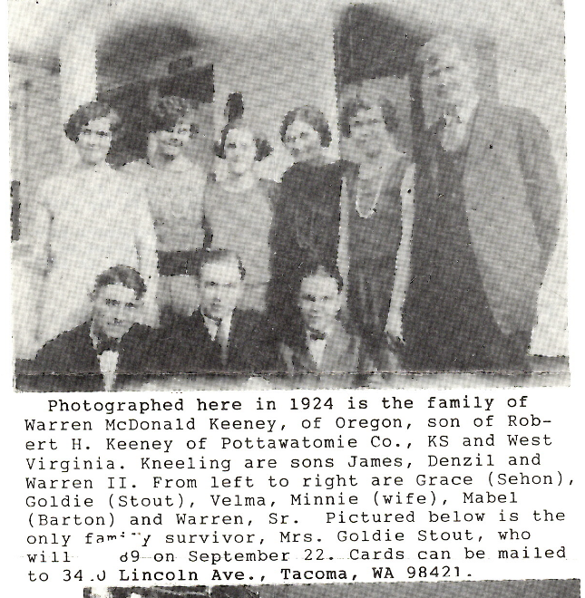
Mary Dale Cladek Keeney (1919 – 1993) was married in 1941 to warn McDonald Keeney II, at Bristol, Colorado.
Alfred E. Pietila, a Keeney in-law, with the husband of Elva Sehon, granddaughter of Warren McDonald Keeney, Senior.
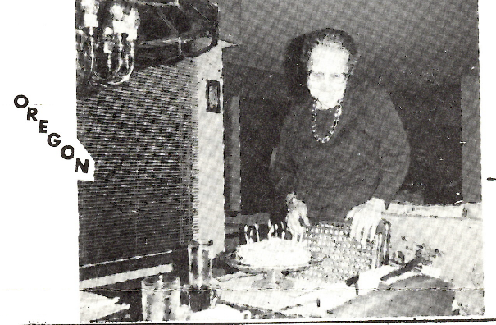

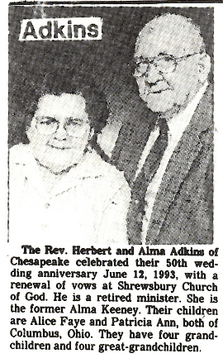
CALIFORNIA
KEENEY
Sharon and Michael Keeney of Lake Arrowhead proudly announced the birth of John Samuel Keeney at Mountains Community Hospital on March 5, 1993, at 12:13 PM. Tthe baby weighed 5 lbs. 9 oz. at birth and measured 19 ¼ inches in length.
The father is employed by Joy Environmental of Houston, TX and the mother is a homemaker.
Rema Story of Byrdstown, TN is the maternal grandmother and Sally Keeney of York, PA is the paternal grandmother.
John joined sister Sara and brothers Joe and Mark at home.

HEAD CRUSHED TO A PULP

A Shocking Accident on the Kanawha & Michigan Railroad Tuesday.
One of the most shocking accidents ever recorded on the Kanawha and Michigan Railroad occurred at Boomer about 4 o’clock Tuesday afternoon which Ira Keeney, a brakeman, lost his life, while engaged in attempting to make a coupling following a running switch. In the approach of the engine to the head of the train young Keeney had prepared to make the coupling as the engine reached the 1st car. In some manner, the engines failed to slow up sufficiently and dashed into the car with such force as to throw the break man between the tank and the footboard of the 1st car and his head was caught, crushing it into an unrecognizable mass. When the other members of the train crew reached the scene the victim was dead, never having uttered a sound.
The train was in charge of Conductor Ed Ratliff, with Engineer Mason at the throttle.
Ira Keeney, was the son of B. G. Keeney, a respected citizen of East Bank, and was a most energetic young man. He was married in May last to Miss Miller, of East Bank, and was very popular among the train men of that (unreadable)ad. He was a member of the Brotherhood of Railway Trainmen and attached to # 398 of Middleport, Ohio. He was a cousin to the Montague boys of Charleston.

IRA LEE KEENEY (b. 20 July 1879, killed 5 July 1904 at age 24, was a son of Baylous G. & Susan Ella Hailey Keeney. He is buried at East Bank, WV.

KENTUCKY
Exploding cable array: Military Channel
Roanoke Times & World News, Sunday, February 14, 1993
Associated Press
WASHINGTON – if tracer missiles thrill you and SCUDs make your heart thud, don’t touch that dial. The Military Channel is planning to bombard you with visions of war, 24 hours a day.
“Military and aviation are hugely popular,” says Douglas Keeney, the visionary who hopes to give new meaning to the term “domestic warfare.”
Keeney is betting there will be an audience for a cable TV channel devoted entirely to battle, war machinery and fighting men and women. John Wayne movies will have a prominent niche, he says.
So far, Keeney said from his office in Louisville, KY, he’s raised about $1 million of the $6 million to $7 million it will take to make the Military Channel a reality. The money is being spent in film production and getting programs ready for the debut late this year.
“If you like news on television, cable TV is willing to give you a 24-hour channel,” he reasoned. “If it’s sports, it will supply you all the time, anytime. If it’s courtroom dramas you like, you get 24-hour Court TV. Want cartoons? You got a cartoon channel. So we are going to have a 24-hour Military Channel.”
Whether he succeeds depends 1st on what happens with the cable TV law enacted last year. It limits cable companies’ ability to raise rates.
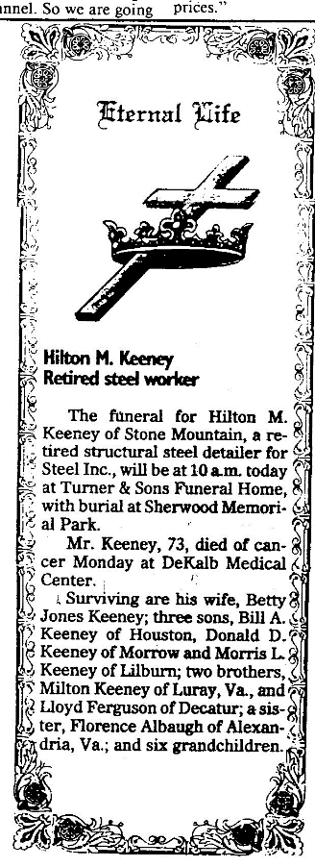
“That really threw a monkey wrench into plans to add additional channels,” said Michael Lustman of Time Warner Cable, the 2nd largest cable company. “It still is up in the air as to what kind of restrictions the Federal Communications Commission will put on cable TV operators’ ability to raise prices.”
Typical day of programming on the Military Channel might have a couple of classic war movies in the morning. There would be news in the evening and perhaps a Navy show called “Night Traps” about landing on carriers. Prime time would be devoted to World War II history, battle history and documentaries.
“Instead of running present-day public service ads, we would run ones from the 1930s, 1940s and 1950s,” Keeney said. “Old recruiting ads will come on.”
He’s also thinking about poetic segment on stealth aircraft. “There will be no talk, just music. You just watch it fly for 6 minutes.”
And is planning to run a series on the 8th Air Force in England in the 1940s called “Hurry Home, Honey.”
Keeney also intends to cover breaking military news. For an incident like the January 17 shootdown of an Iraqi plane by a US F-16, he says, the Military Channel would go live to the breaking news and follow the story all day.
Advertisers, he hopes, will be drawn to what he expects to be a predominantly male audience.
Bridgit Blumberg, spokeswoman for the National Cable Television Association, said the Military Channel is one of a wave of such ventures trying to take advantage of new technology that will allow cable systems to carry 500 channels.
Currently, channel capacity is full.
But Keeney is planning for his channel’s debut and he sees nothing but victory in the air. Already cable operators are calling him, he says, to make sure they’re put on his list.

Helen M. Houdyshell
WHITE SULPHUR SPRINGS – Mrs. Helen Montague Houdyshell, 75, of White Sulphur Springs, died June 18, 1993, in Brian Center, Low Moor, VA, after a short illness.
She was a former teacher in Kanawha County, and talk at White Sulphur Springs high school and Greenbrier East high school until her retirement. She was a member of the Eastern Star, Green Mitt Garden club and former member of White Sulphur Springs Library Board.
Surviving son, Tim M. Of White Sulphur Springs; daughters, Helen Lafferty of Huntington, Sharon Freeman of White Sulphur Springs, Linda Thacker of Mooresville, NC, Joy Domsky of Williamsport, MD; 10 grandchildren, 2 great-grandchildren.
Service will be 2 PM Sunday at Shanklin Funeral Home, White Sulphur Springs. Burial will be 11 AM Monday at Spring Hill Cemetery, Charleston. Friends may call from 6 to 8 PM today at the funeral home. Donations may be made to White Sulphur Springs Public Library, 203 West Main St., White Sulphur Springs.

Frances R. Fisher
Mrs. Frances R. Fisher, 66, of Dunbar died July 11, 1993, at Thomas Memorial Hospital after a long illness.
She attended Humphreys Memorial United Methodist Church, Dunbar, and was a former resident of Huntington.
Surviving: husband, Wilbur M. Fischer; C. W. Keeney of Pittsburgh; sister, Mary Lou Smith of Virginia Beach, VA.
Memorial service will be held at a later date. There will be no visitation. Keller Funeral Home, Dunbar, is in charge of arrangements.

Mrs. Louise French Snyder
DURHAM, NC – Mrs. Louise French Snyder, 78, of 205 Villa Dr. died August 28, 1993, at Durham Regional Hospital after a short illness.
She was a painter. She was a native of Bay City, Michigan, and lived in Mount Hope, WV, Greenwich, Connecticut and Durham.
Surviving: husband, DeWitt Clinton Snyder; daughter, Terence M. York of Greenwich; son, Thomas H. II of New Canaan, Connecticut; sister, Lesban Haas of El Rito, NM.
A memorial service was held Sunday and Durham, and another is planned in Greenwich at date to be announced. In lieu of flowers, memorials may be set to the Louise F. Snyder Foundation at Durham Regional Hospital, Durham, NC 27712.

HELEN M. HOUDYSHELL was a daughter of Earl Black Montague and a granddaughter of Dudley S. & Mary Jane Keeney Montague. Mary Jane was a daughter of Michael & Elizabeth G. Keeney.

FRANCES R. KEENEY FISHER’s family line includes: father, Franklin C. Keeney; grandfather, John Fletcher Keeney; great-grandfather, William Harvey Keeney, the son of John S. Keeney, a son of Michael & Catherine Lewis Keeney. The family settled in Lawrence County, Ohio.

LOUISE FRENCH SNYDER’s husband, DeWitt Clinton Snyder II, son of Thomas Hubert & Ethel Stephenson Snyder and a great great grandson of William S. & Frances Keeney Brawley.

JANET ELIZABETH KEENEY’s husband, Raymond William, is a son of legendary Independence Nugget Keeney (Montana fame) and the grandson of Joseph Elias Keeney (1847 – 1938).
The ancestry of HILTON M. KEENEY dates back to Moses & Phoebe Ann Skeene Keeney, of Virginia and West Virginia.

JANET E. KEENEY
Memorial service for Janet E. Keeney of South San Francisco will be held at 3 PM Saturday at Aldersgate United Methodist Church, 115 El Campo Dr., South San Francisco.
Mrs. Keeney, 66, died Wednesday in Kaiser Permanente Medical Center, South San Francisco.
The native of Chicago grew up in Richmond. She lived in South San Francisco the past 38 years.
She is survived by her husband of 47 years, Raymond; a daughter, Kimberly of San Jose; sons Les of San Anselmo, Greg of Montara and Stacy of Hayward; and 4 grandchildren. She was the mother of the late Clayton Keeney.
The family suggests donations to a favorite charity.

CHARLES ERNEST KEENEY
Charles Ernest Keeney was born February 20, 1894 Prescott, Missouri. He was the son of Bluford and Eliza Jane (Watson) Keeney. He was the last of 16 children to depart this life. He passed away March 7, 1986, at Texas County Memorial Hospital after a long illness.
Ernest entered the service of the US Army, July 25, 1917. He was trained at Camp Funston, Kansas, and attained the rank of Corporal. He served 10 months and after his discharge, he continued his occupation as a farmer.
He was married to Anna Mae Cox on September 10, 1920. To this union 4 children were born.
He was a member of the Church of Christ (Temple Lot). At one time, he was an active member of the local American Legion Post.
Survivors include his wife, Anna, one son, Dr. Ireatess Keeney of Houston, 3 daughters: Mary Jane Medders of Houston, Florence Marie Kommer of Springfield, Missouri, and Alzada Massey of Weatherford, Oklahoma. 10 grandchildren and 10 great-grandchildren also survive. He has many nieces and nephews that will miss him, too.
Services were Monday at the Evans Funeral Home Chapel with Elders Tony Grzincie and John Jones officiating. Burial was at the Pinelawn Cemetery.

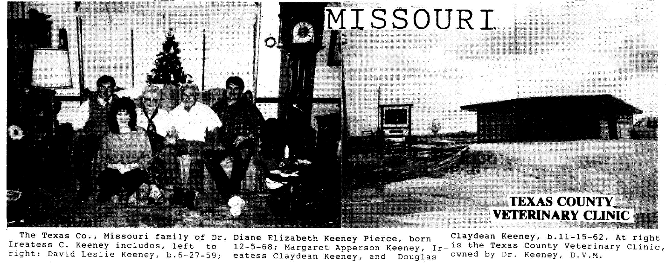

IREATESS KEENEY FAMILY
Peter Keeney was born in 1740; his son Moses Keeney (b. 1770); Abner Keeney, son of Moses, (b. 1810); Bluford Keeney, son of Abner, (b. 1848). Bluford married Eliza Watson in 1871. Sixteen children were born to this union. Charles Ernest (b. 1894) was one of these children. He married Anna Cox in 1920. They had 4 children: Alzeda (Massey) (b. July 17, 1922) who died November 3, 1990, along with her husband, Harold Massey, in an automobile accident in Oklahoma City, OK; Ireatess Claydean (b. June 30, 1926); Mary Jane (b. March 19, 1928); and Florence Marie (b. March 29, 1930).
Ireatess graduated from Licking High School in 1944. He received a BS degree in agriculture and a Dr. of veterinary medicine degree in 1954 from the University of Missouri-Columbia. He began his practice in June 1954 in Houston.
On October 21, 1955, he married Margaret Apperson. To this union 3 children were born: David Leslie Keeney (b. June 27, 1959); Douglas Claydean (b. November 15, 1962); and Diane Elizabeth (b. Dec 5, 1968).
David graduated from Houston High School in 1977, attended the University of Missouri-Columbia one year, then went to Southwest Missouri State University in Springfield, MO, graduating with a BS in animal science. He worked for a long time for a long distance phone company and then as an insurance claims adjuster. He married Carol Jane Moore from New Florence, MO, on June 17, 1989. They now operate an insurance agency in Houston.
Douglas graduated from Houston High School in 1981. He attended Missouri Southern State College in Joplin, MO. On Dec 29, 1984, he was married to Vicki Lynn Tucker of Aurora, MO. To this union 2 children were born: Margaret Elizabeth (b. August 3, 1988) and Jacob Douglas (b. July 21, 1991). They make their home in Springfield, MO, where Doug works for Bolivar Insulation and Vicki is an exercise physiologist at St. John’s Hospital.
Diane graduated from Houston High School in 1987 and attended cosmetology school in Warrensburg, MO. On Dec 31, 1988, she married Stephen Kirk Pierce. They have one son, Kirk Harrison (b. October 13, 1989). They live at Whiteman Air Force Base, MO, where Stephen is stationed.
Submitted by Margaret Keeney

SHELTER INSURANCE
DAVID KEENEY – AGENT
The people of this area are indeed fortunate to have in their midst of friendly insurance agency that has built a fine reputation in this area by serving local needs through all types of insurance, including life, auto, fire, casualty, etc. from reliable companies.
There are a lot of insurance agencies and agents in this area. What makes one stand out above all others? It’s the service and personal interest that they take in the welfare of you, your family and your personal property.
Most of us do not want to think about the many things that could happen to us or property… And there is no need to if we have a competent insurance agency planning for our future security.
For security and peace of mind, we the editors of this 1993 Spring Business Review recommend the SHELTER INSURANCE COMPANY located at 203N. Grand in Houston, phone 967 – 4112 for information or an appointment. We know you’ll be glad you did.

ALZADA MASSEY
Services for former Texas County resident, Alzada Keeney Massey are 2 PM Friday at the Evans Funeral Home Chapel with Elder Larry Beam of Oklahoma City officiating.
Mrs. Massey, 68, and her husband, Harold Massey, were killed November 3, 1990, in a 4 vehicle accident near Oklahoma City, Oklahoma.
Mrs. Massey, daughter of Charles Ernest Keeney and Anna Mae Cox Keeney, was born July 17, 1922, at Houston.
She was a 1939 graduate of Houston High School and received her bachelor’s degree from Southwest Missouri State University in Springfield.
While teaching at Licking, she met and married Harold Massey who was a teacher, basketball coach and served as superintendent for one year.
The Masseys left Texas County in the late 40s and Mr. Massey received his doctorate from the University of Missouri in Columbia. They moved to Goodwell, Oklahoma, and in 1962 Weatherford, Oklahoma, where he was associated with Southwest Oklahoma State University, and Mrs. Massey received her master’s degree.
She was a retired teacher, having worked in migrant worker education in the Oklahoma area. She also served as president of the retired teachers of Oklahoma and was a member of the Church of Christ (Temple Lot) in Oklahoma City.
In addition to her husband, she was preceded in death by her father.
Surviving are one son, William Ernest Massey of Dallas, Texas; one daughter, Marilyn Sue Massey of Stillwater, Oklahoma; her mother, Anna M. Keeney of Houston; 2 sisters, Mary Jane Medders of Houston and Florence Marie Kommer of Springfield; one brother, Dr. I. C. Keeney of Houston; and one grandson.
Burial will be in the Pine Lawn Cemetery at Houston.

