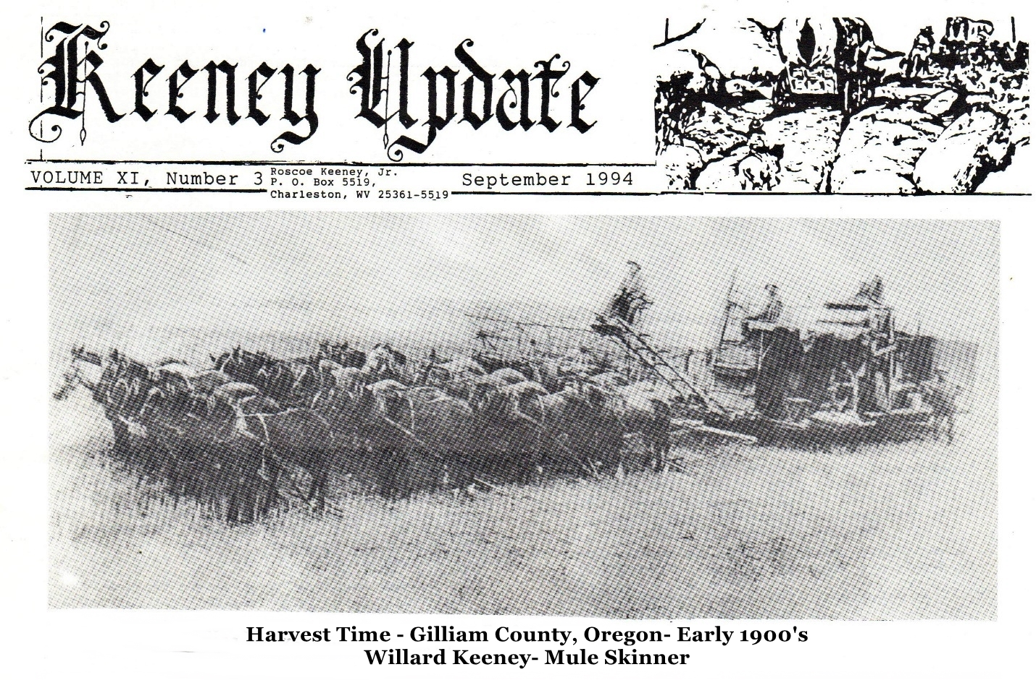

JOHN KEENEY, JR. FAMILY
TENNESSEE: Jefferson County; INDIANA: Fayette County; MISSOURI: Ray & Holt Counties;
OREGON: Lynn, Lane, Wasco, Multnomah, Yamhill, Gilliam and Marion Counties;
WASHINGTON: Walla Walla, King, Pierce counties; CALIFORNIA, IDAHO, MONTANA

JOHN KEENEY, JR., Subject of “WAGONS RUTS WEST,” a 1984 publication by Ralph Keeney, of the Dalles, Oregon, was born in Virginia (now Greenbrier County, WV), but, as a result of the Indian wars along the frontier, which completely emptied the Greenbrier region for a short time, he migrated with some of his brothers to what was known as Lincoln County, NC, which was to become Tennessee when the state lines were set.
In 1805, John was married to Mary Ramsey Buckhalter, according to Jefferson County, TN marriage records. Jefferson County had been organized in 1800 and its early records are filled with land transactions and vital statistics of this family as those of John’s brothers, Jonathan, Thomas and James. Almost all of these early families kept moving westward as new land became available.
The Keeney families were active in the Big Pigeon Baptist Church and the Association of Baptist Churches there. Several of their sons became ministers, especially in the Midwest.
John Keeney, JR. also was a man of many talents-farmer, ferryman, blacksmith, locksmith and gun Smith. He is remembered as a gunsmith because of the guns he made for each of his sons. These later became collector items. Mary Buckhalter Keeney was born in 1783 in South Carolina and died in Linn County, OR. June 24, 1872. John, Jr. Died of tuberculosis in Holt County, MO on 6 December 1845. Three sons also died in Missouri before other family members migrated to Oregon.
In 1851 all the Keeney children except Mary Bogart and Andrew Jackson (who went 6 years later via Nicaragua) joined a large caravan to the Northwest. Many were buried in the Keeney Cemetery in Brownsville, Linn County, OR.
John, JR.’s opposition to slavery was perhaps his biggest motivation for leaving Tennessee. He first held land claims in Fayette County, Indiana, dated November 1, 1811. The children, except for twins Elias and Eli, were born in Indiana. The twins were born in Ray County, MO.
FAMILY OF JOHN, JR. & MARY B. KEENEY
I. MARY ELEANOR KEENEY, b. 6. April 1806 in IN, died about 1850; m. Alexander Bogart 22. December 1822 in Ray County, MO; parents of 9 children
1. SAMUEL BOGART, b. 1832 in Ray County, married Harriet R. Nelson 26. February 1852 in Ray County.
2. WILLIAM W. BOGART, b. 1834 Ray County, MO
3. JAMES BOGART, b. 1836 in Ray County, MO
4. JACKSON BOGART, b. 1838 in Ray County, MO
5. ALEXANDER BOGART, JR., b. 1840 in Ray County.
m. Susan F. Goode 14 July 1865 in Ray County.
m. Nancy J. Johnson 16 November 1882 in Clay County, MO
6. JOHN W. BOGART, b. 1835; went to Oregon, age 45 in 1880 Lane County, OR census; married to Catherine (b. 1846 in MO); children: Annie T. b. 1862, Elizabeth Ida, b. 1864, Mary Nevada, b. 1866, William Garrett, b. 1870, Josephine C. b. 1877
II. THOMAS KEENEY, b. September 1808 in Fayette County, IN; died of tuberculosis in Holt County, MO; will, probated in Holt County 6 December 1842.
m. Sithy Allen, daughter of Ruben & M. Elsie Clevenger Allen; Sithy died in 1844, leaving six orphaned children; these children joined the 1851 caravan to Oregon
1. SILAS JOHN KEENEY, b. 1832, MO; age 38 in 1870 Linn County, OR census; wife: Malinda Pearl (b. 1844) 20 September 1855 in Linn County; m. (2) Sarah Miller. Jesse on 10 March 1870
children: MARY JANE, b. 1857, m. Chesney Keeney (a cousin, son of Abraham) 14. January 1875; ELIZABETH C. b. 1860; MARTHA A. b. 1862; SARAH C. b. 13. July 1864; LAURA M. b. 1866.
2. MARY ANN (Polly) KEENEY, b. 1834 Holt County, MO
m. John Fraker (b. 1828)
3. ELIZABETH J. KEENEY, b. 1836; living with Terry & Mary A. Scott in 1850, MO census;
m. Charles M. Pierce 3. July 1851; children: Sarah E., Nathan E., Josiah J. (All b. MO)
4. NANCY JANE KEENEY
4. WILLIAM THOMAS KEENEY, b. 1836; 14 in 1850 Ray County, MO census, living with Isaac and Annie. Allen
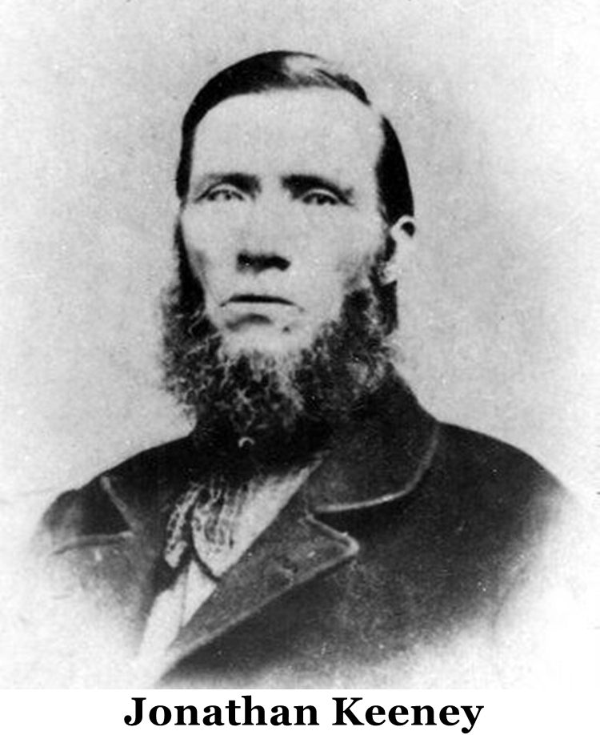
5. JOHN W. KEENEY, b. 1839; Co. C, 1st MO Vol. Calvary, CSA; enlisted 25. December 1861 at Springfield; battles: Sugarcreek, Bentonsville, Elk Horn; left in Arkansas in charge of horses; home address: Holt County, MO
III. ISLEY KEENEY, b. 15. May 1811 in Fayette County, IN; d. 1842 of tuberculosis; will, probated in Holt County, MO in December 1842.
m. Elizabeth Keeney (cousin) 29 January 1832 in Saline County, MO, by Bernie Brown, minister.
1. JOHN KEENEY – to Oregon in 1851 caravan.
2. NANCY ANN KEENEY – to Oregon in in 1851 caravan.
IV. CAPT. JONATHAN KEENEY, b. 27. April 1813 in Fayette County, IN; d. 15. August 1878 at Willow Creek, OR, Dell Cemetery in Baker, OR; started out from work on in 1831, returned to Missouri to get married; KEENEY & FINDLAY were the first to pioneer the route West over the Cascades in wagons; Gold Rush participant in 1849-50; had previously gone to Oregon and in 1846, had a 641.93 acre plot certified; large tract of land embracing Old Fort Boise; later placed the chimney from that Fort in his own home; set out from Missouri again in 1857, driving back 200 2-year-old heifers; establishing a fairy on the Snake River in 1863, moved there in 1865, sold ferry in 1876; served as Capt. in Rogue River War of 1855 over Co. C, 2nd Regiment, Oregon Mounted Volunteers. One historian wrote, “his romantic and eventful life is replete with the history of Idaho and Oregon.”
M. Mary Catherine Shoemaker in July 1837 in Lafayette County, MO; she died 18 April 1896 and was buried at the Old Canyon Hill Cemetery, Caldwell, ID
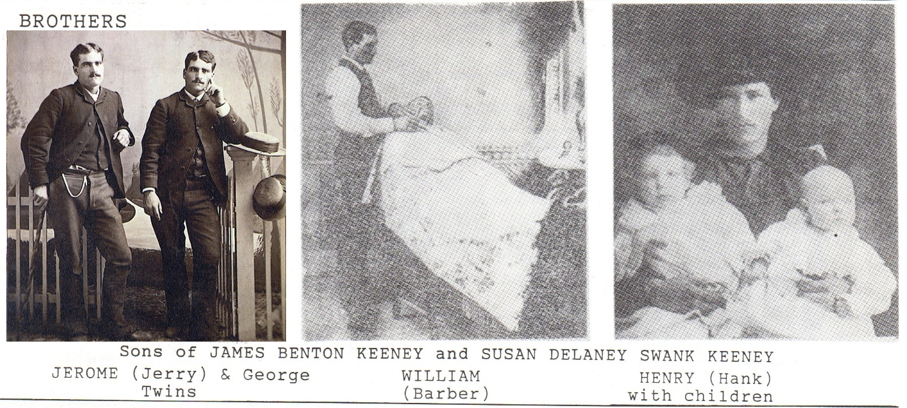 1. JAMES BENTON KEENEY, b. 12. April 1838, d. 1911 in Lane County, OR; first settled near Brownsville, OR, where in 1859. He married Susan Delaney Swank, who with her parents (Harmon & Mary Ann Swank) crossed the plains and settled on a ranch just north of Brownsville. Jim was a victim of wanderlust, trapping and hunting from the coast to the desert. Besides the Brownsville claim, she filed for homestead rights over 422 acres on the Calapooia drainage. He traded with the Indians, and was gone for long periods of time, leaving his family with a sack of flour, a sack of potatoes and some bullets to fend for themselves. Susan died October 12, 1933 at the home of her son, George, at Sweet Home, OR. Children:
K. FRED KEENEY
B. BRICK KEENEY
C. WILLIAM KEENEY – Barber
D. GEORGE W. KEENEY (twin), b. 3. June 1863, died in 1944; buried in Ames Cemetery; law enforcement officer and the state game warden, along with his twin brother; they were long known for a midnight gunfight, resulting from a payroll robbery of a logging firm; Keeneys were applauded for their bravery; George once ran St. John’s hotel; m. (1) May Johnson in 1885, children Wilda & Wayne, (2) Minnie Towne in 1890, children Otis (Hayward, CA) & Vera (San Francisco); (3) Josie Peters 1930
E. JEROME BONAPARTE (Jerry) KEENEY (twin), born 3. June 1863, d. 1946, buried beside his brother in Ames Cemetery; outstanding trainer of sheepdogs; grand parade Marshall for Calapooia rodeo; m. (1) Sarah Malone in 1890, Glenn (son), b. 1891, 19 in 1910 census; (2) Etta Wiley in 1894, children Gladys b. 1895, and Charles 1908; (3) Katy Cole after Etta’s in 1913
F. HENRY (Hank) KEENEY, b. 1878 in OR, age 32 in 1910 Crawfordsville, Linn County census, at which time Hank’s family included his parents, James B. (67) and Susan D. (61); wife: Viola C. (b. 1884 in OR); children: Lester, b. 1899, Henry, b. 1901, Jessie b. 1905, Floyd b. 1908, Charley, b. 1910
G. JASPER HARMON (Jack) KEENEY – lived entire life can Vale/Sweet Home area; representative for Lebanon Paper Mill Company; m. Isabel (Zilah) Ames; both prominent in community.
G. BESSIE KEENEY (married name: Stewart)
H. EVA KEENEY (married name: Geiger)
I. NELLIE KEENEY (married name: Price)
2. GEORGE W. KEENEY, b. 9. August 1841, d. 23. October 1862; never married.
3. ELI J. KEENEY, b. 1845, m. Ellen Swank
4. JOSEPH ELIAS KEENEY, b. 22. August 1847, OR Territory, d. 25. September 1938; boyhood spent in Oregon, California, Idaho, where he knew Boone Helm, George Ives and others who were hung by the vigilantes; his education was acquired in the hard school of the frontier- horses, ropes and six-guns; he was a professional gambler, wearing the typical black tails, hard hat, diamond jewelry and soft kid gloves; to his enemies he was the devil incarnate; a good friend of Doc Holliday and Wyatt Earp. At the age of 76 he shot and killed James Angus in Livingston, ID but was acquitted on self-defense; at 80 he was still dealing cards in Livingston saloons, 2 of which he owned. He didn’t wear glasses and lived to the age of 91.
m. (1) Susanna Robinson, mother of FOREST ELI KEENEY (m. Pearl Dickey), children: Beverly (son), Evelyn, June, Helen, Ethel; (2) Claire Parker, mother of Joseph Sylvester Keeney (b. 1884, m. Gladys Reeder, children: Arthur 1917, Olga A. 1919, Alfred 1920, Earl Lewis 1922, Vern Ivan 1924, Billy Louise 1927) and MABEL PEARL KEENEY (1882-1956) m. Max Mamlock; (3) married Mary Parker, sister of 2nd wife (b. 5. December 1868, m. 24. July 1885), mother of INDEPENDENCE NUGGET KEENEY (1884-1928) m. Rita Alexander, children: RAYMOND WILLIAM KEENEY (b. 1922, resides Santa Ana, CA) and DOROTHY KEENEY (b. 14. September 1927); and CAPT. OLIVER RUSSELL KEENEY, (b. 13. November 1904, d. 15. August 1992); Raymond William’s daughter, KIMBERLY ANN KEENEY, wrote a KEENEY family history as her school research project
5. SARAH M. KEENEY, b. 1850 in Brownsville, OR; d. 27. July 1855.
6. MARY CATHERINE KEENEY, b. 28. February 1852, died 8. August 1937; m. William W. Hockensmith 24. February 1870 in Ada County, ID; eloped and lived in Indiana several years; “neither smoked or drank, swore or played cards; none of these virtues endeared him to Capt. Keeney, who ran him off the place.”; m. (2) William Owen Bond-lived in Halsey, OR
A. GARDNER L. HOCKENSMITH, b. 1874 in ID
B. WILLIAM O. HOCKENSMITH, b. 1876 in OR
C. GEORGE HOCKENSMITH, b. 1879 in OR
D. BALF M. BOND-Banker
D. MONA BOND MOORE-teacher: son: Don
7. PETER LETHREW KEENEY, b. 17 November 1854 in OR, died in 1928; ferryman
m. Clara Estella Benson (b. 1860 in MN, age 20 in 1880 census, Idaho territory.
A. FRED KEENEY 1880-1941 – one child.
B. RENA KEENEY 1882-1971 – one child.
C. JOSEPH KEENEY 1885-1913 wife: Laura; 8 children
D. JOHN F. KEENEY 1887-1961 – one child
D. MAUDE KEENEY 1892-1970 – no children
F. HENRY KEENEY, b. 11. April 1900 – one child.
8. NANCY A. KEENEY, b. 25. November 1856, d. 29 April 1945; m. John Thomas Glenn 19 January 1874; 4 children
9. SUSAN ELIZABETH KEENEY, b. 9. November 1860, died 11 May 1932; m. (1) Oliver Scoville in 1879, 2 children including Mary Catherine, b. 1880; m. (2) Isaac Sterling Froman on 15, December 1883 at Boise, Ida County, Idaho; 6 Froman children, including Jessie James Froman, b. 1886; KEENEY genealogist: Bruce E. Froman, 1823 4th Street N, Nampa, ID 83687

V. JAMES KEENEY, b. 20 August 1816 in Fayette County, IA, d. 27 April 1885 in Linn County, OR; Keeney Cemetery.
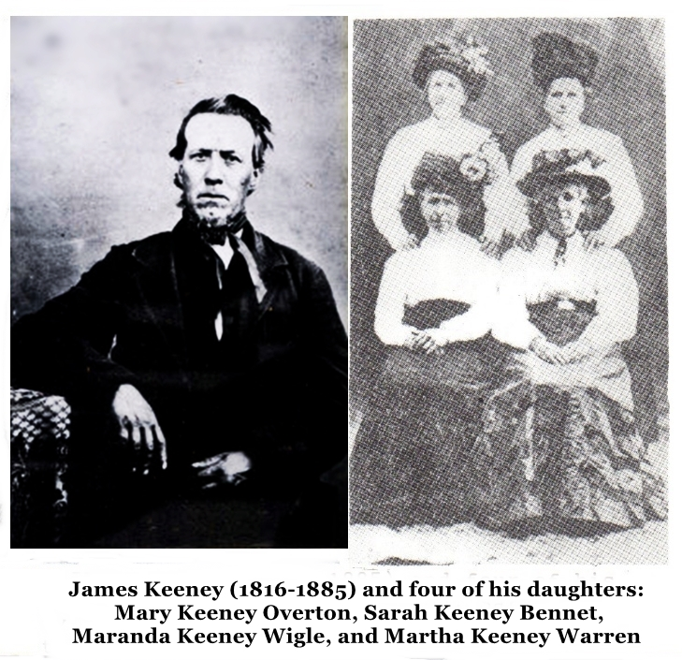
m. (1) Catherine Stewart 19 March 1840 Ray County, MO
1. MARY E. KEENEY, b. 1842 in MO; m. George Daniel Overton (b. 1830 in NY, d. 22 June 1933 in Brownsville, OR), Children: Lincoln 1868, Schuyler 1870, Albert 1872, Bradley 1874, Perry 1876, Fred Overton 1878
2. SARAH CATHERINE KEENEY, b. 1844 in MO
m. Alexander Bennett (b. 1842); son: John A. Bennett (1880-1954) m. Emma Ellen Brattian (1885-1957) parents of Lois Elsie Bennett Browning (1903-1988)
m. NANCY KEENEY (1809-1862), daughter of Thomas & Lavina Boles Keeney (cousin) on 1 March 1846.
3. MARANDA KEENEY, b. 1847; age 32 in 1880 census
m. Jacob H. Wigle (b. 1842 in IL) 20, December 1865.
Children: Mary O. 1867, Sarah C. 1869, James E. 1874, Martha J. 1879
4. IRENE KEENEY, b. 1849; 21 in 1870 census
5. MARTHA ELIZABETH KEENEY, b. 1852, d. 1 September 1932 in Yakima, WA; m. George Warren 14. January 1884 in Linn County, OR
m. Maranda Ruth Michael (1839-1919)
6. JAMES MORDECAI KEENEY, b. 23 November 1878; listed in 1920 Deschutes County census; wife: Elsie E. (b. 1882)
VI. ABRAHAM KEENEY, b. 11 December 1818 in Fayette County, IA; d. 25 May 1843 in Holt County, MO; will probated in Holt County; wife: Elvira
1. CHESNEY KEENEY, b. 19 September 1841, in MO; age 79 in Canyon County, Idaho census, living with his father-in-law, James C. Lloyd
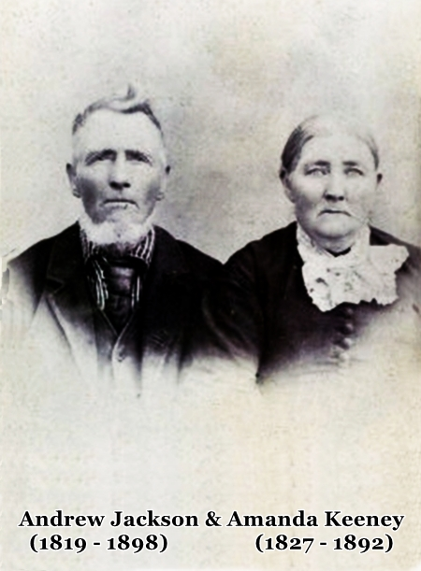
m. Mary Jane Keeney (cousin), daughter of Silas Keeney, on 14 Jan 1875.
VII. ANDREW JACKSON KEENEY, born 7 October 1819 in Fayette County, IN; moved with his family to Ray County, MO in 1820; bought a farm in 1841, in Holt County, MO; m. (1) Elizabeth Mulholland 18 November 1841, in Henry County, MO; Elizabeth was drowned in Missouri River in 1843; enlisted in 1847 as a private in the Missouri Mounted Volunteers and serve 6 months patrolling the northern border from the Oregon coast to Wyoming; m. (2) Hannah Daniels Cooper (widow) 3 June 1849 and left for California via Nicaragua; visited family members in Oregon long enough to show up in 1850, OR census, but returned to Holt County, MO to farm for several years, where his next 4 children were born; early in 1857 Jack sold his farm and headed for California, sold his outfit there and headed for the Williamette Valley of Oregon where his mother and brothers had settled; bought the Milton Riggs Donation Land Claim of 640 acres, near Goshen, where she and Hannah settled in a little log cabin; and, died of heart disease in 1860 and was buried on Cloverdale Road in the Keeney Cemetery; Jack M. (3) Amanda Jane Morse Matthews, 42-year-old widow, and became the father of 4 more children; he added 250 acres to his holdings, built a rancher home of Pioneer type (still standing), and engaged in farming and sheep raising; Jack was a generous man and his home was known as a “Wayside Inn”.
M. (1) Elizabeth Mulholland (1825-1843). In MO
1. FRANCES KEENEY, b. 1842, drowned with her mother in 1843 in the Missouri River, Holt County.
M. (2) Hannah Daniels Cooper (b. 3. June 1830, in AL, d. 15. March 1860 in Lane County, OR)
2. ANNA ISABELLA COOPER (step-daughter), b. 18 November 1847 in MO, d. November 1919 Morrow County, OR, m. James W. Matlock on 22 February 1863 in Lane County; 11 children
3. ELIAS P. KEENEY, b. 27 June 1852, d. 31 July 1857 on the trail to California.
4. JAMES MADISON KEENEY, b. 15 December 1853 in Holt County, MO, d. 8 February 1913 in Lane County, OR
m. Mary Susanna Handsaker (b. 30 October 1861, b. 17 September 1936, daughter of Samuel & Sara Cannon Handsaker; Pl;easent Hill Cemetery; m. 2 February 1879
A. CLARA BELLE KEENEY, b. 29 October 1879 at Dexter, Lane County, d. 3. November 1958; m. Nelson, Oscar Williams (1879-1931); children: James Nelson (1913-1915), Mary Ione 29 July 1914, Oscar Keeney Williams 1916 m. Helen Carlson, Sara Frances 11. July 1917, m. George Leep, Helen Dee (1918-1979 ( Los Angeles)
B. HARRY GARFIELD KEENEY, b. 20. October 1881 at Goshen, d. 7. October 1936. Salem, Marion County
m. Delia G. Tibbets (1884-1964); no children
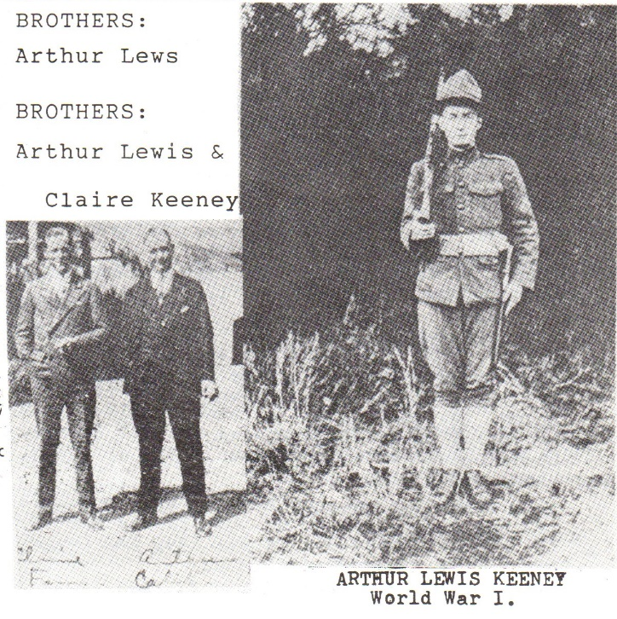
C. ARTHUR LEWIS KEENEY, b. 7. February 1896, died 4 May 1967 in Amarillo, Texas: m. Josephine Moore (1898-1968), Sgt. AEF World War I; children: Nellie Mary Keeney 28. February 1921 at Salem m. McCrory M. Burleson and Jane Willetta Keeney. 12. December 1924 (never married): Arthur ran Keeney Funeral Home, Corvallis
D. CLAIRE HANDSAKER KEENEY, b. 13. September 1899 at Jasper, Lane County, d. 3 September 1992 in Orange, CA, buried Whittaker, CA; m. Katherine Bush Kelly (1900-1974): no children; lived with his mother (Mary Edwards) in 1920 census
5. GEORGE R. KEENEY, b. 22. January 1856 in MO, d. 18. June 1859 in Oregon.
6. WILLIAM DANIELS KEENEY, b. 27. February 1857 in MO, d. 11. April 1930 at Dexter, Lane County; m. (2) Rebecca C. William 19 March 1893.
7. JOHN BLANDEN KEENEY, b. 20. October 1859 in Lane County, d. 1 September 1942 Condon, Gilliam County, Oregon; m. Ellen L. Hurt 1881 and moved to Gilliam County, returning to the Andrew Jackson farm, near Goshen in the 1890’s; appointed US Deputy Marshall and returned to Gilliam County, in 1903, with assignment to disperse vigilantes; large family home and heirlooms were destroyed in a disastrous fire in 1931.
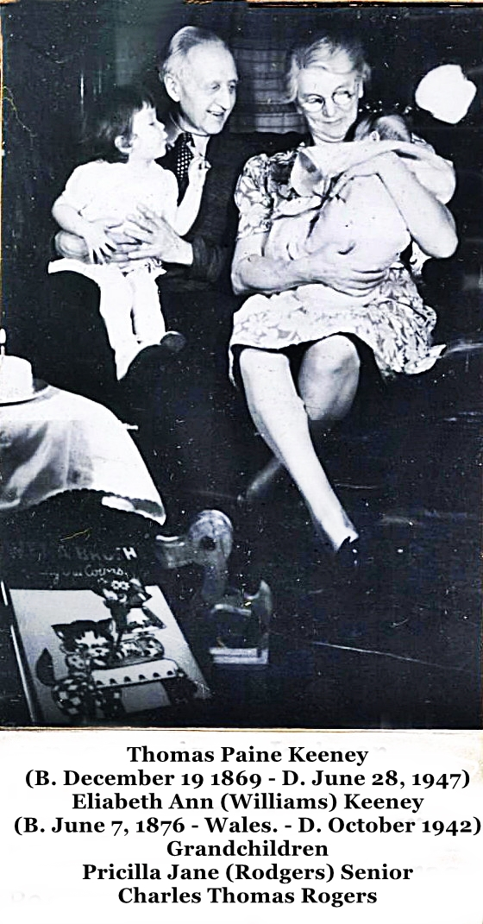
M. Ellen Leora Hurt (b. 19 June 1865, d. 27 April 1929, daughter of Isaiah & Sarah Miller Hurt; buried with her husband at Condon Cemetery.
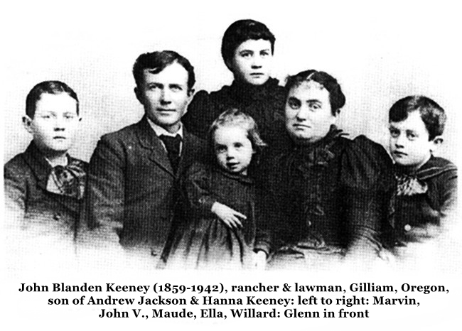

A. MAUDE H. KEENEY, b. 1 December 1882, d. July 1958 at Seattle, King County, WA; m. Charles Sawbucker; no children
low B. RHODA CLYDE KEENEY, b. 10. January 1884 in Lane County, d. 25. September 1884; Keeney Cemetery.
C. IRA MARVIN KEENEY, b. 7. July 1885, d. 1 February 1945 at Portland, Multnomah County
D. WILLARD WARREN KEENEY, b. 10. February 1888, died. 27. August 1958 at Portland, Condon Cemetery; m. (1), Lara Crawford. 23. August 1920 at Walla Walla, WA, (2) Alice Loa Crall (b. 1905 in Iowa), daughter of Ralph & Ida Sommer Crall; learned to fish and swim in Williamette River, worked as farmhand and mule driver, then for Union Pacific Railroad; fought in Belgium, France and Germany in World War I, including the battle of the Meuse-Argonne with the 91st division.
M. Lara Crawford in 1917, but refused to join Catholic Church, and they were divorced
m. Alice Loa Crall 23. August 1920 at Walla Walla.
CHILDREN: JACK LEROY KEENEY 17 March 1920 1m. (1) Pauline Chappel (2) Emily Shamp (3) Theola; RALPH RAY KEENEY 12 January 1923 m. (1) Rosie Huxell 29 November 1944 (2) Roberta Adelia Doty 29 December 1949, daughter of Harold Willis & Dolores Catherine Bull Doty; author of WAGONS RUTS WEST, history of John Keeney, Junior family; HAROLD BLANDING KEENEY 3. May 1925, d. 10 May 1925, Condon Cemetery; LOA MAY KEENEY, b. 28. September 1926, m. Sam Irving Snyder 19 May 1943; IDA DEE KEENEY, b. 16. September 1929 at Portland, m. Edward Orville Kelty 11 July 1949; BILLY FAE KEENEY, b. 17 February 1932, m. Walter Russell Lacy 8. August 1951, 6 children; WILLIAM WARREN KEENEY, b. 12. November 1933, m. Gloria Gail Roman in Seattle 1 September 1957, 6 children; BESSIE JO KEENEY, b. 25. December 1935 at Condon, m. Ronald R. Lamoreaux 28 March 1953 in Klickitat, Co., WA, 6 children
8. REBECCA ANN MATTHEWS (stepdaughter)
9. MARTHA ELLEN KEENEY, b. 1 December 1862 at Goshen, d. 6. December 1911 at Tacoma, WA, m. Nelson Erastus HANDSAKER 19 September 1886 in Lane County (1860-1920)
A. WILLARD NELSON HANDSAKER, b. 19. July 1887, d. 23. February 1918, at Spokane, WA, engineer with Northern Pacific Railway, m. Bertha Wilhelmina Skartvedt (1893 and SD-1975 in MN)
B. ERWIN KEENEY HANDSAKER, b. 22. December 1888 at Tacoma, d. 30 January 1930 at Vancouver, train accident
C. ANN HENRIETTA HANDSAKER, b. 18. April 1893, d. 17 September 1961 at Tacoma, m. Ralph Heaton (b. In VA, d. 23. September 1957 in Tacoma), no children
D. DOROTHY ELLEN HANDSAKER, b. 3. August 1898, died. 23. February 1977, m. Paul Scott (1910-1983) in New York City in 1945; both died in Massachusetts; textbook illustrator for Roe, Peterson & Co. And graduate of Chicago Art Institute
10. BENJAMIN FRANKLIN KEENEY, b. 14. October 1865, died 14. August 1935, of Goshen, Lane County; poultry farmer, attended Monmouth College, Constable, JP, Deputy Sheriff, state legislator in 1923; 640 acre farm.
M. (1) Martha Alice Cummings 23. October 1886.
A. Hugh CUMMINGS KEENEY, b. 2. June 1892, d. 20. December 1973 at the Dalles, OR; m. (1) Jessie Askew, (2) Myrtle Darrien on 9. September 1921.
M. (2) Charity Alice Taleaferro (b. NC) 9. April 1877.
B. HOBART SELLWOOD KEENEY, b. 16. August 1898 in Lane County, d. 4. February 1972, in St. Helens, Columbia County, OR; buried at the Dalles, Wasco County
m. (1) Marie Elizabeth Zimmerman 2. August 1918.
A. HOBART V. KEENEY, b. 3, December 1990
B. KENNETH L. KEENEY, b. 12 August 1923.
C. DOROTHEA MARIE KEENEY, b. 4. February 1930
m. Verna Blanche (b. 29. May 1969)
C. FREDERICK CLINTON KEENEY, b. 11. June 1903, d. 9. February 1970 at Oakland, CA; m. Ruth Omart on 2 November 1927; no children
11. ANDREW ALVA KEENEY, b. 14. December 1866, d. 4. February 1954; Pleasant Hill Cemetery
m. (1) Nannie B. Wallis 18 October 1899; infant child died at birth, (2) Alice Robinson (d. December 1956); daughter: Frances m. Elmer Maier
12. THOMAS PAINE KEENEY, b. 19 December 1869 at Goshen, d. 28. June 1947 at Portland; went to barbering school, then business school went to China following the Boxer Rebellion and operated furniture factory in Hong Kong; returned home in ill health in 1906; travel and sales ventures then and family had a rough time during the Great Depression and having son Bob in the military during World War II.
M. Elizabeth Ann Williams 19 December 1898 at Tacoma, WA (b. 7. June 1876, d. 21. October 1942; buried with her husband as Lincoln Memorial in Portland, OR;
m. (2) Catherine Bouy in fall of 1943
A. GWLADYS MURIEL KEENEY, b. 21. April 1899 at Seattle, d. 14. February 1924, at Portland; m. 21. June 1923 to Frank Whitney; no children
B. ROBERT JACKSON KEENEY, b. 15. October 1904 in Hong Kong (Kowloon), m. Rosemary Gardner on 10 June 1937 on the Oregon coast.
C. ELIZABETH JANE KEENEY, b. 19. September 1910, m. Howard Foskett Rogers at Phoenix, AZ on 11. November 1938; children: Priscilla Jane Rogers, b. 24. January 1940, m. Samuel Palmer Senior III; Charles Thomas Rogers, b. 12. December 1941 m. Sara Miriam Simkowitz (b. in FL); Robert Douglas Rogers, b. 23. June 1943, m. Kristina Karamanos on 21 December 1970
VIII. REBECCA KEENEY, b. 4. July 1821 in Fayette County, IN, d. 23. September 1895 at Amity, Yamhill Co., OR.
m. (1) William Landingham 24. November 1838 in Ray County, MO; (2) Daniel Bennett Putnam (widower with 6 previous children, on 27. November 1851; raised a total of 18 children (5 Landingham, 7 more Putnum); went from MO to Oregon in 1851 caravan after Mr. Landingham’s death in 1849; she and Daniel Putnam are buried at Amity, Oregon Cemetery
1. GEORGE MADISON LANDINGHAM, b. 23. June 1849 in MO, d. 13. April 1899 at Cloverdale, Tillanook County, OR.
m. Mary Alice Buoy 4. October 1876 at Creswell; daughter: Lula Alma Landingham, b. 21. January 1899, d. 8. September 1988 in Milwaukee, OR m. Henry Newton Burke (1895-1973) 3. July 1917 (grandparents of Diane Klare House, PO Box 45464, Tacoma, WA 98445)
IX. ELI KEENEY (twin), b. 18. December 1828 in Ray County, MO, d. 10. November 1878; buried at Pleasant Hill Cemetery, Lane County
m. Elizabeth G. Pierce (b. 1 December 1832, d. 31 Jan 1904) on 27. February 1848 Holt County, MO
1. MARY ELLEN KEENEY, b. 1848 in MO; m. Alvah D. Larkin 15. June 1865 in OR; son: Eli Alvin Larkin, b. 1866.
2. FRANCES KEENEY, b. 11. October 1850; died on the Oregon Trail 20 August 1851; buried in Wasco County near Oregon Trail Memorial
3. SILAS KEENEY, b. 5. April 1854; head of family in 1880 census; d. 3. December 1922;
m. Nebraska Trimble 24. December 1880; lived in Wheeler County, in 1900 Oregon census
4. JONATHAN (blind John) KEENEY, b. January 1856 in Lane County; violinist, lost his sight when kicked by a horse, popular musician for dances; died in 1916, and buried in Pleasant Hill Cemetery.
5. ELIZABETH RUTH KEENEY, b. 1858 in Lane County; aged 12 in 1870 census
6. LEATHA F. KEENEY, b. 1861, m. Cassius W. Rychard lived with brother Silas in 1920 Lane County census
7. ROSE KEENEY, b. 16. November 1872, d. 13. December 1876.
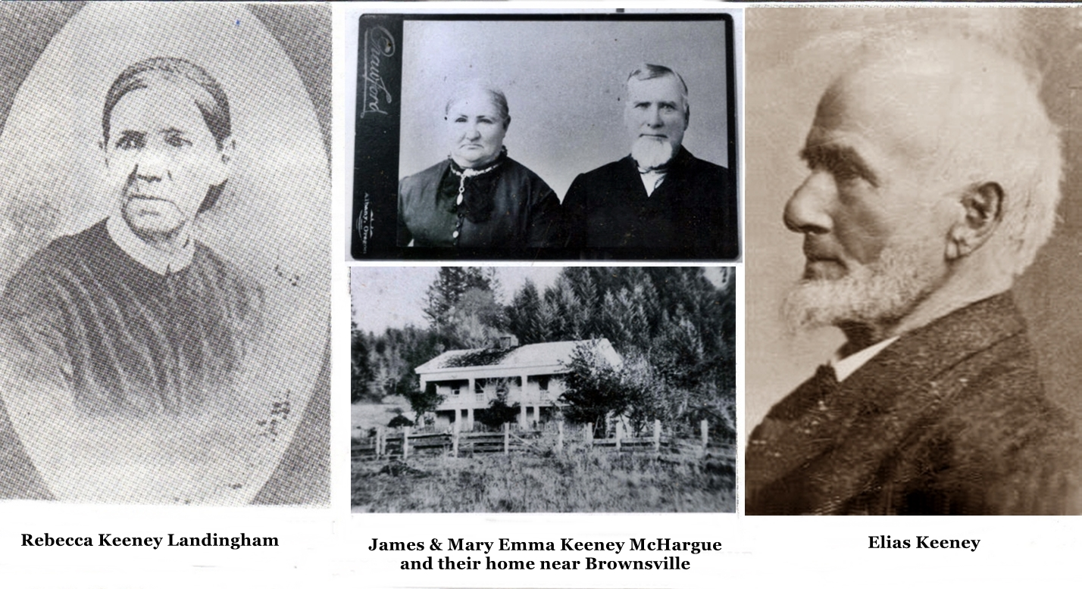Eli & Elias Keeney opened the Last Chance Saloon in Junction City, Lane County, in 1871.
X. ELIAS KEENEY (twin), b. 18. December 1828, d. 20. December 1910; youngest and largest son of John Keeney, Junior; member Co. C, 4th Regiment, OR Mounted Volunteers in 1856; had gone to Oregon in 1846, but returned to marry and accompany his mother and family members. In 1851 caravan; meanwhile he joined his brother Jonathan in the California gold rush; Methodist Episcopal layman, Road supervisor, educator in Eugene 1891-1900; returned to Brownsville. 1901.
M. Margaret Jane Hyatt 26. November 1850 in Holt County, MO; she died on way to Oregon
m. Lucinda G. Van Winkle (b. 1840 in TN) 28. June 1860 in Linn County; she d. 15. February 1884
m. Matilda Lee Noffsinger 13. December 1887 in Lane County, at home of Sam Holloway
traditions concerning Elias Keeney: hard fighting, hard drinking roisterer” (written by his granddaughter)
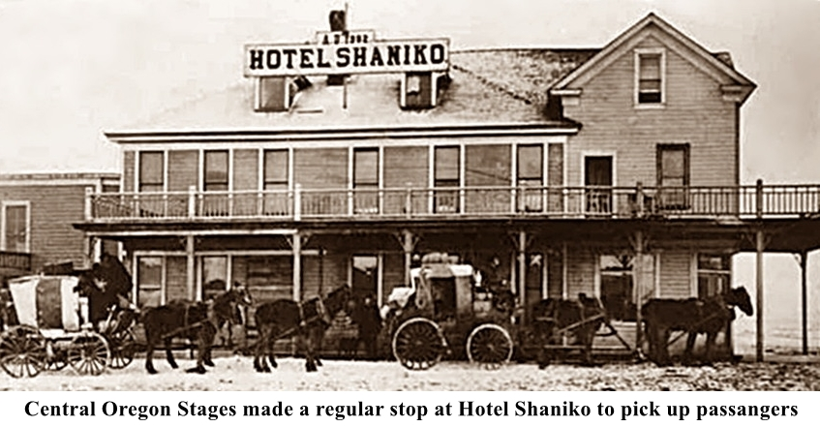
1. ELI J. KEENEY, b. 8. November 1852-settled in Phoenix, AZ, died of tuberculosis in 1905.
2. REBECCA KEENEY WARMOTH, b. 1855; died young
3. MARY EMMA KEENEY, b. 1858, 22 in 1880 census had rheumatic fever as a child, but cared for the younger children; m. James McHargue and lived for years in Shaniko, Oregon, where they operated the Old Shaniko Hotel; children: Lillie May McHargue 1875, William C. McHargue, Otto McHargue 1879, Kitty McHargue (Hume), Ida McHargue (Hanson)
4. JOHN H. KEENEY, b. 1 July 1859, died in 1940 in Albany, OR; lived mainly in Nevada and California and was engaged in highway construction, as well as being a farmer and stockman never married.
Children of Elias & Lucinda:
5. GEORGE W. KEENEY, b. 8. August 1861, in Linn County; living in Lane County, in 1910; wife: Vinnie (b. 1873); children: Otis W. Keeney, b. 1891, Vernard R. Keeney, b. 1893.
6. RHODA KEENEY, b. 1863, m. (1) James Vaughn of Halsey, (2) James Bond in 1888 at the family home in Brownsville. He was born in Iowa, the son of a Baptist minister; Mrs. JW Moore, of Harrisburg, OR was a Bond daughter.
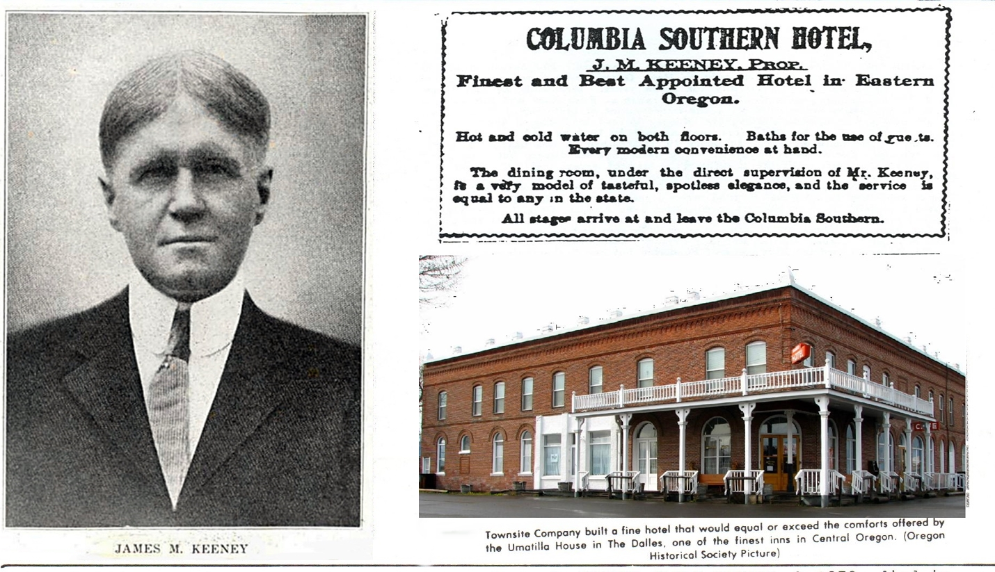7. JAMES M. KEENEY, b. 15. October 1865, d. 31 January 1952; operated the Columbia Southern Hotel in Shaniko, OR. 1901-1911; never married— his sweetheart died in the Heppner Flood of 1903; “a salty old guy if my memories of him are any indication”-H. Rees, author
8. EDWARD ELIAS KEENEY, b. 1870; died in 1880s of tuberculosis in Linn County.
9. HOMER J. KEENEY, b. 1873, died in Mill Valley, CA in November 1938; physician, practice medicine in Portland; wife: Lucille P. (B. 1890 in CA); children: Homer J., Junior 1905 and Jean 1912, both born in OR
10. PHILIP CLARK KEENEY, b. 1868, died before 1880 of tuberculosis.
11. LEROY J. KEENEY, b. June 1876 in Linn County; lived in Moscow, ID in 1938, m. Alice Stevenson 18 October 1898 in Linn County.
12. ILENA J. KEENEY WRIGHT-educator in Shaniko, OR in early 1900’s; also lived in Portland and San Francisco.
XI. SARAH ELIZABETH KEENEY, b. 1830 in Ray County, MO; m. William E. West 28 March 1849 in Ray County (Mormon record)

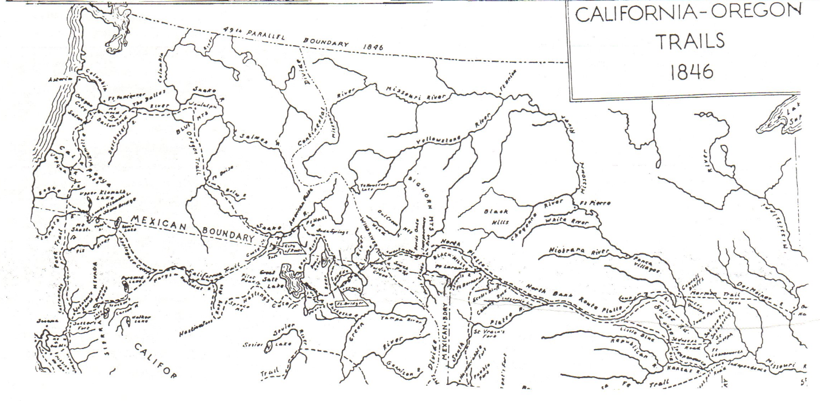JOHN NELSON KEENEY DESCENDENTS
Pennsylvania to Iowa
Descendants of ALEXANDER KEENEY to the 6th generation were listed in the February 1993 UPDATE. Frederick C. Keeney (Hixson, TN) and other descendants, beginning with JOHN NELSON KEENEY:

1 – John Nelson KEENEY – 137 (1820)
Sp-Permelia TUPPER – 138 (1823).
– Mortimer Theodore KEENEY – 139 (1844)
sp-Julia REYNOLDS-142 (1848)
3 – Edgar Nelson KEENEY-143 (1868)
sp-Anna B.-601 (1869)
3 – Hattie M. KEENEY-144 (1875)
sp-Grant BROWN-279
4 – Harold BROWN-339
2 – Frederick Morris KEENEY-24 (1847)
Sp-Josephine OSINCUP-25 (1850)
3 – Watson Frederick KEENEY, Dr. (1874)
sp-Lola Gail CRITCHFIELD-8 (1889)
4 – Frederick CRITCHFIELD KEENEY, Dr.
sp-Betty Jean NELSON-2 (1924)
5 – Wendy Lisabeth KEENEY, Dr. (1950)
sp-Alan JEFFREY Dr.-15
sp- Mahlon Charles KENNICUTT II, Dr. (1922)
5 – Nancy Gale KEENEY-4 (1951).
5 – Frederick Watson KEENEY-5 (1954)
sp-Elizabeth Mane MCADAM-17 (1954)
6 – Frederick McAdam KEENEY (1978)
sp-Debra Lee GATHANY 19 (1956)
6 – Erin Elyse KEENEY-20 (1991)
5 – Janis Anne KEENEY-6 (1956)
Sp-James Michael WALKER-21 (1954)
Sp-Zoran LORINC-22 (1962).
4 – Watson Solomon KEENEY-9 (1925)
sp-Jeanne OTTO-23 (1927).
3 – Gilbert Nelson KEENEY-44 (1877).
sp-Martha (Mattie) MORRIS-40 (1875)
4 – Frederick Morris KEENEY-39 (1906)
sp-Clare Marie DAVIS-280 (1906)
5 – David Morris KEENEY-281 (1929)
sp-Florence Grace BLOOMQUIST-285
5 – Charles Melvin KEENEY-282 (1930)
sp-Phyllis SHEARER-286.
6 – Susan KEENEY-394 (1951)
6 – Karen KEENEY-396 (1953)
6 – Stephen KEENEY-395 (1958)
6 – Kimberly KEENEY-397 (1960)
sp-Darlene BERG-398
6 – Kelly KEENEY-399 (1963)
6 –Shan KEENEY-400 (1965)
sp-Audrey-402
5 – Clare Gilbert KEENEY-283 (1932)
sp-Hazel Mane GAYLORD-287 (1926)
6 – Larry Douglas KEENEY-288 (1959)
sp-Carrie WILSON-382
7 – Christopher KEENEY-383 (1982)
7 – Joey KEENEY-384 (1983)
7 – Nicholaus KEENEY – 385 (1984)
7 – Angela KEENEY – 386 (1986)
6 – David Gilbert KEENEY-289 (1961)
6 – Morris Wayne KEENEY-290 (1963)
sp-Corlea WETHERALD-387
7 – Justin Wayne KEENEY-389 (1985)
7 – Jacob ALLEN KEENEY-390 (1987)
7 – Mason Andrew KEENEY-388 (1989)
sp-Florence CRIST-284
4 – LAWRENCE Gilbert KEENEY (1910)
sp-Adelaide (Penny) SYBENGA (1914)
5 – Martha Adelaide KEENEY-292 (1939)
sp-Robert D. HEDDENS – 295
5 – Cynthia Ann KEENEY-293 (1945)
5 – Mary Marshall KEENEY-294 (1947)
4 – Paul Nelson KEENEY-54 (1912)
sp-Evelyn BECK-296 (1913)
5 – Dennis Ramond KEENEY, Dr. (1937)
sp-Betty GOODHUE-300 (1937)
6 – Marcia Ann KEENEY-301 (1962)
5 – Patricia Louise KEENEY-298 (1944)
sp-Howard Charles GOODHUE-302
6 – Sherry GOODHUE-340 (1966)
6 – Charles GOODHUE-341 (1967)
6 – Lon GOODHUE-342 (1971)
6 – Julie GOODHUE-343 (1972)
6 – Jennie GOODHUE-344 (1973)
5 – Janis Ellen KEENEY-299 (1946)
sp-Steve JACKSON-345.
6 – Steve Jr. JACKSON-346 (1968)
6 – Mark JACKSON-347 (1969)
3 – Edith Lizzette KEENEY – 43 (1882)
sp-Cassius Everett READ-55 (1871)
4 – Charles Everett READ-56 (1911)
sp-Elva Pearl BURTIS – 303
5 – James Charles READ-304 (1940)
sp-Frances-348
5 – Kathrine Neva READ – 305 (1942)
sp-Kreiling-349
4 – Josephine Emily READ-57 (1912)
sp-Donald ? WILLIAMS-306.
5 –Verle Alvin WILLIAMS-307 (1933)
sp-Mary Sue EARLY-314
6 – Stephen Lee WILLIAMS-315 (1960)
6 – Randall Joe WILLIAMS-316 (1961)
5 – Francis Eugene WILLIAMS-308 (1934)
sp-Hilda HARTER-317
5 – Merrill Everett WILLIAMS-309 (1937)
5 – Charles Ernest WILLIAMS-310 (1938)
sp-Jean PETERSON-318
5 – Mildred Elaine WILLIAMS-311 (1939)
5 – Stanley DEAN WILLIAMS-312 (1940)
5 – ALLEN James WILLIAMS-313 (1945)
4 – Katherine E. Virginia READ-58 (1914)
sp-Lloyd MCCREERY-319.
5 – Lew Read MCCREERY – 320 (1949)
5 – Paul Allen MCCREERY-321 (1951)
4 – Edith Elizabeth READ-59 (1916)
sp-John DEW-322
5 – Mary E. DEW-323 (1947)
4 – Laura Ruth READ-60 (1918)
sp-Fred STAUFFER-324
5 – Gary Fred STAUFFER-325 (1948)
5 – Ruth Ann STAUFFER-326 (1949)
sp-EDMONDS-381
sp-Harold J. MATKZE-327
3 – Theodore Wayland KEENEY-42 (1883)
sp-Bertha Blanche TITTSWORTH-61 (1885)
4 – Theodore Jean Watson KEENEY (1914)
SP-Pauline Edris NELSON-328 (1914)
5 – Jean Ann KEENEY-329 (1935)
Sp- William Adam BASINGER (1928)
6 – Lon Lee BASINGER (1957)
sp-Gary John REED (1957)
7 – Amanda Lynn REED
7 – Leah Ann READ (1982)
7 – Tyler John REED (1988)
6 – Brian Lee BASINGER (1958)
sp-Joyce Ann SUTHERLAND (1961)
7 – Michelle Ann BASINGER (1981)
6 – Denise Lynn BASINGER (1959)
sp-Mark Frank STEVENSON (1955)
7 – Jame Lynn STEVENSON (1981)
7 – Lisa Marie STEVENSON (1985)
6 – Chris Alan BASINGER (1963)
sp – Janelle SOESBE-720
6 – Shaun Eric BASINGER (1966)
6 – Michael Rene BASINGER (1972)
sp – Mary MINAHAN-330
5 – Theodore Miles KEENEY (1943)
5 – Gary KEENEY-332 (1947)
4 – BRUCE Nolan KEENEY-63 (1923)
sp-Audrey SALYER-333 (1929)
5 – BRUCE Nolan KEENEY II (1951)
sp – Gwendolyn M. KENDALL-914
5 – Karen Ann KEENEY-335 (1954)
sp-Chester SIMON-915.
6 – David Samuel SIMON-916
6 – Philip SIMON-917.
6 – Luke SIMON-918
sp-Barbara COOK-336.
5 – William Lee KEENEY-337 (1961)
6 – Julie Kate KEENEY-919
sp-Dixie FREE-614
5 – Charlotte KEENEY-920
3 – Leon Dunmore KEENEY-41 (1885)
sp-Mary WHITE-64 (1889)
4 – Robert Leon KEENEY-65 (1917)
sp-Ardis Helen TOSTENSON-275 (1917)
5 – Robert Leon KEENEY-276 (1945)
sp-Kathy HALL-372
6 – Stephanie KEENEY (1979)
5 – Marcia Lynn KEENEY – (1949)
sp-William ROSENBERRY
6 – Peter ROSENBERRY -374 (1981)
6 – David ROSENBERRY-375 (1984)
6 – Mary ROSENBERRY-376 (1987)
5 – Susan Ardis KEENEY-278 (1954)
sp-ZAIN MOHAMMED-377
6 – Johan ZAIN-378 (1982)
6 – Sarah ZAIN-379 (1984)
6 – Sabrina ZAIN-380 (1989)
4 – Mary Josephine KEENEY-66 (1920)
SP-Robert Douglas SIMPSON-338 (1925)
2 – Elmer L. KEENEY-140 (1850)
sp-Angie E. KEENEY-600.
3 – Mamie R. KEENEY-602 (1881)
3 – Roy E. KEENEY-603 (1888)
sp-Cynthia A.-604 (1880)
2 – Eugene Wade KEENEY-141 (1856)
sp-Viola-605 (1862).
3 – Myrtle B. KEENEY-606 (1883)
3 – Lulu B. KEENEY-607 (1885)
3 – Lewis W. KEENEY-608 (1886)
3 – Effie M. KEENEY-609 (1888)
3 – Daisy B. KEENEY-610 (1890)
3 – Ida F. KEENEY-611 (1891)
3 – Bertie C. KEENEY-612 (1894)
3 – Opal E. KEENEY-613 (1897)

73 KEENEY FIRST COUSINS
JOHN S. KEENEY, born 9. May 1849 in Fairview, Cabin Creek, Kanawha County, WV (then VA), son of Stires J Keeney & Mildred Gatewood Keeney, grandson of Moses Keeney & Frances Harris Keeney; married 16 November 1871 at Winfield, WV to
HANNAH CATHERINE FRAZEE, born 6 August 1853, daughter of Isaac & Catherine Davis Frazee of Carter County, KY, raised by her uncle and aunt Flem Davis & Lucinda Keeney Davis (a daughter of Michael Keeney); died in 1944; grandsons in military uniforms served as pallbearers
I. DAISY MAY KEENEY, b. 1872, d. 1874
II. URIAH ZARA KEENEY, b. 4. May 1874, died in May 1928

Born died address
I. DAISY MAY KEENEY 1872 1874
II. URIAH ZARA KEENEY 4 May 1874 May 1928
m. Martha (Patty) McDowell 1878 1960
On 4 Sep 1895
1. WILLIAM EARLE KEENEY 11 Sep 1896 5 May 1980 burial-Ashland, KY
2. SELMA FRANCES KEENEY 12 July 1899 Dec 1990 bur.-Lexington, KY
(White/Kiger)
3. PATTIE CATHERINE KEENEY 19 Jan 1902 Dowagiac Nursing Home.
(Lee/Langdon) 610 Uneta, Dowagiac, MI
III. MCDONALD KEENEY 28 July 1877 16 May 1938 Witcher Cemetery
m. Mamie Chloe Stanley 1882 1957 Witcher Cemetery
4. MAXINE STANLEY KEENEY 30 November 1912 14 June 1992 bur.-Lewisburg, WV
(Harless)
5. HANNAH MARGARET KEENEY 16 January 1914 2000 Orchard Ave.
Belle, WV, 25015.
6. DOROTHY LEE KEENEY 10 February 1915 7 Kieffer Dr.
(Gwin) St. Albans, WV, 25177
7. MILDRED AGNES KEENEY 8 August 1916 2000 Orchard Ave.
Belle, WV, 25015.
8. ALBERT MCDONALD KEENEY 3 June 1918 408 Main St., Belle, WV.
(Bus).
9. HELEN PAULINE KEENEY 9 November 1920 820 Adrian Road.
(Bennie Metheny) Charleston, WV 25314
10. GEORGE MCCLURE KEENEY 18 August 1922 Rte. 4, Box 149
Hurricane, WV 25526.
IX. NICK BURKS KEENEY 18 June 1878 20 Sep 1951 Witcher Cemetery.
m. Mary Elizabeth Buckholt 1879 1907 Craig Cemetery, Alloy
married 21 Jan 1903
m. Susie Flowers 1890 1971 Witcher Cemetery.
Married 28 May 1912
Children of Nick & Lizzie:
11. SYBIL KEENEY 20 Mar 1904 20, Mar 1904
12. HELEN GOULD KEENEY 6 Feb 1907 509 Washington Ave.
(Cline) Nitro, WV, 25143
Children of Nick & Susie:
13. NICK B. KEENEY, JR. 1914 18 Oct 1918
14. TRABER GATEWOOD KEENEY 7 Jan 1916 3 Feb 1952
(T. G.)
15. LOUISE KEENEY July 1917 18 Oct 1918
16. IDA MAE KEENEY 10 Jan 1919 14 Nov 1937 Witcher Cemetery
17. U. Z. (Pete) KEENEY 14 Feb 20 26 June 1989 bur. Quantico, VA
18. RACHEL KEENEY 29 Jan 1922 7 Feb 1993 bur. Medina, OH
(Brubaker)
19. GERTRUDE LEE KEENEY 17 Dec 1924 12200 Valley View St.
(Trudy Richie) Garden Grove, CA 92645
20. JOHN S. KEENEY III 14 Mar 1926 28 Oct 1989 Witcher Cemetery
21. CHARLES B. KEENEY 21. June 1928 24 Mar 1971 Witcher Cemetery
22. MARY SUSAN KEENEY 1 July 1930 408 8th St.
(Crawford) Belle, WV, 25015
V. FLEM DAVIS KEENEY 3 Aug 1879 23 Nov 1975 Witcher Cemetery
m. Ida Meadows 11 Nov 1903 1884 1931 Witcher Cemetery
23. MACEL LEONA KEENEY 1 July 1904 1 July 1928
(Kelley)
24. FLEM DAVIS KEENEY, JR. 4 Sept 1905 12 Nov 1935
(Brother)
25. CHARLES MCDONALD KEENEY 11 Nov 1907 7 Quail Cir., N. Beaufort, SC
26. LILLIAN MAE KEENEY 27 Dec 1909 22 Oct 1988 Witcher Cemetery
(Douglass)
27. MARY ETTA KEENEY 29 Oct 1912 344 E. Edgewater Way
(Thom) Newark, DE 19702
29. ERNESTINE KEENEY 1914 1914
29. EMMA FRANCIS KEENEY 20 Apr 1916 5979 Hickory Meadow # 8
(Frankie Harmon) Memphis, TN 38115.
30. LEROY MALCOLM KEENEY 21. April 1921 1017 B St.
St. Albans, WV, 25177
VI. ROSCOE CONKLING KEENEY 7 Jan 1882 1 Feb 1969 Witcher Cemetery
m. Maggie Alice Paxton 1885 1945 Witcher Cemetery
4 Nov 1904
31. JULIA ANNA KEENEY 13 Mar 1907 118 West Virginia Ave.
(Arthur) Dunbar, WV, 25064
32. FRANCES MYRTLE KEENEY 19 July 1909 426 Plum St.
(Kilburn) Wyandotte, MI 48192
33. NICK B. KEENEY II 19 June 1911 2101 East Dupont Ave.
Belle, WV, 25015.
34 ALMA MAE KEENEY 5 Mar 1917 3527 Cotner Ave.
(Rose) Charleston, WV 25306.
35. MARGARET ALICE KEENEY 24 April 1920 2420 Sherwood
(Cline/Kapanowski) Trenton, MI 48183
36. ROSCOE C. KEENEY, JR. 13 Sep 1922 PO Box 5519
Charleston, WV 25361.
37. CALVIN COOLIDGE KEENEY 8 Jan 1925 16 Sep 1992 Woodall Cemetery
Elkview, WV
38. WILLIAM HAROLD KEENEY 19. Oct 1927 427 Elm St.
S. Charleston, 25303
VII. DANIEL WEBSTER KEENEY 23 Aug 1864 11 Apr 1973 bur. near Anderson, IN
m. Myrtle George 6-3-1908 1891 1980
39. WALTER RUSSELL KEENEY 24. Oct 1909 21 April 1987 died in Arizona
40. JOHN ELBERT KEENEY 11 Sep 1911 2 July 1987 Buried in Indiana
41. THOMAS EBON KEENEY 11 Sep 1914 14 June 1938 died of leukemia
42. WILLIAM DAVID KEENEY 29 Dec 1960 Marion, IN 46952
43. HERMAN AGSTEN KEENEY 28 May 1921 HCR 78, Box 482
Neselle, WA 98638
VIII. JOHN S. KEENEY, JR. 8 June 1886 20 Nov 1951 Witcher Cemetery
m. Rosa Cline 12-20-1916 1895 101 18th St.
East Belle, WV, 25015
44. JOHN EDWARD KEENEY 24 Jan 1918 PO Box 123,
Walton, WV 25286.
45. PHILIP PRESTON KEENEY 7 July 1920 22 March 1993 Kanawha Valley Memorial
Gardens, Glasgow, WV.
46. ROSALIE KEENEY 28 Jan 1922 101 18th St.
(Burris) East Belle, WV, 25015.
47. ADA LENORA KEENEY 8 Feb 1924 2011 Australia Way
(Walker/Meadows/Beals) Clearwater, FL 33913
48. FLOYD WILLIAM KEENEY 7 Nov 1925 402 Roberts Cir.
Green Cove Springs, FL 32043
IX. WALTER HENSON KEENEY 20 July 1888 20 April 1957 Witcher Cemetery.
m. Annie Hill on 9-18-1911 c. 1890 1918
m. Maude Carolyn Jarrett 1899 1979 Witcher Cemetery.
On 20 May 1919.
Children of Walter & Annie:
49. WALTER HENSON KEENEY, JR. 19 Dec 1912 26 April 1991 Montgomery Memorial Park.
50. JAMES HAROLD KEENEY 17 Sep 1914 29 Nov 1978 buried in Florida
51. CARMLEE KEENEY 1917 1918
52. GRACE ELLEN KEENEY 1 Dec 1917 447 South Crescent Dr.
(Price) Melbourne, FL 32901
Children of Walter & Maude:
53. DANIEL WEBSTER KEENEY II 30 Jan 1921 25 May 1992 buried at Mason, OH
54. WYNDOM PAUL KEENEY 20 Oct 1922 15 Nov 1992 Tyler Mt. Memorial Gardens
55. MARY LOUISE KEENEY 6 July 1926 10 March 1941 Witcher Cemetery
X. HANNAH CATHERINE KEENEY 3 Aug 1890 6 Sep 1962 Witcher Cemetery
(Katy Fout)
m. John Anderson Fout 21 Oct 1890 30 Sep 1989 Witcher Cemetery
on 10-26-1910
56. ANNA FRANCES FOUT 27 Sep 1911 1708 East Park Ave.
(Milam) Victoria, TX 77901
57. EDITH CATHERINE FOUT 18 June 1913 4 July 1970
(Meadows)
58. MARY ELIZABETH FOUT 7 March 1916 Ravenswood Village Health Cen.
(Lizzie Skeens) 200 S. Ritchie, Ravenswood
59. CLIFFORD LEE FOUT 6 Feb 1918 27 Jul 1918
60. MABEL LEE FOUT 6 Feb 1918 30 Mar 1918
61. JOHN ANDERSON FOUT, JR. 3 April 1920 3 April 1920
62. CLYDE EDWARD FOUT 12 Aug 1922 4 Sep 1983 Buried in Melbourne, FL
“John Jack”
63. HUBERT BOLLING FOUT 21 Sep 1927 13 March 1991 Montgomery Memorial Park
(Jim)
XI. FRANCES HOLT KEENEY 7 March 1892 9 March 1963 Witcher Cemetery
(Fannie Hill)
m. Charles Cameron Hill 1888 1963 Witcher Cemetery
on 11-1-1916
64. CHARLES CAMERON HILL, JR 14 Aug 1917 16 Mar 1977 Tyler Mt. Gardens
65. FRANCES HANNA HILL 24 Aug 1918 31 Mar 1994 Tyler Mt. Gardens
(Scruggs)
66. ANNA CATHERINE HILL 24 July 1919 PO Box 691, Belle, 25015
(Howard)
67. GRACE MADGIE HILL 2 Oct 1920 2 June 1921
68. HELEN LOUISE HILL 12 July 1922 1914 East Dupont Ave.
(Hudnall) Belle, WV 25015.
69. JOHN EBON HILL 21 Aug 1921 330 Sky Dr., Belle 25015
XII. EBON OAKES KEENEY 8 Jun 1894 21 July 1976 Witcher Cemetery
m. Grace Lenora Wood 1892 1975 Montgomery Memorial Park
on 12-23-1914
XIII. ROBERT H. KEENEY July 1896 12 June 1982 Witcher Cemetery
m. Sallie Bell Powell 1899 1988 Witcher Cemetery
on 6-18-1917
70. MARGARET HELEN KEENEY 21 Oct 1918 27 Jun 1963 Witcher Cemetery
71. DORIS, EVELYN KEENEY 7 Dec 1920 2010B E. Dupont Ave.
(Hall) Belle, WV, 25015.
72. ROBERT H. KEENEY, JR. 15 Aug 1926 5143 Hopewell Dr.
Cross Lanes, WV 25313.
73. THOMAS OAKES KEENEY 21 Jun 1934 1806 West Riverview Dr.
Belle, WV, 25015.

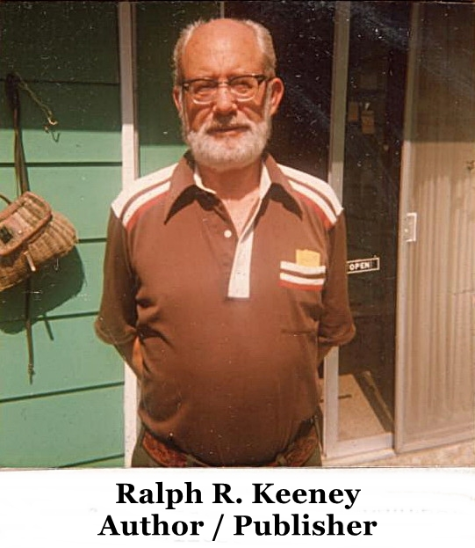
RALPH R. KEENEY, son of Willard W. Keeney (mule skinner pictured on p.1) and great-great-grandson of John Keeney, Jr., published “Wagon Ruts West,”, a genealogical collection of this family, including intimate accounts of their migration West, lives at 214 E. 13th Street, the Dalles, OR 97058.

Contributions to cover most of the cost of printing and mailing this special issue came from: Marcella Fuller, Nashville, TN $50; Patricia F. Kaufman, Bartlesville, OK $30; James & Susan DeRam (IL), Frederick C. Keeney (TN), Ileen Bass (VA), all $25; Robert Keeney (Accomac, VA), Lester E. Keeney (FL), Phyllis Tumulty (CT), John & Laura Platter (MD), Velma E. Adams (MO), Raymond E. Kinney (MI), Jean Johnson (IA), and Mildred Keeney (WV).

OBITUARIES

Ethel M. Quenon
LEXINGTON, KY – Ethel Marguerite Keeney Quenon, 86, of Lexington, died June 28, 1994, at Central Baptist Hospital, Lexington, after a short illness.
She was born in Kanawha County, WV, she attended New River State and taught in public schools in Kanawha Co. and Wise County, VA. She was a member of Centenary United Methodist Church, Lexington.
Surviving: son, Andrew R. Of Lexington; sister, Ida Mae Mehlman, Summit, NJ, 5 grandchildren; 3 great-grandchildren.
Service will be 11:30 AM Friday at W. R. Milward Mortuary, Lexington. Friends may call from 6 to 9 PM Thursday at the funeral home. Memorials may be made to the American Cancer Society, 160 Moore Dr., Suite 201, Lexington, KY or Arthritis Foundation, 145 Romany Rd., Lexington, KY.

George Keeney
ALDERSON – George E. “Toby” Keeney, 71, of Alderson, died Thursday, August 4, 1994, at Greenbrier Valley Hospital, Fairlea, after a short illness.
He was born in Alderson. He was a self-employed laborer.
Surviving: sisters, Wanda K. Hinkley of Alderson, Virginia C. Henderson of Millsboro, Delaware; nieces and nephews.
Service was to be 2 PM today. Loganacre Funeral Home, Fort Spring, with the Rev. Frank Jones officiating. Burial was at Muddy Creek Cemetery, Blakers Mill, near Alderson.

John Keeney
DEEP WATER – John Keeney, Senior, 79, of Deep Water, died August 8, 1994, in a Charleston hospital after a short illness.
He was a retired coalminer from Central Appalachian Coal Company.
Surviving: wife, Mabel Hendrix Keeney; son, John, Junior, of Deep Water; daughters, Norma Keeney, of Deep Water, Mary White of Beards Fork.
Private graveside service will be in Blue Ridge Memorial Gardens, Prosperity. Friends may call from 6 to 9 PM today at Blue Ridge Funeral Home, Beckley.

Thelma L. Cantley
Thelma L. Cantley, 81, of Dry Branch and Capital City Nursing Home died July 8, 1994 at Thomas Memorial Hospital, South Charleston.
She was a member of dry branch Freewill Baptist Church and a lifelong resident of Cabin Creek.
Surviving: son, James, of Nitro, Jerry and Jack, both of South Hill, VA, Robert of Chesapeake, Darrell of Marmet, Kenneth of Grayson, KY, Frank and Roger, both of Charleston, John of Giles; daughters, Dorleen Pomeroy of Crown Hill, Patricia Pack of Chesapeake; brothers, Hewitt Kenney of Decota, Adrian Keeney of Beckley, Jack Keeney, of Shelby, Ohio, Stacy Keeney of Chesapeake, Paul Dunbar of Miami, Michigan; sisters, Inez Brockell of Dawes, Julia Moore, of Beckley, Madeleine Hall of Piqua, Ohio, Ruth Sadler of South Charleston, Ann Ream of Willard, Ohio; 35 grandchildren; 19 great-grandchildren.

Charles E. Keeney
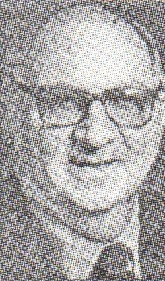
Charles E. Keeney, 79 of 2803 Rommel Dr., Charleston, died August 3, 1994, at his home following an extended illness.
He was a retired owner of the Eleanor NAPA Store and a member of the Wesley United Methodist Church and the Eleanor Lions Club.
Survivors: wife, Lena Irons Keeney; son, Charles I. Keeney of Charleston; sisters, Lucille Canterbury, of Melbourne, Florida, Elmo Scott of Dawes and Eileen “Sparkie” Bass at Lebanon, VA; brothers, Lawrence Hobart Keeney of Eskdale and William “Bill” Keeney of Huntersville; 2 grandchildren.
Our friends may call from 2 to 4 and 6 to 8 PM Friday at Bartlett-Burdett-Cox Funeral Home.

OBITUARIES: ETHEL M. QUENON was the oldest daughter of Theodore (1878-1965) & Daisy Brewer Keeney, granddaughter of Forster & great-granddaughter of William & Sally Huff Keeney; GEORGE KEENEY (Toby) is the last KEENEY in the Alderson area descending from the David & Peninah Bailes Keeney family; his parents were Clarence Mason and Maude Feamster Keeney; JOHN KEENEY was a son of Benjamin F. & Mary Florence Moore Keeney, with grandparents lived in Lawrence County, OH;, CANTLEY was the oldest in the Harry Leslie/Ethel L. Hudnall Keeney family and granddaughter of Andrew Jackson Keeney (1867-99); CHARLES EARL KEENEY was a son of James T. & Edna Jacobs Keeney, prominent family in the Eksdale area, and a grandson of William & Sally Huff Keeney.

