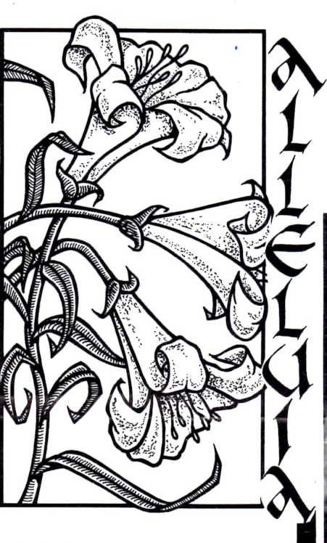
Keeney Update
VOL VII, Number 1 Roscoe C. Keeney, Jr. MAR 1990
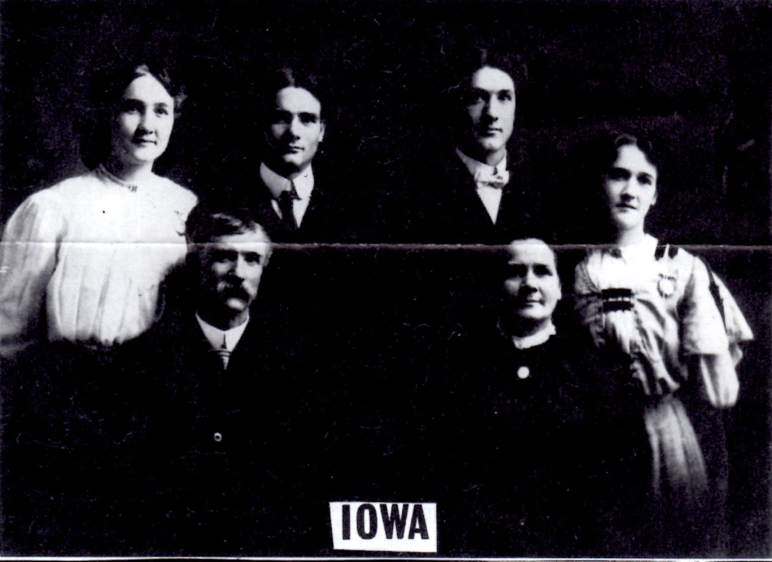
IOWA KEENEYS
John Wesley (1853-1921) and Addlaide Long Keeney (1864-1928) and children Ethel Keeney Moeller (1888-1955), Fred Keeney (1881-1963), Byron Keeney (1882-1977, and Golda Keeney Smith (1891-1980) (Updates 9/85 & 6/88)

NANCY JANE KEENEY COINER FAMILY

Family of Stires Jade Keeney (1813-1876), son of Moses (1766-1840) and Frances Harris Keeney, and Amelia Gatewood Keeney (1813-1860), daughter of Ransom & and Elizabeth Burke Gatewood:
ROBERT H. KEENEY (1834-1912) family and Potawatomi Co., Kansas, scattered to Oregon and West
MCDONALD KEENEY (1836-1910)-Cabin Creek area
NANCY JANE KEENEY COINER (1838-1894)-mother of a large family, mostly miners; Eskdale area
MICHAEL KEENEY (1840-c. 1888)-Fayette Co., WV
MOSES W. KEENEY (1843-1901)-raised family at Belle, WV; buried at Witcher
ADALINE KEENEY WHITE (1844-1917)-St. Albans, WV
MARY AGNES KEENEY NOWLAN (1847-1922), wife of railroader, lived in Summers Co., WV
FRANCES KEENEY, b. 1847, age 2 in 1850
JOHN S. KEENEY (1849-1932)-Witcher, WV

Family of NANCY JANE KEENEY COINER:
8. NANCY JANE KEENEY, b. 1838; age 11 in 1850 census, 44 in 1880 census; believed to be buried at Red Warrior; died in 1894
m. George H. Coiner (b. 8-10-1832, d. 11-29-1904) listed as farmer in 1860 census, age 28, next door to Nancy’s parents at Cabin Creek; lived with daughter Fannie in 1900; Red Warrior Cem..
9. STIRES J. COINER, b. 1854, age 6 in 1860 census, 56 in 1910; buried at Red Warrior
m. Alice Jane Pettit (b. 5-1859 in Nicholas) on 12-24-1878 by Rev. J.H. Roberts; 41 in 1900
10. CORA COINER, b. 11-8-1879 in Kanawha Co.
10. EFFA COINER, born and died 11-8-1879
10. VIRGIE FRANCIS COINER, b. 5-1885, d. 1848;
buried beside husband at London
m. Frank Kazupski (b. 5-17-1876 in Warsaw,
Poland, d. 10-25-1963; lived at Whitesville; married
5-23-1910 by Rev. Philip Pauley
11. ANDREW KAZUPSKI, b. 5-10-1911; deceased
11. PANSEY KAZUPSKI JERRELL-died in Florida
11. MARY ALICE KAZUPSKI KENNEDY-
Fayetteville, Arkansas; reported father’s death
10. GEORGE CLARENCE COINER (called
Clarence, listed as George C. in 1910 census), born
10-27-1887, died in a Coal River train accident on 4-
11-1913 at age 25
m. Mintie Basham (b. 1888) on 8-14-1909; she
married J Theodore Meadows on 10-21-1914
11. VAN G. COINER, died at age 1
11. IMOGENE COINER
11. MATTHEW COINER
10. ELIZABETH (LIB) BROOKLYN COINER, born
10-27-1890, d. 4-23-1956; London Cemetery
m. Molley R. Woods (b. 3-19-1887, d. 3-6-1983) at
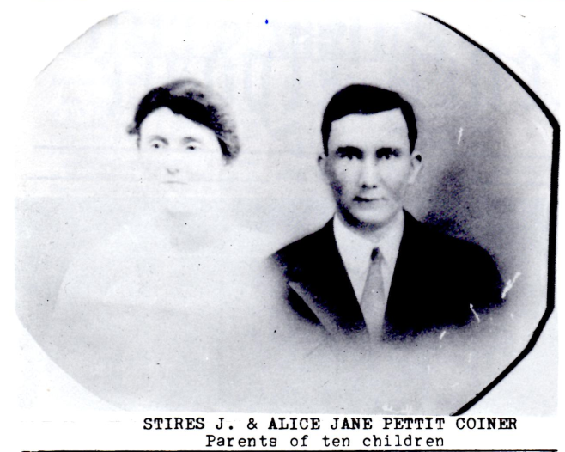
age 95 at Cooper’s Creek)
11. VIRGINIA A. COINER, b. 6-19-1920, died 3-
10-1981; married and divorced; nurse
12. JAMES ROSEN (son)
11. JAMES WILLIAM COINER-Charleston, WV
11. BETTY LOU COINER, b. 11-17-1926 at
Kayford; died young
10. NANCY B. COINER, b. 9-1892, died before
1977; m. Patrick L. Beirne (b. 10-4-1884, d. 12-15-
1977, son of P.L. & Mary Jane Beirne); coal
operator Nicholas Co.; Barren Creek Cemetery
11. CHARLES P. BEIRNE-lives at Queen Shoals
11. HELEN MARY WHITED-Spencer, WV
11. JOHN LEONARD VERDI, b. 12-28-1921 at
Queens Scholes, d. 8-17-1963; Barren Creek
Cemetery
10. JOHN SIZEMORE COINER, b. 6-9-1895 at
Fairfield, d. 1-30-1947 in mine slate fall: Pvt., 135th
Mg. Bn., 37th Div., World War I; Standard Cemetery
m. Edith Josephine Bragg (b. 4-27-1900, died 5-14-
1974; par.: George & Elmira Collins Bragg)
11. ALMA COINER DAUSCH-Baltimore, MD
11. NANCY COINER MALONE-Vincenttown, NJ
11. STEPHEN DUANE COINER, b. 12-22-1931,
died 8-3-1979; Sgt., US Army in Korea, where a
supply camp was named for him; divorced; buried
at Standard Cemetery on Paint Creek
Children: Charles D. and John Coiner (in WV in
1979); David, Greg, Thomas and James Coiner
(living in Maryland 1979)
10. RUTH M. Coiner, b. 3-18-1897, d. 1973
m. James S. Perry (b. 1892) on 3-6-1924
11. JACQUELINE PERRY MILLER, b. 7-4-1926 at
Brush Creek; lives at Gauley Bridge
11. JAMES S. PERRY, JR.-Lives in Florida
11. ALICE PERRY
11. FRANKLIN PERRY
10. JAMES HARRY COINER, b. 4-1-1900, d. 6-6-
1976; coal miner, lived at Queen Shoals; buried at
Barren Creek Cemetery
m. Nora Hansen
11. JAMES HARRY COINER, JR.-Roanoke, VA
11. VICTOR L. COINER: Columbia, SC
11. DON ROY COINER, b. 6-3-1929, d. 3-26-1970
in slate fall at Cannelton Coal Co.
m. Sharon Creasey; lived at Charleston Hts.
12. RAYMOND COINER-Huntington
12. ELIZABETH ANN COINER-Huntington
12. SANDRA COINER
11. ELIZABETH COINER ROLLING-Baltimore, MD
11. NETTIE COINER POZZIE-Woodbridge, VA
11. FRANCES LOUISE COINER SMITH, b. 1-7-
1934
11. BERTIE COINER-lives at Clendenin
11. CAROLYN COINER-lives at Clendenin
11. JOHN PAUL COINER, b. 8-2-1942-Atlanta, GA
11. LOWELL THOMAS COINER, b. 1-21-1948-Nitro
9. MARY ANN COINER, b. 9-1-1856; age 54 in 1910;
ran boarding house in Eskdale for many years
m. P. Washington Ballard (b. 4-1854 in Monroe Co.)
on 8-25-1885 Rev. C. J. Rippetoe
10. WILLIAM HENRY BALLARD, b. 9-8-1882, died
2-4-1955; Eskdale Baptist Church member; buried at
London
m. Elizabeth Batton (b. 7-22-1884, d. 1-3-1942),
daughter of James O. and Carolyn V. Keeney
Batton, granddaughter of Moses Walls Keeney
11. CLARENCE ASHBY BALLARD, b. 8-30-1910 at
Carbon; lived at Jochin in 1955
m. Dolly Maxine Lawrence
12. SANDIA ANN BALLARD, b. 11-5-1934
12. DONALD LEE BALLARD, b. 3-8-1937
11. RUSSELL BALLARD-lived in Chicago in 1955
11. CHARLES MELVIN BALLARD, b. 1-5-1914 at
Eskdale, d. 7-31-1987; buried at London
m. Charlotte Hester Blake (b.1917) 1-20-1934
12. CHARLES MELVIN BALLARD, JR., b. 10-31-
1934
m. Joann Cravens-live in Charleston
13. MICHAEL THOMAS BALLARD, b. 4-28-1958
12. KENT MEREDITH BALLARD, b. 8-28-38, d. 3-
31-41
12. CHARLOTTE H. BALLARD, b. 8-28-38, d. 3-
31-41
12. LARRY K. BALLARD, b. 7-18-1942 at Decota
11. ROBERT BALLARD-lived in Belle, WV in 1955
11. DANIEL BALLARD, b. 1-3-1924 at Eskdale;
lived at Dayton, OH in 1955
11. LENA BALLARD (oldest child)-Cleveland 1955
m. Shirley D. Atkinson
12. NORA ELIZABETH ATKINSON, b. 9-28-1921
11. LILLIAN MAY BALLARD, (1904-1977)
m. James Sampson Russell (1898-1945)
12. JAMES S. RUSSELL, JR., b. 7-5-1922
12. WILLIAM FREDERICK RUSSELL, b. 12-23-
1924
12. DORA ARLENE RUSSELL, b. 2-6-1927 at
United
12. ROY PARK RUSSELL, b. 8-22-1933 at
Wevaco
11. ELIZABETH BALLARD THOMPSON-lived at
Carbon in 1955, Libertyville, IL in 1977
10. LILLY M. BALLARD FISHER, b. 5-1885
m. James M. Hatfield (b. 1881) 12-15-1902
11. GLADYS HATFIELD, b. 4-18-1913 at Carbon
10. GEORGE W. BALLARD, b. 3-22-1887; died
young
10. BERTHA BALLARD b. 5-1889
m. R. P. Scott (b. 1877 in NC) 9-27-1905
10. JAMES H. BALLARD, b. 1-22-1891
m. Effie Chancey Selbe (b. 5-18-1895, died 12-13-
1977) 8-21-1912 by Willie Coiner
Children: David Ballard, Joe Ballard, Retta Hamrick,
Betty Dyer and Maxine Nelson, all of Loudendale;
James Ballard, Richard Ballard, Maggie Lambert
and Grace Wells, of Charleston; Hannah Kirk,
Gandeeville
10. FOREST BALLARD, b. 6-1892
m. Monnie Lewis (b. 1896) on 6-27-1912
11. ALICE BALLARD, b. 11-13-1922 at Eskdale
11. DONNIE BALLARD, b. 5-30-1933
10. HATTIE R. BALLARD, b. 6-7-1895 Acme; died before
1955
m. Fred Tucker (b. 10-5-1892, d. 1-15-1956) on 6-26-1911,
son of Wm. R.& Selena White Tucker
10. J. RUSSELL BALLARD, b. 2-1897
m. Lucille Marie Jones (b. 1906) 6-28-1922 at Eskdale;
lived at South Charleston 1955
10. ELLA F. BALLARD, b. 4-1899; buried at Pratt
m. Samuel A. Swartz (b. 1891) 12-19-1914
11. SAMUEL A. SWARTZ, JR. (1917-1926)
11. FRED KENNETH SWARTZ, b. 2-5-1917 at Eskdale, d.
2-17-1990; buried at Pratt
m. Georgia Louise Kirtner (b. 1919)
Children: Cheryl Adkins, Kenneth Swartz, and James
Swartz of Smithers, WV; Myrna Proffit, of Hansford;
Margaret (Peggy) Huddleston, of Duck; and Nina
Goodrich, Brunswick Hills, OH
11. MARY E. SWARTZ CARTER-Palm Bay, FL
11. ANNA LOU SWARTZ, b. 5-18-1933; deceased
9. PERNELLA CLEMENTINE (TINEY) COINER, or 9-1-1859, d. 1942; IOOF Cemetery, East bank
m. (1) Mr. Lloyd; m. (2) Mr. Webster m. (3) Van G. Bannister (1854-1942), widower and father of Clara P., m. Thornton Johnson; Amelia T. m. Theodore Schlaegel; and Beatrice F. Bannister, m. Randolph Skiles; I00F Cemetery; married Tiney Webster 12-2-1902
10. ETHEL LLOYD, b. 8-10-1883, d. 6-7-1923; buried
beside her mother at IOOF Cemetery
m. Elmer Roy Spencer (b. 6-1-1876, died 6-13-1957), 2nd
wife: Ruby Hope
11. E. Pauline Spencer, b. 1899
m. Fletcher Garrett Hartley (b. 8-14-1892, d. 6-7-1962) on
6-16-1915; lived at Marmet; American Legion Post Cmdr.;
Grandview Cemetery
12. BETTY HARTLEY LEE-Charleston
12. DORRIS HARTLEY KEPNER-Roanoke VA
11. LAURA MAY SPENCER, b. 5-11-1903 at Ohley m. J.
William Cummins; no children
11. LLOYD SPENCER, b. 1906; lives at East Bank, WV
11. GENEVIEVE ANN SPENCER, b. 10-23-1908 at Ohley;
d. 3-26-1987; schoolteacher
m. Dr. Wirt W. Duff (b. 11-16-1902, died 7-28-1986;
Elkview physician 50 yrs.
12. ROBERT LLOYD DUFF-lives at Poca
11. LOUISE SPENCER-lives in Charleston
m. Blair M. Amole
11. LEONA CLEMENTINE SPENCER-lived in Clearwater,
FL: deceased before 1987
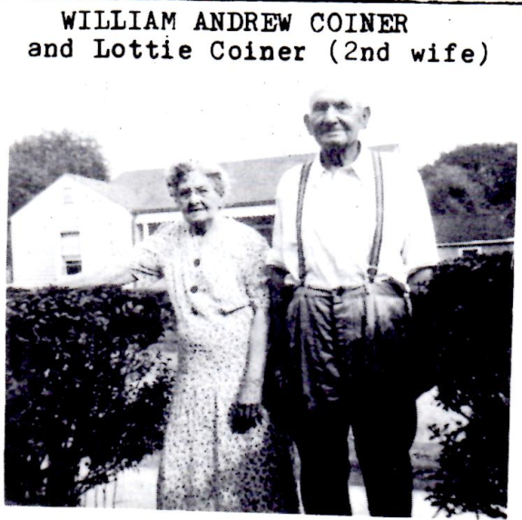
9. FANNIE H. COINER, b. 3-16-1864; d. 9-6-1903; unmarried; listed with father in 1900 census
9. SARAH ELLA COINER, b. 7-11-1866, d. 2-1-1940 at Whitesville, Boone Co.; Spring Hill Cem., Huntington, WV; member, Whitesville Baptist
m. John W. Branham (b. 1865) on 11-4-1891
10. BRUCE Y. BRANHAM, b. 9-28-1892, died on 11-24-
1958; Chief Clerk, Web Coal Co. and Assistant City Auditor,
Charleston; Sp. Hill Cem.
m. Naomi Lee Russell (b. 1894) on 12-23-1916
11. ROBERT L. BRANHAM-Whitesville, WV
11. DON C. BRANHAM-Akron, OH
10. DANIEL FREDERICK BRANHAM, b. 3-30-1895 at
Acme, d. 8-24-1963; WW I vet, Masonic, K of P; Whitesville
merchant since 1922
m. Mary Elizabeth Bradley
11. JACK BRANHAM-Sophia, WV
11. DANIEL F. BRANHAM, JR., b. 2-20-1931 at
Whitesville; lived at Sylvester in 1963
10. GEORGE SHANNON BRANHAM, b. 11-13-1896
m. Quilla V. Dorsey (b. 1896) on 11-1-1917
m. Goldie Hedrick 10-6-1922 by Rev. G. W. HOLT
10. SYLVIA BRANHAM MARTIN
9. LAURA VIRGINIA COINER, b. 1870; died young
9. WILLIAM ANDREW (WILLIE) COINER, b. 3-3-1873, d. 1-8-54; mine foreman at Whitesville; resided at Acme (1910) and Marmet; Graceland Cem.
m. Mary Frances (Bertie) Frye0 (b. 10-1-1872, d. 2-15-1918) on 7-3-1893 by Rev. Thomas M. Spaulding; buried at Red Warrior Cemetery
10. CHARLES LEWIS COINER, b. 5-1896, d. 7-3-1962
lived at Eunice; funeral at Crab Orchard
m. Ada Belle Cantley (b. 1901, d. 9-7-1962); buried at
Sunset Memorial Park, Beckley
11. FRED B. COINER, b. 1916 in Kanawha Co., d. 1919;
buried at Red Warrior Cemetery
11. CLAUDIA MARIE COINER, b. 9-17-1917
m. Fred Persinger; lived in Clarksville, TN
11. MARY FRANCES COINER, b. 6-25-1920 in Boone
m. James Thompson-Crab Orchard, WV
11. CHARLES WILLIAM COINER, b. 3-1-1922 at Mordue,
Boone Co.; lives in Cleveland, OH
m. Norma Cole on 2-27-1947
11. HELEN LOUISE COINER, b. 4-9-1925, d. 10-9-1925
11. CAMERON DEWEY COINER, b. 7-5-1925, died 2-24-
1976; lived in Cleveland, OH
m. Evelyn Weikle
11. JOHN LEWIS COINER, b. 1-26-1927
m. Francis Miller; lives in N. Carolina
11. U. JAMES COINER, born and died 1928
11. JACK NEAL COINER, b. 4-11-1930 and Edwight
m. Jo Ann Thompson (divorced)-Dover, TN
11. JOANN COINER, b. 2-4-1933 at Glenn Rogers
m. Bobby Jarrett-lived in Cleveland, OH
10. ERVAN DEWEY COINER, b. 8-10-1898 at Acme, d. 3-
3-1969; m. (1) Claudia Maria___ in Raleigh Co.; she died in
childbirth
m. (2) Ruth Dorothy Johnson Matheson (b. 9-23-1904 in
Chicago, d. 7-6-1987, in Putnam Co., daughter of John &
Dorothy Johnson Matheson), buried at Barboursville
Children of Ervan and Ruth Dorothy:
11. ERVAN DEWEY COINER, JR., B. 3-17-1923 at
Mordue, Boone Co., lives at Hurricane
11. GEORGE ROBERT COINER, b. 6-2-1925; lives at
Milton, WV
11. MARGARET LOIS COINER, b.10-9-1926 at Edwight;
m. Ray Watson
11. KENNETH ROGERS COINER, b. 10-24-1928 Edwight,
Raleigh Co.; lives at Hurricane
m. Mary Louise Ellis (b. 1934, d. 3-4-1990)
12. CYNTHIA L. COINER SHELTON-Greer, SC
12. MARY LYNN COINER STOVER-Hurricane
12. JANET S. COINER HECHESKY, b. 10-29-1964
12. KENNETH ROGERS COINER, JR.-Lititz, PA
12. BRUCE ALLEN COINER-Smyrna, TN
12. STEVEN E. COINER-Hurricane
12. TIMOTHY WAYNE COINER, b. 9-17-1963
12. JOHN WESLEY COINER, b. 10-29-1964
11. FRED ALLEN COINER, b. 2-5-1931 at Marmet
m. Loretta McDougal
11. BRUCE ALLEN COINER, b. 2-5-1931 at Marmet: d. 7-
20-1958 in auto wreck; Navy veteran
10. IRENE COINER, b. 7-15-1900 Acme, died in 1940’s;
buried at Handley Cemetery
m. Hulen James Goodyear
11. BILLY CHARLES GOODYEAR, b. 10-23-1923, d. 1-9-
1990; UKV Cemetery, Glasgow
m. Juanita Redden
Children: Robert Goodyear and Michael Goodyear,
Handley, Kath Goodyear Griffith, Hernshaw
11. DON GOODYEAR (1926-1988)
m. Beulah Lewis (b. 1926) on 9-28-1946
11. MARGARET ANN GOODYEAR LUTES, b. 1927
m. Jess Henry Baldwin (b. 1924) 7-20-1946
Children: Carol Lee Baldwin, Jeff Henry Baldwin, Jr.,
James Ray Baldwin
11. BETTY JUNE GOODYEAR, b. 7-26-1928 at
Whitesville, Boone Co.
11. HELEN IRENE GOODYEAR, b. 1933
m. John Mack Baldwin on 5-28-1955
10. CHARITY IRENE COINER, b. 7-15-1900 at Acme; d. In
1940’s; Handley Cemetery
10. WILLIAM ISAAC COINER, b. 3-31-1902, died 5-15-
1973; Pinegrove Cemetery, McCorkle
m. Ollie Jane Alderman Clark; (widow b. 1903) on 3-26-
1924 at Edwight
11. WILLIAM HARMON COINER, b. 11-29-1923 at
Edwight;
lived at Sumerco in 1973
m. Flo Tucker on 2-22-1947 at Hugheston
11. RANDALL EUGENE COINER, b. 9-21-1927 at
Mordue; killed 4-16-1953 in Battle of Pork Chop Ridge,
Korea
m. Deloris Musa in Knoxville, TN
11. REGINALD EARL (JACK) COINER, b. 12-4-1929
m. Sandy McCommack
11. JUNE COINER, b. 9-11-1926 at Mordue; died as child
11. BETTY LOUISE COINER, b. 12-7-1932
m. (1) Joseph Clark; (2) Jim Smith
10. HELEN ELIZABETH COINER, b. 7-3-1904, died 10-6-
1982 at Huntington
m. George Bennett Baker (b. 1893 in PA) on 8-9-1923 at
Marmet by Rev. J.E. Hartman
11. BETTY BAKER BRAY- deceased
Sons: George Bray, Joe Bray
11. GEORGE B. BAKER, JR.-Frankfurt, KY
11. JESSE BAKER-born at Logan
m. Eugene Clark-lives in Huntington
11. JOHN C. BAKER-Huntington, WV
10. ETHEL F. COINER, b. 7-18-1906 at Marmet; died
young
10. RAMSEY LORENZO COINER, b. 1-27-1909 at Acme,
d. 9-19-1924; Graceland Cemetery
9. GEORGE W. COINER, b. 11-20-1878, d. 2-11-1882

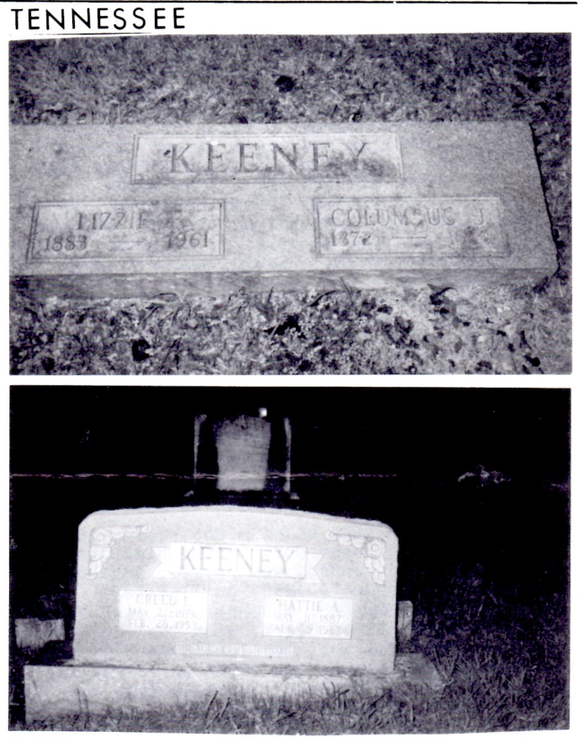
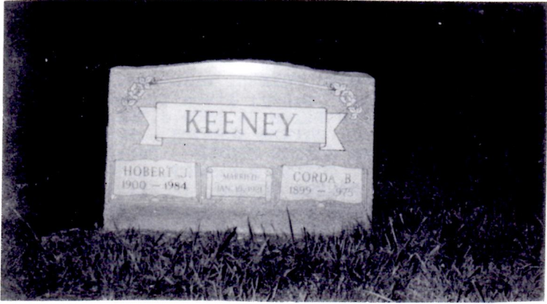

ANDERSON COUNTY, TENNESSEE descendants of Joseph Keeney (b. 1765) and William (b. 1795), include COLUMBUS JACKSON and Lizzie Fraker KEENEY, their son HOBART J. KEENEY and wife, Corda B.; And C. J.’s. Brother, CREED FULTON and Hattie A. Lowery KEENEY. Hobart’s son, Jack, works in county government and is running for county clerk in the May 1st election.
(Overton Cemetery, formerly “Toad Hill Cem.”)

Oregon

BENJAMIN F. KEENEY. Inseparably associated with the upbuilding of Lane Co. is the honorable career of Andrew J. Keeney, who, in addition to establishing a large farming enterprise near Goshen, gave to the state of his adoption children who maintain his good name, and keep in constant mind his worthy and upright life. Of these, none are more truly representative of northwestern force and enterprise than Benjamin F. Keeney, who occupies part the original claim purchased by his sire, and where Benjamin F. was born October 14, 1865.

Andrew J. Keeney was born in Holt Co., M0, and was the son of a blacksmith who had early settled in the middle west. Remaining on the home farm until his marriage with a Miss Mulholland his life was shortly after saddened by the death of his wife, to whom he was devotedly attached. In time he married Mrs. Hannah Cooper, who bore him three sons, of whom James M. lives in Eugene, Oregon; William D. Is a resident of Caldwell, Idaho and John B. lives in Olex, Oregon. For 3rd wife Mr. Keeney married Mrs. Amanda J. Matthews, the following children being born of this union: Mrs. Martha E. Handsaker, of Tacoma, WA; Benjamin F. of Goshen, Ore.; Andrew A. of Massena, NY and Thomas P. of Hong Kong, China. Mr. Keeney was ambitious and farsighted, and was naturally impressed with favorable reports he heard of the far west, to which he finally decided remove his family. Crossing the plains with ox teams, he mined for a few months in California, coming then to Oregon, his choice of residence being Lane county, at that time beginning to assert its independence as an agricultural and stock raising section. Locating on the farm, a part of which is now owned and occupied by his son Benjamin, he laid the foundation for the present splendidly appointed farm which is become the pride of the owner and the neighborhood. To his original purchase he added from time to time, and at the time of his death, during the 90s, at the age of seventy-five years was the owner of six hundred acres, the greater part of it valuable land. He raised large numbers of fine stock, as well as fruit, grains, hops and dairy products, amassing considerable wealth as his harvests increased in extent and variety. He was no politician, but was vitally interested in his church, to the maintenance of which he gave liberally, as he did also to all worthy local charities. His life and effort were such that his name became associated with all that was noble and of good import.

From the district schools Benjamin Keeney went to Monmouth College, where his apt mind and powers of concentration accomplished far more in a given time than does the average student. For several terms he applied knowledge as an educator, remaining in the meantime, home farm, where he worked in the harvest fields during the summer. After his marriage with Martha Cummings he went to housekeeping on a part of the old claim. To himself and wife were born two children, Hugh C. and Hobart S. His second marriage occurred in 1902, with Charity A. Taliafero, a native of North Carolina. It were difficult to find a more perfectly appointed farm than that purchased in the early days by the elder Keeney, his son having added those aides to modern agriculture which rob the occupation of its hard and discouraging aspect, and in their place substitute the possibility of an easily acquired competence. Poultry-raising is a department of activity to which Mr. Keeney has devoted considerable study, and is one of the best authorities on poultry to be found in the state. With practical results he has raised Barred Plymouth Rocks, this fine breed reaching its highest excellence under his scientific treatment. In this connection he is a member and secretary of the Willamette Poultry Association, with headquarters at Eugene, and a member of the State Poultry Association. A staunch adherent of Republicanism, Mr. Keeney has been prominently identified with official undertakings in the county, having served as constable, justice of the peace, deputy sheriff, deputy clerk, school clerk for thirteen years, deputy assessor for eight years and notary public. He is a welcome member at numerous fraternal gatherings, including the Independent Order of Odd Fellows, the Knights of the Maccabees and the Woodmen of the World.

Willamette Valley Biographical Record, 1903

PENNSYLVANIA
THE HISTORY AND FAMILIES of the BLACK ROCK CHURCH of the BRETHREN (1738-1988)
Elmer Q Gleim

In 1767, John Kuny (Keeney) and Henry Kuny (Keeney) were listed as residents of Germany Township, York Co., Henry pay taxes on hundred acres of land. He arrived in America aboard the ship Mayrttila on September 21, 1765. He signed his name in German script, “Heinrich Kuny”. Henry’s brother, John, arrived in America eleven years earlier and had also settled in Germany Township. (4)
“Morgan Edwards listed “Henry Geiny” as a member of the Little Conewago congregation in 1770. By 1779, he was being taxed for one hundred acres of land. On January 21, 1781, he drew up his will, “being very sick”. This will was filed on February 15, 1781. The terms of the will, judged by the normal standards of the era, were extremely liberal toward Anna, his wife. Henry stipulated that Anna could keep the farm, if she wished. “If it children do not obey her commands”, or she should choose to remarry, she could then sell the farm, if she preferred. About fourteen months after Henry’s death, Anna asked the court to appoint guardians for her children. (5) These guardians were chosen from the membership of the Little Conewago congregation. Apparently Anna had decided to remarry.
The will of Henry Keeney itemize such clothing as a lindsey jacket, a pair of old lindsey breeches, 2 pairs of stockings and 2 under-jackets. An inventory of the estate, signed on February 17, 1781, indicated the kind of household and farm equipment used by the German Baptists of the later 18th century. Among the numerous items were the following: 2 spinning wheels, a lantern, a flour cest, bread baskets, “shoo” leather, a kneading trough, a loom with tools belonging thereto, a half bushel of wheat, a mare colt, two sows with young, four cows, two heifers, one bull, one steer, and six sheep. Executors for the will were Samuel Flickinger and Henry Hoff. The will was signed by three witnesses from the Little Conewago congregation: Daniel Utz, John Keeny and Henry Danner.
The family of Henry and Anna Keeney consisted of the following persons:
Magdalena (1766- )
John S (July 7, 1768-June 21, 1848). He was
granted three pounds of hard money more than any
one of “my other chirling” (children). He was
married to Magdalena Petrie (October 10, 1770-
July 19, 1828)
Anna (1773- )
Henry (1775- )
Barbara (1778- ) who married Jacob Falkenstein
Jacob (1780- ) who became the ancestor of the
Keeney families in Washington Township, York
Co., PA
A record from Switzerland shows that Jacob Brungart was granted a permit from Prince William Henry to migrate to America. He settled in Breaknock Township in Lancaster County, PA, in 1760. In the year 1773-1774, he purchased land in York County close to the present site of the Black Rock Church. The first home built on this land was a log structure. By 1789, he transferred the land to Martin Brungard who had it patented under the title of “Martinsburg”. This Martin Brungard was married to Catherine Wentz, the daughter of Valentine Wenz, the immigrant. In 1802, Martin Brungard moved to Centre County, PA. Their only known children were:
Margaret ( - ) who married Daniel Bear
Mary Magdalena ( -1858) who married George
Utz (1774-1842)
Members of the Brungard family are buried in the cemetery at St. Jacob’s Stone Church.
The land and the log house owned by the Brungard family eventually became the property of Jacob Buser (1827-1874), whose daughter was married to Arron S. Baugher. Members of the Buser family were active in both the German Reformed and the German Baptist congregations. In 1773, the land known as “Martinsburg” contained a log house and two hundred and sixty acres.

The Congregation of 1770
Morgan Edwards, a minister of the Philadelphia Baptist Church (1761-1771), hoped to complete a full report of Baptist congregations in Colonial America. A part of this ambitious undertaking was a work known as Materials Toward a History of the American Baptists, Both British and German (1770). In this volume, he described the German Baptists as “the harmless talkers” and “the visible people of God on earth”. To this writer we owe the listing of the membership of the Little Conewago congregation years immediately preceding the American Revolution.
From these records we may judge the sizes of the various Colonial congregations. By 1770, the German Baptists existed in twenty-one congregations. Memberships in six congregations influential in the life of the Little Conewago congregation reveal the following:
Conestoga, consisting of eighty-six persons
and fifty-three families
Pipe Creek, consisting of seventy members
in thirty-five families
Members of the Keeney family have remained very active in the life of the German Baptist Brethren denomination. A son of the immigrant Heinrich Keeny was named John S Keeney (July 7, 1768-June 21, 1848). George N Falkenstein described him as a man of “medium height and weight, a man of considerable ability but of reserved and retiring disposition”. In the period from 1800 until his death in 1848, he ministered as a German language exhorter of the Little Conewago Church.
John S Keeney bought a track of two hundred and fifty-six acres in 1792 in partnership with Jacob Petry. These brethren paid six hundred pounds for this land which lay along the road between Sinsheim and Jefferson, PA. In 1794, John S Keeney became the sole owner of one hundred and eighty-four acres of land in the eastern portion of this track. The land now borders the community of Jefferson (Codorus), and is nearly within sight of the Chestnut Grove Church.
John S Keeney was married to Magdalena Petry (Oct 10, 1770-July 19, 1828), the daughter of Stephen Petry. Their children were:
Henry (Nov 2, 1793-March 1, 1862) who
married Anna Yount, daughter of Samuel
and Catherine Eby Yount
John P (April 23, 1796-July 24, 1867) who
married Elizabeth Wehrley (May 13, 1800-
April 9, 1877), daughter of John George
and Eve Hoover Wehrley. John P Keeney
was elected to the ministry by the Little
Conewago congregation on March 28,
1840
Jacob (November 25, 1798-July 26, 1868)
was married to Salome Falkenstein (April 6,
1799-Sept 24, 1859). They resided near
Glen Rock, PA
Mary (July 22, 1801-March, 1810) who was
buried at the Chestnut Grove Meetinghouse
Cemetery
Samuel (Dec 5, 1803-Nov 29, 1884) was
married three times: 1) To Catherine Hoff,
2) To Magdalena Grove (March 28, 1804-
May 17, 1830) and 3) To Elizabeth Stouffer
Michael (May 24, 1807-April 25, 1850) who
married Barbara Bollinger (May 29, 1794-
June 27, 1860). Both are buried at the
Chestnut Grove Meetinghouse Cemetery
David (July 5,1813-Nov 4, 1879)
Jonathan ( - ) who is buried at the Chestnut
Grove Church Cemetery
After the death of Magdalena, John S Keeney was married to Elizabeth _____, who is buried in an unmarked grave at the Chestnut Grove burial grounds. There was one son to this union. He was named Aaron (Aug 20, 1831- ) and continued to reside in the Jefferson area, working his trade as a saddler.

Gwen Boyer Bjorkman of Bellevue, WA supplies this very interesting information.
She speculates, “John Kuny (Keeney), who arrived in 1756 and settled in York Co. PA, then headed for VA (now WV)??”
The dates would make this possible.
Others whose ancestry dates back to York County are invited to submit information for future UPDATES.

The Fallibility of Census Records
This is borne out by the belated listing of the NANCY KEENEY COINER FAMILY. She was left out of the first two genealogies of the Stires Jade Keeney family.
In 1837, when Nancy was born, birth records were not kept by the state. In 1853, when she married George H. Coiner at age 16, his name was recorded in official records this George Comer. Fruitless searches uncovered no such couple.
Then in 1860 census, in Paint Creek house #2272 we find George H. Kiner, farmer 28, Nancy 24, Cyrus (not Stiers J., his name) 6, Mary 4, and Permelia C. 8/12.

OBITUARIES

Janice M. Champe
Mrs. Janice Montgomery Champe, 88, of 410 Ferry St., Montgomery, died Wednesday, March 7, 1990 in Montgomery General Extended Care Unit after a long illness.
She was a homemaker and a member of Montgomery Presbyterian Church. She was a lifelong resident of Montgomery.
Surviving: son, Sewell Preston of Edison, NJ; 2 grandchildren.
Memorial service will be 7 p.m. Saturday at Montgomery Presbyterian Church with the Rev. Arthur H. William Jr. officiating. Burial will be in Montgomery Memorial Park, London.
Friends may call after the service at 410 Ferry St. The family suggests donations to Montgomery Presbyterian Church or West Virginia Tech Scholarship Fund. B. C. Hooper Funeral Home, Montgomery, is in charge of arrangements.

Kenneth Keith Keeney
Kenneth Keith Keeney, 68 of Star Route Box 758, Leewood, died Jan. 31, 1990, in General Division, CAMC, after a short illness.
He was a retired miner for Carbon Fuel Co. No. 9, an Army veteran of World War II. He attended Carbon Free Will Baptist Church.
Surviving: wife, Lucille; brothers, Hewitt of the Decota, Adrian of Beckley, Jack of Shelby, Ohio, Stacy of Chesapeake; sisters, Thelma Cantley of Crown Hill, Inez Brockell of Miami, WV, Julia Moore of Beckley, Madeleine Hall of Newark, Ohio, Ruth Sadler of South Charleston, Ann Ream of New Haven, Ohio.
Friends may call after 7 p.m. Sunday at Fiddler-Frame Funeral Home, Belle.

Mrs. Mary Lou Coiner

Hurricane-Mrs. Mary Lou Ellis Coiner, 56, of 354 Teays Lane, Hurricane, died March 4, 1990, and Putnam General Hospital after a long illness.
She was retired chief Deputy of Putnam County Assessor’s Office. She was the pianist for and attended Hurricane Bible Church. She was a member of Putnam County Democratic Club, former Miss Putnam County and a lifelong resident of Hurricane.
Surviving: husband, Kenneth R. Coiner Sr.; daughters, Cynthia L. Shelton of Greer, SC, Mary Lynn Stover and Janice S. Hechesky, both of Hurricane; sons, K. Roger Jr. of Lititz, PA, Bruce A. of Smyrna, Tenn., Stephen E. of Hurricane, Timothy W. of Homestead, FL, John W. of Winfield; sister, Patricia S. Elliott of Oak Ridge, TN; eight grandchildren.
Service will be 1 p.m. Wednesday at Hurricane Bible Church with Pastor Art Hage and the Rev. Ken Hilling officiating. Burial will be in Valley View Cemetery, Hurricane. Friends may call from 7 to 9 p.m. today at Chapman Funeral Home, Teays Valley
.
Mrs. Halcy Marks
Massillon, Ohio-Mrs. Halcy Marks, 71, of Massillon, formerly of Bomont, WV, died Dec. 7, 1989, at Massillon Community Hospital after a short illness.
She was a retired of director purchasing for the Massillon Community Hospital.
Surviving: daughter, Dena K. Berens of Massillon; son, Ronald D. of Massillon, sisters, Esther Parrish of Arizona, Lulu Wolfe of St. Albans, WV,, and Roberta Miller of Michigan; brothers, Lawrence Samples of Elkview, WV, Orvis Samples of Belle, WV and James of Ohio; four grandchildren.
Service and burial was Saturday in Massillon, Arnold-Lynch-Miller Funeral Home, Massillon, was in charge of arrangements

Mrs. Julia Ann Bonham
Born June 26, 1931
Died March 2, 1990
Survived by
Husband, Curtis Bonham; son, Michael Bonham; daughters, Mrs. Sandra McLaughlin, Mrs. Kim Taylor and Mrs. Jo Anne Bonham; mother, Mrs. Edna Stanley; brothers, Tony, Richard, Jerry and Larry Stanley; sister, Mrs. Kay Holtsclaw; 5 grandchildren.
Services from
Witcher Baptist Church
Time
Monday, March 5, 1990 11 a.m.
Clergy
Rev. Billy Wilburn
Interment
Witcher Creek Cemetery

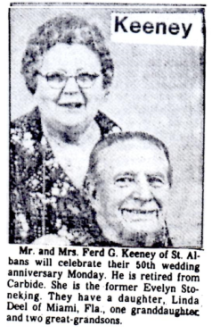
JANICE MONTGOMERY CHAMPE the great great granddaughter of Nancy Keeney
& Henry Montgomery (Keeney Update, March 1986, P. 4)
KENNETH KEITH KEENEY, p. 46, Keeney relatives, son of Harry Leslie & Ethel
Hudnell Keeney
MARY LOU COINER-family listed in this issue
HALSY FAYE SAMPLES MARKS, p. 26, Keeney Relatives; granddaughter of
Harrison Columbus & Nettie Estep Keeney, Clay Co. WV
JULIA ANN STANLEY BONHAM, p. 59, Keeney Relatives; wife of Curtis Bonham,
great grandson of Rev.T.Y. Keeney
FERD G. & EVELYN KEENEY, p. 19, Keeney Relatives; family listed in David
Keeney family Update in 1989

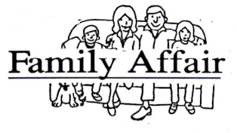

MICHIGAN: Phillis Keeney Smith appreciates material published on her ancestors, Abner and Seth Keeney. She sent an invitation to the Keeney Reunion at 10347 Dixie Highway, just north of Erie, MI, at noon July 7.
For information: Mrs. Joel M. Mihovich, 24221 Morton, Oak Park, MI 48237.
KENTUCKY: David Keeney, age 15, Paris, KY 40361 is collecting genealogical information on Bourbon Co. Keeneys. The address is 156 Grimes-Batterton Rd.
JOSEPH W. FOULKE, 345 Moutain Rd., Wilton, CT 06897 descends from Warren Co., Iowa, Keeneys and Ellison relatives who live along the New River of VA/WV and fought in the American Revolution.
CALIFORNIA: Kenneth R. Keeney, P.O. Box 578, Brownsville, CA is a great grandson of Jonathan Keeney (Update, Vol. 6, No. 1). He has sons Kenneth Reid, b. 12-30-1949; Bruce Paul, b. 9-23-1952; and Blake Philip, b. 5-6-1961.
ANGELS: Generous support has come from “family members” to pay for this issue: California-R. R. Massey, Bloomington 25, Wm. W. LeBar, San Diego 5; Margaret Foster, Vacaville; Florida-Christian Keeney, Neptune Beach 20; Georgia-Robert Douglas, Jr., Lilburn 25; Iowa-Marion Moeller, Maquoketa 20, John & Rebecca Keeney, Keokuk 20, Jean Roller, Clinton 10; Michigan-Phyllis K. Smith, Erie 20; Minnesota-Evelyn J. Mohr, Bloomington 5; Tennessee-Jack Keeney, Clinton 15; Texas-George H. Keeney, Abilene 30; Washington-Gwen H. Bjorkman, Bellevue 5;WV-Naomi M. Pollock, Wellsburg 5, Anna C. Howard, Belle 10.

REV. KEENEY PREACHED 1ST SERMON IN 1881

From the record of the first sermon preached in what is now Curtis district, to the present time covers a spam of 135 years, but the elapsed time since the formation of the first religious group is only 116 years. From this early beginning, and down through the years, churches of the built and, in some instances, passed from the scene.
The history records that one Rev. John Keeney preached among the pioneers in 1821, but there is no available record as to the source of his origin or whither he went. It is generally accepted that he was one of the several itinerant preachers who traveled abroad during that area early period.
Hardesty’s Historical-Geographical Encyclopedia, copyrighted in 1884, provides the information that “in 1840, a Baptist church was organized on Left Hand of Reedy, by Rev. Thomas Cain. Its membership included: John D. Thomasson and his wife, Mortica Thomasson and wife, James E Burdett and wife and Margaret Burdett. The second church organized was Methodist Episcopal and the third was Methodist Protestant.”
(From Spencer, WV; Story on Roane County Churches; JOHN D. KEENEY itinerant minister
Family detailed in September 1989 KEENEY UPDATE)

From: Baptist Examiner 1917
OBITUARY
KEENEY
Mrs. Elizabeth Keeney, wife of David Keeney, died March 28, at the home of her daughter Mrs. Rose Largent at Longacre. Mrs. Keeney joined the Slaughter’s Creek Baptist Church and was baptized by Rev. Martin Bibb in 1860. Sister Keeney leaves to mourn their loss, two girls and one boy. Mrs. Rose Largent at Longacre; Mrs. J.N. Watkins of Troutdale, VA, and Mr. George Keeney of Portsmouth, Ohio. She also leaves, four brothers and one sister. Her husband, two daughters and one son having preceded her. Sister Keeney lived a Christian life and she leaves many friends to mourn for her.
The funeral was preached by the writer at the Baptist Church at East Bank and the body laid to rest in the Odd Fellows Cemetery.
W. H. Keeney

