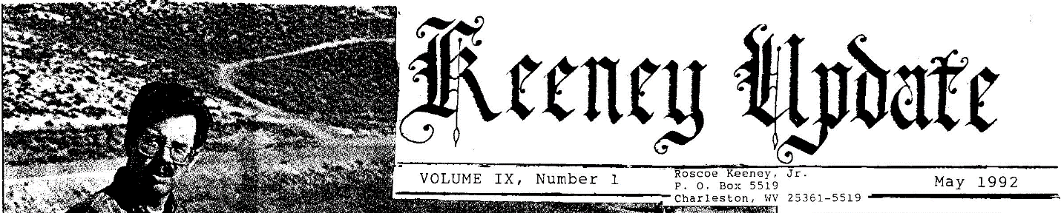
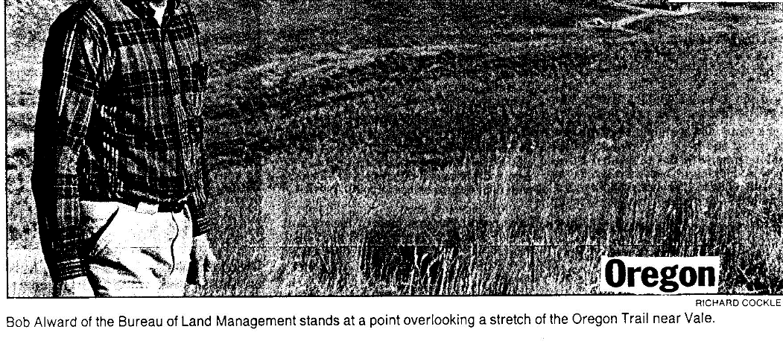

Restored piece of Oregon trail makes pioneers’ crossing vivid
  - The rutted stretch of land near Vale offers a Vista of a day’s span of ox-drawn wagon travel in the 1840s
by RICHARD COCKLE
Correspondent, the Oregonian

VALE-standing atop a block near the southeastern Oregon farming town of Vale, Bob Alword points to the worn wagon ruts.
“The Oregon trail is sometimes said to be the longest graveyard in the world.” Said Alward, a US Bureau of Land Management recreation planner.
This spot, known locally as Keeney Pass, may be unique in the nation. From it, a visitor can see the route of a whole day’s wagon journey pioneers came to Oregon 150 years ago.
And the land looks remarkably as historians think it did when ox-drawn wagons made the arduous 2170- mile trek that some believe claimed the lives of one pioneer and 10.
“This stretch could serve as a typical day across the high desert plains,” said Alward. “It was a long, dry, typically dusty trek.”
The time capsule affected Keeney Pass is enhanced because the BLM has replanted the native grasses.
In fact, the BLM interpretive site at Keeney Pass may look better now than it did 150 years ago, because the pioneers oxen, horses and other livestock are not cropping the grasses down to bare dirt, said Angel Dawson, a BLM archaeologist.
“It was noted in diaries as a hot, dusty pull up this hill and down the other side,” Dawson said. “However, there are not many places left as such intact ruts and largely unchanged vistas, where you can appreciate just what consisted of one day’s travel.”
From the interpretive site, visitors can see the place where the covered wagons across the Snake River at Old Fort Boise to the southeast, said Alward. To the north is Malheur Crossing on the Malheur River, near the hot springs where Vale now stands.
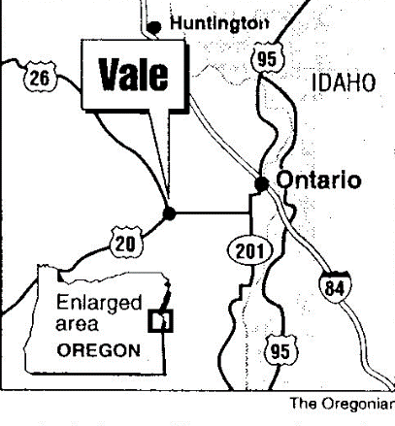
Historians say only about 10% of the original pioneer route to the Williamette Valley from Independence, Missouri, has survived the ravages of time. The most common destroyers of the historic ruts been pipelines, roads, agriculture and subdivisions.
BLM crews recently redesigned the interpretive site and rebuilt the structure that was losing its roof to rot, Alward said.
Last summer, crews burned 5 acres at Keeney Pass as part of a plan drawn up by Gene Findley, the district’s botanist, to restore native vegetation.
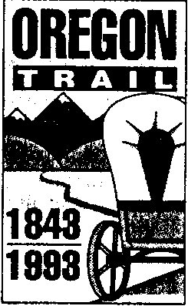
“Even though most of the grass disappeared with the first wagon trains of the season, we felt that it was important to show visitors what these Eastern Oregon steppes looked like,” said Findley. “We used the burn to get rid of introduced species and other weedy types and replanted the area to Indian rice grass, giant wildrye, sagebrush and rabbitbrush.”
For color, BLM workers added wildflowers, including penstemon and Indian paintbrush.
New interpretive panels will be in place this spring to complete the effort, said Alward.
The Oregon Department of Parks and Recreation, Malheur County, a Boy Scout troop from Ontario and students from nearby Nyssa also helped the $45,000 project, he said.
Refurbishing efforts are planned at other segments of the Oregon trail this year as well. Between Vale and Farewell Bend, BLM crews will add interpretive signs at Tub Springs and Alkali Flat and will improve access by installing cattle guards where gates now stand, Alward said.
At Birch Creek, just south of Farewell Bend, a new interpretive sign is being developed. And plans are in the works at Echo Meadows, 20 miles west of Pendleton near Interstate 84, to improve parking, add interpretive signs and construct a footpath to a small overlook.
The BLM also is helping in the construction of the $10 million National Historic Oregon Trail Interpretive Center near Baker city.
Scheduled to open May 25 and attract 200,000 visitors a year, it is among the biggest building projects in the BLM’s history. It will open a full year before most of the national 1993 Oregon Trail Sesquicentennial celebrations take place.

Briefly
ROSCOE NOTES: I’ll be doing research in Nashville in early June as well as at the National Archives early July. I’d like to find solutions for many requests, but don’t count on it!

VISITORS: Frederick C. Keeney, of Jackson, TN, with ties all the way back to Alexander Keeney, plans to stop by in a few days and compare records. David Raese, of Kent, W A, now living in the Philadelphia area, by shared the fantastic family record he is assembling on the David Jackson Keeney family. “Jack” was David’s great-great-grandfather, was sheriff of Jackson County, WV and a delegate to the West Virginia constitutional convention in 1863. From information carried in the last UPDATE, David located the graves John B. & Rachel Keeney, “Jack’s” parents, near Ripley.

REPORTERS: thanks to Keeney kin in Iowa, Virginia, Idaho, Indiana, Arizona and Maryland for sending information for this UPDATE. This is how we can help each other.

MISSOURI WEST: material is almost ready for publication covering the Michael Keeney/Nancy Ann Wiley family, starting in East Tennessee and continuing in Cass County and other nearby counties in Western Missouri. Offsprings of this family are invited to add their bits of Keeney history.

VOCATIONAL: editor Roscoe is associate pastor of Kanawha City Baptist Church, Charleston, as of May 1, working with a live wire pastor, Ron McClung. Duties vary from day to day, with a major emphasis on visitation and Bible teaching. Drop ins are always welcome.

JOHN WILSON KEENEY FAMILY:
Dixie Dent Walker, granddaughter of John Wilson Keeney (P. 86 KEENEY relatives) reports the following deaths: Harold E. Keeney, St. Petersburg, Florida, age 89, 13 March 1991; Mildred (Bea) Keeney Foster Goodman, age 85, 5 September 1991; Rufus Lee Keeney, died 1990 in California; John Keeney, brother of Rufus, died in Hawaii 29 January 1991.
MAIL CALL: Jeanne Irene Keeney Panzer, daughter of James H. Keeney of Kentucky (p. 5, Dec. ’89 UPDATE) is now confined to a nursing home at 215W. 6th St., Cookeville, TN 38501; she will be 93 August 27 and loves mail. Her husband, David A. Panzer, was born 11-1-1891 in Romania and died 10-12-1988 in TN.
There are three Panzer daughters: Marjorie Miller 5-7-1919, m. Harold J. Kumerow; Eileen Hazel, b. 12-30-1920, unm. and lives in Cleveland; Jeanne Marie 2-7-1936, m. Paul Kerwin. One son, Doctor James D. Panzer, b. 9-17-1930, M. D. In Cookeville, TN where he specializes in dermatology and allergies. He marries Jane J. Borreson.
Grandchildren are Margaret E. Kerwin, b. 2-4-1971, Heley Allison Panzer, b. 3-22-1964, and Hadley Alexis Panzer, b. 3-4-1961. Hadley has worked recent summers in the white water rafting recreational program on the new River in West Virginia.
Mrs. Panzer was born at Olive Hill, KY and was raised by relatives in the Cleveland, Ohio area. She did not know her full name until the John C. Keeney family was listed in the UPDATE.

DEP chief takes 1st Rock tour
by Barry Collins
Register Correspondent

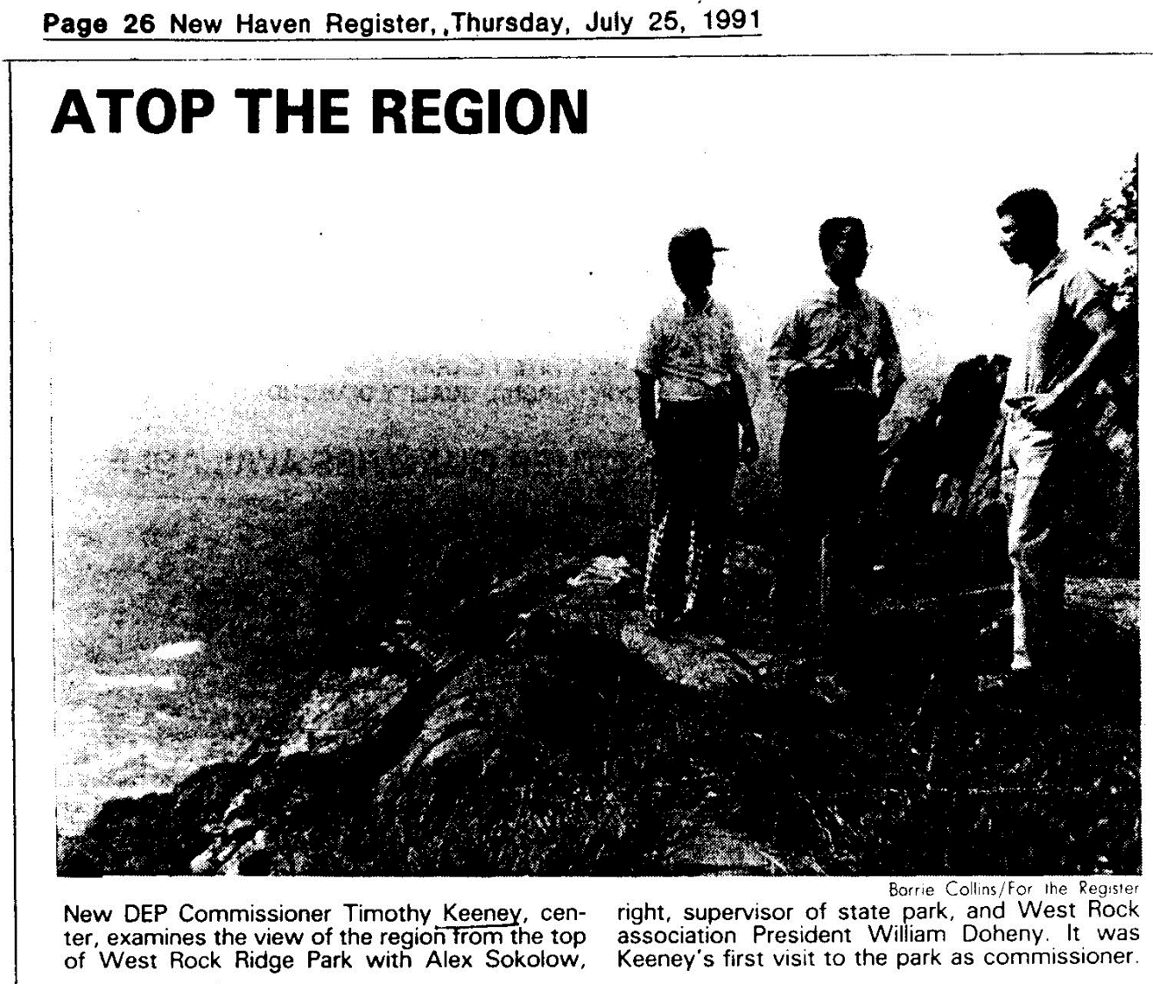

Funding for state parks and other conservation needs may be in for some rough sailing in the current fiscal year, but there’s a strong new hand on the tiller at the State Department of Environmental Protection.
On his first visit to West Rock Ridge State Park recently, Commissioner Timothy Keeney pledged to push for release of authorized money and seek out innovative ways to meet his departments multiple responsibilities, including state parks, air and water quality improvements and boating safety.
“I want to work on the DEP having the resources to do its job,” Keeney said as he surveyed Long Island Sound, New Haven and its vast wooded suburbs from the clifftop look out on the summit of West Rock. Keeney’s visited the six-mile-long ridge, to see some of the parks unique features and review its needs.
Later, at the West rock Ridge Association’s reception for Keeney with area legislators and local officials, the Commissioner outlined his priorities, including:
- pushing for release of previously authorized land acquisition on, “we’ve got $18 million in the pipeline,” Keeney said, “and were going to go after it.” Release of $2 million a month would enable the D P to “start moving” on a plan while land prices are a relative bargain, he said.
- Seeking $2 million from the private sector to improve Connecticut’s heavily used shoreline parks. Corporate help headed off area state Park closing this spring, he noted. While Park user fees were increased last year, Keeney said, “they’ll never cover all costs. The state has an obligation to operate the parts.”
- Cleaning up water in Long Island sound in revitalizing its recreation fishing in cooperation with New York.
A federal study with recommendations is due in January. “The sound is probably the most beautiful natural amenity Connecticut has,” Keeney said. “Everyone’s within 1 to 1 ½ hours of it."
- Reducing the DEP backlog of air, water and disposal permits.
West Rock Association President William Doheny told Keeney the park is incomplete because the ridge’s northern end, under intense development pressure, isn’t protected within the park. The state hasn’t released $1.2 million in bonded West Rock funds for several years, even for two contracted parcels, he said.
Acquiring key land at the north end is critical to protecting the integrity of the “Blue Trail” connection with Sleeping Giant State Park and the “feel of wilderness” there, Doheny said.
Meanwhile, the association plans to encourage groups to make appropriate use of the park for jogging, cycling, hiking, fishing and nature study, among other things. It will also seek federal historic register status for Judges’ Cave, where two English judges hid after condemning Charles I to death in the 1600s. Park funds are also needed to restore more of the summit drive, Doheny said.
Keeney, a Somers native, returned to the state after 15 years at the federal level (including coastal management), at a cut in salary. A key attractant is Connecticut’s high environmental awareness, he said.

RICHARD M. KEENEY
313 Rue St. Peter Metairie, Louisiana 70005
HOME (504) 833-5025

Dear Roscoe:
I’d like to update you with my family to let you know what is happening for your next “Keeney update” printing.
My father, eleventh generation Cecil Madison Keeney, son of Grover Cleveland (Runt) Keeney still resides in New Orleans, Louisiana.

I married Constance Diane Lampos and fathered two children: Sean Madison Keeney born June 10, 1970, and Amy Michelle Keeney born April 19, 1976. Constance (Connie) and I have since divorced and I remain unmarried at this time. Sean is attending Vanderbilt University and will graduate in May, 1992 with honors in Economics and Business. Amy is in the 10th grade (and beautiful).

Thanks for keeping us up-to-date. Please add me to your mailing list using the above address. Thank you in advance.

Yours truly, Richard M. Keeney

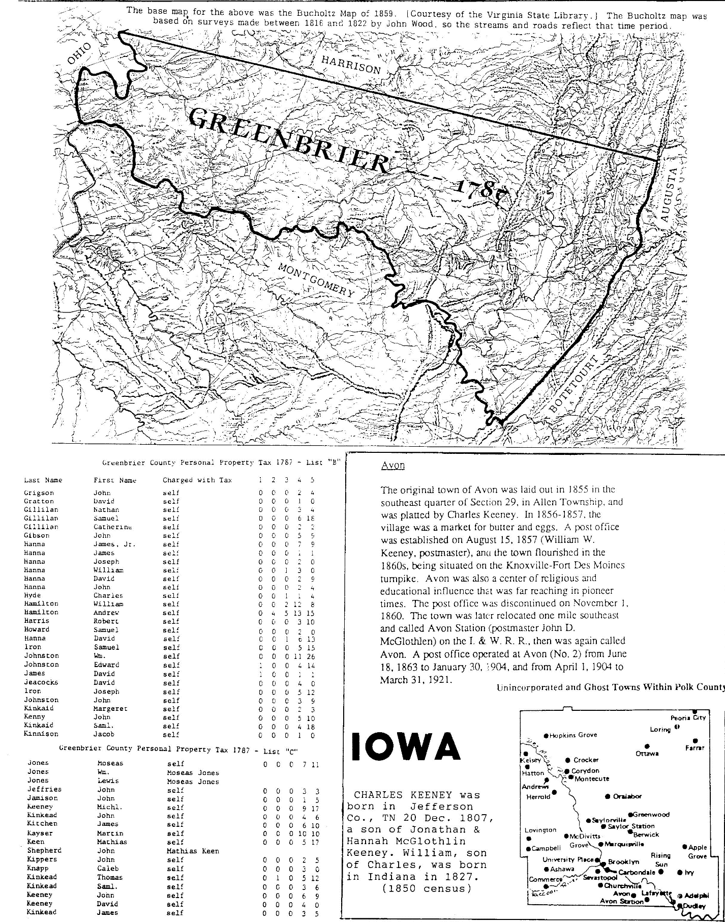

FAMILY RECORD
Page A2 CARROLL COUNTY TIMES
  - MARYLAND

Clara Jane Grossnickle 62, of near Westminster
Clara Jane Grossnickle, 62, of Salem Bottom Road, near Westminster died Friday, April 10, 1992, at Johns Hopkins Hospital after a brief illness.
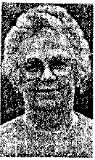
Born July 15, 1929, in Frederick County, she was a daughter of the late Ephriam Eli and Margaret E. Smith Keeney. She was the wife of the late George Thomas Grossnickle, who died in 1972.
Grossnickle was a member of the Union Bridge United Methodist Church. She was formerly employed with each. L. Hearts and the Union Bridge Clothing Company for 20 years. She retired from Joseph A. Bank in 1991. She was an avid bingo player, patronizing various local fire companies.
Surviving are two daughters, Linda Joy of Mount Pleasant and Susan Hoff, with whom she resided;
sisters Miriam Reynolds of Baltimore, Annie Muller of Middleburg, Margaret Main of Orlando, Florida, Catherine Johnson of Johnsville and Nina Martin of Taneytown; and three grandchildren.
Funeral services will be held at 11 AM Monday at the Union Bridge Funeral Home of D. D. Hartzler, with her pastor, the Reverend Dwight Sheesley, officiating. Interment will be in the Beaver Dam Cemetery. The family will receive friends at the funeral home Sunday, from 2 to 4 PM and 7 to 9 PM. Memorial contributions may be made to the Rocky Ridge Volunteer Fire Company, Rocky Ridge, M.D. 21778 or to the Union Bridge United Methodist Church, PO Box 460, Union Bridge, M.D. 21791.

  - IOWA
Nellie Holtz

Nellie L. Holtz, 92, Maquoketa, died Saturday, March 7, 1992 and University Hospitals in Iowa City.
Funeral services were held Monday, March 9 at 10:30 AM at Haylock-O’Hara & Lahey Funeral Home in Maquoketa with the Reverend Belva Duncan of United Church of Christ officiating. Burial was in Mount Hope Cemetery, Maquoketa.
Visitation was Sunday, March 8 with a Pythian Sisters Service held at 7 PM.
Mrs. Holtz was born March 26, 1899 in Andrew to John H. And Mary Kimball Keeney. She married Ben Holtz on January 3, 1917.
She worked at the Tot Shop, Bill Molers and other Maquoketa stores as a clerk before retiring in 1972.
She was a member of United Church of Christ; a 50-year member of Pope Rebecca Lodge # 136 and a 60-year member of Pythian Sisters # 138, all of Maquoketa.
Survivors include three grandchildren and eight great-grandchildren.
She was preceded in death by her husband; two daughters, Maxine Campbell and Donna Said; one infant son; one grandson, Jack Lee Campbell; two brothers and one sister.
A memorial fund has been established.
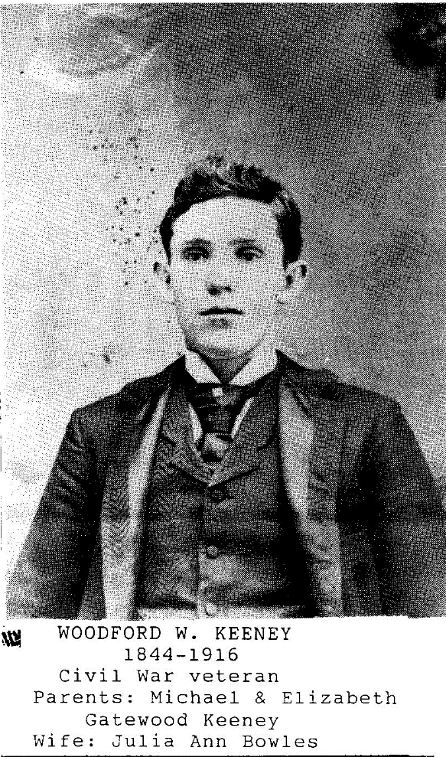
Hobart W. Paul

Hobart W. Paul, 74, of 2010-B DuPont Avenue East, Belle, died December 25, 1991 in General division, CAM C, after a short illness
He was retired painter at Young’s Developers. He was a member and deacon of Witcher Baptist Church. He was an Air Corps veteran of World War II and lifelong resident of Belle.
Surviving wife, Doris Keeney Hall; sons, Don of South Charleston, and Charlston, brother, C. B. Of Melbourne, Florida; sister, Sayeola Underwood of Tad; two grandchildren.
Service will be 1 PM Saturday Witcher Baptist Church with the Reverend Charles Prouse officiating. Burial will be in Witcher Cemetery. Friends may call after 7 PM today at the Fidler-Frame Funeral Home, Belle, and one hour prior to service at the church.

Keaney, Margaret

In Southington, May 6, 1991 Mrs. Margaret (Schmidt) Keaney, 84 of 408 Main St., Southington, mother of James A. Keaney, of Cheshire, also survived by a granddaughter.
Funeral services will be held Saturday at 10 AM in St. Peter’s Episcopal Church, Main St., Cheshire, with the Reverend Stephen Fales, Rector officiating. Burial will be in St. Peter’s Cemetery, Cheshire. Friday from 5 to 8 PM.
Connecticut
New Haven Register,
Wednesday, May 8, 1991

Donna Said

Donna Mays Said, 65, of Maquoketa, died Sunday, August 11, 1991 at St. Luke’s Hospital, Davenport.
Funeral services were held Tuesday, August 13 at 10:30 AM at Haylock-O’Hara & Lahey funeral home in Maquoketa with the Reverend Belva Duncan officiating. Burial was in East Iron Hill Cemetery.
Visitation was Monday, August 12 from 3 to 5 PM and from 6 to 8 PM at the funeral home. A memorial fund has been established.
Mrs. Said was born May 9, 1926 in Maquoketa to Ben and Nelly Keeney Holtz. She married Edwal Said
on July 26, 1942 in Kahoka, Missouri.
The couple farmed north of Maquoketa for 38 years.
She was a member of United Church of Christ, Maquoketa, and a past member of Pythian Sisters.
Survivors include her husband of Maquoketa; one daughter Diana (Mrs. Steve) Ketelsen of Clinton; two sons, David and Dennis Said of Rockford, Illinois; eight grandchildren and her mother of Maquoketa.

  - Illinois

Roscoe Keeney
FIELDON-Roscoe Jr. Keeney, 63, died unexpectedly at 11:38 AM Tuesday, April 30, 1991, at Jersey Community Hospital in Jerseyville.
He retired in 1987 of the carpenter from Alton Local 377, after 32 years of service.
Born in Alton on December 7, 1927, he was the son of the late. Roscoe and Gretchen (Barnett) Keeney.
He and the former Marianne Tinsley were married on December 9, 1950, at Davenport, Iowa.
Surviving are his wife; two daughters, Cindy McKinney of South Roxana and Sheila Fernandez of Colorado Springs, Colorado; five sons, Barry Keeney of Alton, twins Bruce and Michael Keeney, both of Bethalto, Russell Keeney of Cedar Rapids, Iowa, and prayed Keeney of Fieldon; nine grandchildren; three sisters, Louise Ehr of Monrovia, California, Arlene Moore of Bethalto and Genon Mayfield of Glendale, Arizona; and a brother, Leroy Keeney of Bethalto.

Anna W. Jacobs

Anna Winebrenner Keeney Jacobs, 92, Marmet died February 26, 1992, at Marmet Health Care Center.
She was a lifelong resident of Charleston.
Surviving: three grandchildren.
Private service will be held at a later date. The body was donated to Marshall University Medical School. Milton Funeral Home is in charge of arrangements.

MRS. PAULINE KEENEY SNEED

Born July 12, 1920
Died March 25, 1992
Survived by
Son, Rev. David Allen Sneed; sisters, Adrian Tincher and Judy Short; stepbrother, Richard Harrison; two grandchildren, Jonathan D. Need and Leah Carla Sneed.
Services from Witcher Baptist Church

Mrs. Pauline K. Sneed

Mrs. Pauline Keeney Sneed, 71, of Charleston, formerly of Witcher, died March 25, 1992 at Marmet health care Center after a long illness.
She was a native of Witcher in a lifelong resident of Kanawha County. She was a member of Evans Memorial Baptist Church and Ladies Fellowship Class. She was a former employee of Frankenbergers, Episcopal Diocese of West Virginia and Salisbury, Hackney and Lapinski Law Firm.
Surviving son, the Reverend David Allen of Hico; sisters, Adrian Tincher of Charleston, Judy Short of West Palm Beach, Florida; two grandchildren.
Service will be 1 PM Saturday Witcher Baptist Church with Reverend David Sneed officiating. Burial will be in Witcher Cemetery, Belle. Friends may call from 7 to 9 PM today Stevens-Grass, Malden, and from 10 AM to service time at the church.

Mrs. Sylvia Keeney

HURRICANE-the Sylvia Keeney, 62, of Rte. 3, Box 106, Hurricane, died April 16, 1990, at Thomas Memorial Hospital South Charleston after a long illness.
She was a homemaker and a Baptist. She was a native of Hughes Creek.

Surviving: sons, Rufus of Ansted, Floyd California, David of Nevada; daughter, Diane Keeney of California.
There will be no service or visitation. The body was cremated. Cooke Funeral Home, Cedar Grove, is in charge of arrangements.

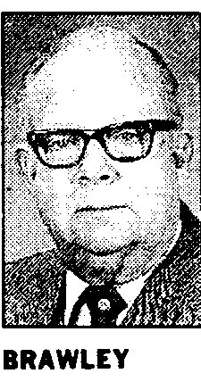
WV

  - City historian Brawley dies
By KAY MICHAEL
DAILY MAIL STAFF
Harry Brawley- an educator, a broadcast pioneer, former city councilman and Charleston’s best-known city historian-has died at the age of 82.
Brawley died Wednesday at the Dunbar Health Care Center.
His death came about three weeks after he suffered a stroke in his South Hills home.
“It’s a tremendous loss, not only to his family but to the community,” Brawley’s friend and former colleague, Joe Farris, said Wednesday.
“But he left a legacy. He was a veritable bottomless pit of information about the history of Charleston.
“And because of his background in radio and television, who but Gary Brawley think to preserve that history on five videotape? His legacy is that collection at the library.”
Brawley never tired of speaking to groups about the history of the valley. His “Old Charleston” slide presentation became a kind trademark.
Born in Charleston, he was struck by polio as a child. It was a time when polio victims-mostly children-rarely dreamed of walking again.
Brawley had no time for self-pity. He told friends he was lucky that his family had the means to get him the best medical care available, and the grit to insist that he keep moving.
It paid off. Until his later years, Brawley relied only on a cane for mobility.
He went on to receive bachelor’s and master’s degrees from West Virginia University, become a teacher, and married his college sweetheart, Betty Carson.
In the 1940’s, he joined WCHS Radio as public affairs director. He took his love of teaching with him. And when the station television station when on air, Brawley’s duties expanded.
It was Farris, a veteran of WCHS and current member of the State House of Delegates, who dubbed Brawley West Virginia’s “dean of political analysts.”
As election time rolled around, Brawley was in charge of political programming and debates. And he was generally on target when he predicted the outcome of a race.
Bos Johnson, retired WSAZ television news director, knew Brawley is a friend and a competitor.
“He has to be considered the father of educational broadcasting in this state,” Johnson said. “He convinced us commercial station that had to do education. Not just entertainment. But flat-out education…
“He got a public broadcasting commission going, then structured the beginnings of public television stations in the state. The first one was in Morgantown and the second was in Huntington/Charleston. That was the way he had envisioned it.”
Johnson said Brawley was enough of an educator to know the television had an obligation to teach, and enough of a politician to know how to persuade the governor and Legislature to shell out money needed to get public stations on the air.
Brawley left WCHS to become the first executive director of the West Virginia Educational Broadcasting Authority in 1965. He left the authority in 1972, after laying the foundation for the state’s network of public radio and television stations.
Once retired, he had time for public service. He ran and was selected to Charleston City Council.
He was a lifelong Democrat. But his friendships crossed party lines.
Former City Attorney John Charnock, a Republican, said Brawley set a standard for public service.
“If any councilman can equal his service, that will be in the best interests of the city.” Charnock said late Wednesday, after learning that Brawley had died. “He was loyal and faithful, no matter who the mayor was-Democrat or Republican. He wanted what was in the best interests of the city.
“He was a leading vote getter and the partisan end of it didn’t faze him. He didn’t care about a person’s affiliation. He loved the city.”
Brawley began to curb his activities a little when he suffered a stroke about seven years ago. He spent most of the past few years confined to a wheelchair. But his wife, Betty, saw to it that he kept his civic commitments.
Charles Byrd, who was a member of Charleston Lions Club with Brawley, said he was impressed by the unobtrusive way, Betty Brawley accompanied her husband to meetings, left quietly, then returned at the end of the luncheon sessions to take him home.
Boz Johnson said he, too, was touched by the Brawley’s partnership.
At the end of January, Johnson was honored by state broadcasters for his years of service.
“Betty wheeled him in,” Johnson recalled. “When I saw them there, I had tears in my eyes. That was the nicest tribute I got.”
Brawley’s list of accomplishments is long. And he relished each accolade.
He was pleased several years ago when city officials named a downtown walkway from Charleston Town Center to Capital Street in his honor.
He has been recognized by Lions Sight Foundation, and has resigned Distinguished West Virginian Awards from former Governor Arch Moore, former Governor Jay Rockefeller and the West Virginia Broadcasters Association.
A news film library at the West Virginia Cultural Center carries his name.
He was a part-time instructor of Morris Harvey College (now the University of Charleston) for 46 years, and he taught Sunday school class at the Village Chapel Presbyterian Church in Kanawha City.
Brawley was first president of the Community Council, president of the Kanawha County Teachers’ Association, charter member of the Anvil Club, first chairman of the West Virginia Medical Eye Bank; chairman of the Kanawha County Public Assistance Council, president of the Charleston Open Forum, district governor of the West Virginia Lions, and a driving force behind the Charleston-Kanawha Bicentennial celebration in 1988.
Until his most recent illness, he continued to write historical articles for Goldenseal Magazine.
In addition to his wife, he is survived by his daughters, Sara Stebbins of Alexandria, Virginia, Harriet Nottingham and Ann Reeves, of Charleston; a sister, Mrs. Virgil Frizzell of Charleston; nine grandchildren; and one great grandchild.
Service will be 11 AM Saturday at Village Chapel Presbyterian Church with the Reverend W. F. Mansell Jr. officiating. Burial will be in Spring Hill Cemetery.
Friends may call from 2 to 4 PM and 7 to 9 PM Friday at Barlow-Bonsall Funeral Home. The family suggests donations to the West Virginia Educational Broadcasting Authority, 600 Capital St., Charleston WV 25301, or to Village Chapel Presbyterian Church.

Kathyrn J. Heineking
SHELBY-Kathyrn J. Heineking, 77, of 83 Raymond Ave., died Saturday afternoon Crestwood Care Center following a lengthy illness.
Born in Hollister, Ohio, September 12, 1912, to George and Adda Zimmerman Price, she had been a Shelby resident since 1951.
Mrs. Heineking was a member of the First United Methodist Church of Shelby, where she was a Sunday school teacher and choir member. She was also a member of the Christian Business Women’s Association, Shelby Business and Professional Women’s Club, and the Ohio Genealogical Association.
She was a 1931 graduate of Mansfield High School and co-owner of Shelby Home Appliance more than 20 years, retiring in 1976.
Survivors include a son, Bruce Heineking of Columbus; two daughters, Malinda Heineking of Arlington, Virginia and Sharon Sbrissa of North Miami Beach, Florida; six grandchildren; five brothers, Robert Price of Sacramento, California, Russell Price of Sandusky, George Price of Mansfield, Lewis Price of Detroit, Michigan and Harper Price of Davenport, Iowa; and two sisters, Mae Wagner of Heath, Ohio, and Mary Letizia of Mansfield.
She was preceded in death by her husband Robert Heineking in 1987; a daughter, Janice Laddm: Four brothers, John, Earl, Paul, and Carl Price; and one sister, Ruth Beechler.
Calling hours are from 3 to 5 9 PM Tuesday at the Barkdull Funeral Home. Services will be held at 10:30 AM Wednesday at First United Methodist Church by Dr. Carl G. Beighley. Burial will be in Oakland Cemetery.
Memorial contributions may be given to the church in care of the funeral home.

HARRY BRAWLEY was a great great grandson of Moses and Frances Harris Keeney and the great-grandson of their daughter, Frances Keeney and William S. Brawley. His mother was carried J. Harless, granddaughter of Foster H. Keeney, brother of Frances.
CATHERINE J. HEINEKING was a granddaughter of Stephen S and Catherine Keeney (1834-1917) Price and the great-granddaughter of John C. and Sara F. Keeney. Her parents, George Harvey & Patty Zimmerman Price, died in 1945 and are buried in Mansfield, Ohio.
PAULINE KEENEY SNEED was the second daughter of Emery S. & Hannah Bonham Keeney and a granddaughter of Reverend Thomas Y. Keeney.
SYLVIA HORNSBY KEENEY was the wife of Rufus L. Keeney, who died recently in California. (P. 86 Keeney Relatives)
ANNA W. KEENEY JACOBS was the wife of Jerry Wilford Keeney (1896-1950), of Cabin Creek, and the mother of Millicent Keeney Richards and Jack W. Keeney, both deceased (P. 20, Keeney Relatives).

ANGELS: Contributors paying for this issue of the UPDATE: Juliana C. Cole, FL $25, Robin Teagarden, FL $25; Hartford N. Price, IL $25; Joyce Hoffman, WV $20; and $10 each from Dorothy Summers, WV; Marion Moeller, Iowa; Mrs. James Forster, CA; and Bruce Froman, ID. Also Patricia Foulke Kaufman, OK $25.

MARYLAND
COLONIAL FAMILIES OF THE UNITED STATES
Steiner
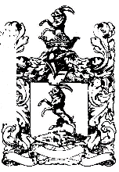
HENRY STEINER, Captain (deceased), b. In Frederick, Maryland 23rd June, 1775 d. 18th May 1825; organized “Steiner’s Battery” of Artillery, which he commanded in the War of 1812; m. 20th May, 1806, Rachel Rebecca Murray, b. 17 June 1784; d. 27th June, 1850, Cincinnati, Ohio; daughter of John and Rebecca (Colegate) Murray of Maryland.
ISSUE ALL b. IN FREDERICK, MD.
- Henrietta, b. 3rd May 1809; m. In Baltimore, M.D. 29th of December 1834, Reverend T. P. C. Shelman, b. 12 February, 1811; d. 6th December 1882i: son of Michael and Sarah Maria (Bostwick) Shelman.
  - Henry Steiner Shelman, b. 6th October, 1835.
  - Margaret Jane Shelman, b. 9th October, 1836; d. 27th December, 1854.
  - Michael Shelman. b. 1st of October, 1838; d. 18 July, 1857.
  - Rachel Rebecca Shelman, b. 22 March, 1840; m. (Firstly) 17th August, 1857. John M. Miller, 9th January, 1821; d. 16 January, 1865; (secondly) seventh July, 1869, Captain William P. Van Dorn, b. 29th of April, 1835; d. 11 June, 1894.
ISSUE BY 1st m.
1². Henrietta Shelman Miller, b. 24 June, 1857; m. 28 to June, 1883, Edward B. Jones, b. 13th January, 1857.
2². Betty Orr Miller, b. 6th March, 1859; d. 2nd July, 1873.
3² Ada B. Miller, b. 26th March, 1861; m. 13th August, 1883, Jay K. Keeney, b. 20th July, 1860.
ISSUE
1³. Henrietta Victoria Keeney, b. 22nd June, 1884; m. Second June, 1903, Earl Dunzweiler, b. 16th April, 1883.

ISSUE
1⁴. Edward Richard Dunzweiler, b. 11th July, 1904.

2³. Carrie Appie Keeney, b. 16th February, 1885.
3³. Durbin Metz Keeney, b. 30th November, 1889.
4³. Mary Keeney, b. 27th July, 1892.
5³. Margaret Keeney, b. 6th April, 1894.

KANSAS
FUN IN THE LEGISLATURE
From the Lawrence Daily Journal, March 2, 1881.
The young people of Topeka held the ball in the Senate Chamber on Friday evening, February 25. The ball was a nice affair, and a large number of the members of the legislature were present. At the time, on the other side of the building the house was in session. But here we will let {Noble L.} Prentice, in the Atchinson Champion, described the last recorded freak of the house:
“While senators were attending the scene of ‘revelry by night,’ and their soft eyes were looking love to some extent to eyes which spoke again, as it were, the house was in session and considering sidewalks in cities of the first class, and kindred subjects and other momentous questions. In course of time the house discovered that this was growing monotonous, and that several of its members were absent, indulging in the light fantastic toe, instead of employing their brains in the service of the state. The Sergeant at arms was directed to bring in the absentees, and soon, with a ferocious air, advanced to the bar with Mister {James F.} Keeney of Trego. The apparition of the gentleman in full evening dress, and with a bouquet in his buttonhole, was as startling as if the Sultan of Turkey had advanced down the center aisle to converse with Mr. {John} Schott. Mister Keeney was put through a great variety of ‘motions.’ He was referred to all the committees; he was made the special order; his enacting clause was stricken out; he was laid on the table, and he was, greatly to his relief, finally discharged. Thus the wise virgins of the house kept their lamps trimmed and burning while the foolish Senate maidens gave themselves away.”

Connecticut
Thomas Keeney, a native of Litchfield, Connecticut, which first located at Wapwalopec, came to Wilmot home seeking in 1786, and lived alone the first season and a brush cabin. The next year he brought his family, and in 1788 was arrested as one of the abductors of Timothy Pickering, taken to Wilkes-Barre and kept in confinement all summer. During his absence, a party of men tried to take his canoe and attempted to push it into the river, but Mrs. Keeney hung to the chain with such determination, even after being dragged into the water that the men gave it up and left the brave woman in possession. His daughter, Mercy, in September, 1788, married Richard Keeney, a distant relative, being Wilmot’s first bride and groom. She, like her mother, was a woman of great resolution. On one occasion a party of men had driven a panther up a tree at Rocky Forest, and Mercy, although but 16 years of age, volunteered to stand under the tree and keep the panther up, while the men ran home to get their rifles with which the animal was killed. In 1812, Thomas Keeney sold to John Gamble and removed to Chemung, New York.

Thomas Keeney enlisted in East Hartford Connecticut and served as a private in the Continental troops of the Revolutionary War. A part of the time he served under Captain Bissell and under Colonel Pipkin.
Thomas Keeney made application for pension 11 September 1832 at which time he was 81 years old and resided in Onondaga County, New York his pension was allowed for three years actual service as a private. Doc: NSDAR Nos. 393102, 368-327, 83268 and 88448.
P. 145, Volume 1, Haverly’s Pioneer and Patriot Families of Bradford County, Pennsylvania, is a courtesy of Janet C. Billings, Avon Park Florida

MRS. CORDIE PARSHALL PARK
Born in Richburg, New York
Wife of Irving K. Park
Descendent of Thomas Keeney and of Peabody Pratt.
Daughter of Luther Parshall and Emily Stanley, his wife
Granddaughter of Ransom Parshall and Phyla Chapman, his wife;
Frederick Stanley and Mary A. Pratt, his wife
Great-granddaughter of Asa Parshall and Susanna Keeney, his wife;
Jedediah Pratt and Parma Parker, his wife.
Great great-granddaughter Thomas Keeney and Mercy Lamb, his wife;
Peabody Pratt and Sara Buckingham, his wife.
Thomas Keeney, (1751-1840), was placed on the pension role of Onondaga County, New York, 1833, for three years actual service is private in the Connecticut militia. He was born in Hartford, CT; died in Tioga, PA, and is buried in Chemung, New York
Peabody Pratt, (1757-1824), enlisted as private, 1777, for three years in Captain Martin Kirtland’s company, Colonel William Douglas’s Regiment of the Connecticut militia. He was born in Saybrook, Connecticut; died in Mount Morris, NY.

MRS. EVA W. KEENEY STARK
Born in Pennsylvania
Wife of S. Judson Stark
Descendent of Mark Keeney, Pennsylvania.
Daughter of Ephriam J. Keeney and Elizabeth Nye, and his wife.
Granddaughter of Seth H. Keeney and Mary Wall, his wife.
Great-granddaughter of Joshua Keeney and Phebe Sturdevant, his wife.
Great great-granddaughter of Mark Keeney and Abigail B. Keeney, his wife
Mark Keeney, (1740-1804), had served in the early wars, was a soldier in the Revolution. Born in Litchfield, Connecticut and died in Wyoming County, PA.
DAUGHTERS OF THE AMERICAN REVOLUTION

