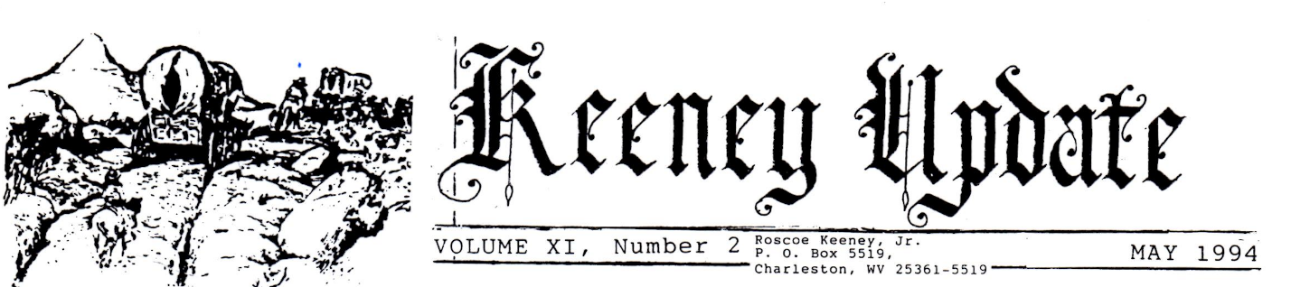

KEENEY BROTHERS IN THE MISSOURI TERRITORY AFTER 1810
Settlers in Saline, Ray and Holt Counties
The JOHN JONATHAN KEENEY family, originating in Greenbrier County, PA (now WV) and expanding into eastern Tennessee, found itself moving westward as the Western states were opened up to settlement about the time of the War of 1812.
The first stop seemed to be Fayette County, IN, where some branched out into neighboring Hendricks and Montgomery County, but some of the Keeney brothers (sons of John Jonathan) sought their fortune along the Missouri River in the NW part of what became the state of Missouri. Settlement took place in Saline County, but more permanent homes were established in Ray and Holt Counties.
The oldest son, JOHN, JR. (1772-1845) was listed on the Ray County tax list and in 1830 and 1840 census. He died in Holt County, as did some of his older sons. Following his death, his wife Mary and the families of most of his surviving children joined to caravans headed West along the Oregon Trail. This family has been documented in detail in WAGON RUTS WEST, a 180-page 1984 publication by Ralph R. Keeney (b. 1923) a defendant who lives in and writes from the Dalles, Oregon.
NANCY ANNA KEENEY, the only daughter listed in the large JOHN JONATHAN family, was born about 1782 in TN and became the wife of John M. Oldham on 25 December 1807 in Missouri. She died in Rives County, MO in 1835.
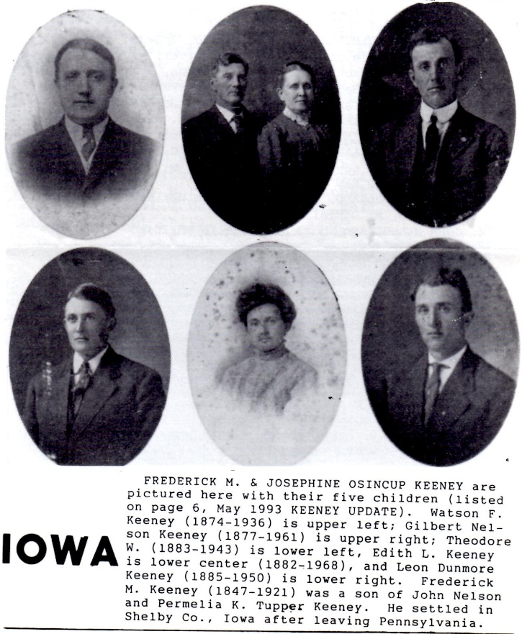
JONATHAN ANTHONY KEENEY (1778-1850), whose family was highlighted in the January 1994 KEENEY UPDATE, apparently made at least one venture to Missouri, but he and his family remained in the Hendricks County area of Indiana, except for those later migrated Polk County, Iowa. Jonathan himself died in Avon, IA. In 1850, soon after his arrival there. His oldest son, JOHN HIRAM KEENEY, spent 6 years in Missouri before returning to the Keeney family 320 acre farm in Hendricks County, IN.
JOSEPH DAVID KEENEY, brother of John, Jonathan, Mary and others, died intestate in Richmond in Ray County, Missouri. In 1837 and probate records show that his estate was administered by brothers John and James. Joseph married Susan Tromley in Ray County on 17 June, 1836.
THOMAS KEENEY, who received 80 acres from Gabriel Pruitt in Saline County, Missouri on 20 September 1822, and his wife Nancy applied for dismissal from their Indiana church on one. October 1814 and were on the very first wagon to appear in Saline County, in 1816. He had sold his Indiana land to his father and brother. He and a Rev. Peyton were reportedly the first preachers to settle in Saline County.
Another brother, JAMES KEENEY, has a place in Lafayette County, MO history (p. 213) as follows:
from Lafayette County marriage record:
the first marriage in the county is a curiosity and we copied verbatim et spelatim, etc.
Lillard County, know ye, to home it may concern that this 8th day of February 1821, was joined together in the holy state of matrimony James Keeney and Annie Ramsey by me.
Jonathan Keeney, G. M. (Gospel minister)
this James Keeney, according to daughter Elizabeth Pierce, built a dam in Tennessee across the Chickamauga River, used by troops during the Civil War. He was born about 1780, in Tennessee and was drowned in 1841, fording the river near Paducah, KY. 10 children born to James and Annie in their short marriage. Annie remained a widow until her death 17 July 1899.
The Iowa genealogical Society and Mormon sources list MICHAEL KEENEY, who married Nancy Ann Wiley, as another brother in this family, but other sources listed as a son of Thomas, a brother of the first John Jonathan. This family, which settled in Cass County, Missouri, was listed in detail in the previous issue of KEENEY UPDATE.
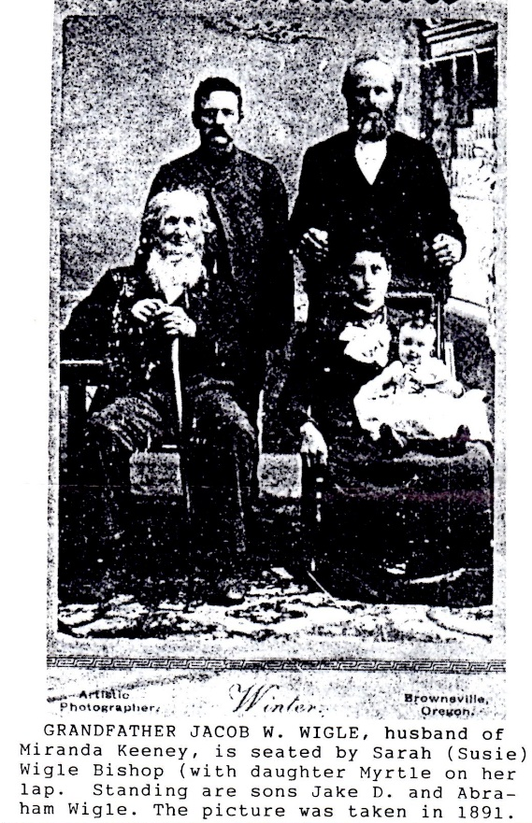
New Garden is located near the western border of Ray County, about 4 miles east of a little north of Excelsior Springs. In 1842. The New Garden Primitive Baptist Church was organized with 15 members, all of letters from Big Pigeon Baptist Church Cocke County, Tennessee. No doubt they were all Keeney’s or Keeney family members. There was a legend for many years that the church was known as the Church of the Lost Child. This region has been explored by Lewis and Clark on their exploration to the West and Ray County was formed from Howard County in 1821. Its principal stream is called Crooked River, with several creeks as tributaries. KEENEY CREEK is one of these.
Prior to their coming to Missouri the Keeneys had been members of the New Bethel Baptist Church in Fayette County, IN and had organized the Big Bottom Baptist Church in Saline County, MO. In these churches. Thomas Keeney made efforts to be ordained; records show that he was given the "privilege of exhorting" and the opportunity to “exercise his gift”. In Tennessee and Indiana. His wife, Nancy, was also mentioned as a member of the church.
Missouri Valley KEENEYS not previously listed by family in KEENEY UPDATE:
2. THOMAS KEENEY, born circa 1780 Cocke County, TN; died, c, 1846 in Holt County, MO; probate files 18 April 1846 and Probate Court, Polk County, by Lavina Keeney; listed as minister and ferryman
m. (1) Nancy Fugate, believed to be a daughter of John & Eleanor Morgan Fugate, RES. In Cocke County, in the early 1800s (born 1780, died 1832); mother of first 6 children of Thomas Keeney
m. (2) Lavina (Levina, Lovina) Ainsworth, mother of 2 daughters born much later than the others; Lavina m. Henry Fellows on 12, December 1848 after the death of Thomas; 1850, Polk County census shows Henry, Lavina and Amanda Keeney as a household
3. MARTHA KEENEY (Patsy), b. 11 Jan 1806 in TN; d. 22. September 1879 in Lane County, OR; m. Edward
Mulholland 10 October 1827 and Ray County, MO
4. ELIZABETH MULHOLLAND, b. 4. November 1825, drowned 3. February 1843 while crossing Missouri
River; married Andrew Jackson Keeney, son of John, Junior, on 18 November 1841 in Henry County,
MO; no children
4. THOMAS MULHOLLAND, b. 27. October 1827 in MO; died 18. August 1903 in Inyan Kara resident; m.
Mary Davisson from IN, and 24. August 1848 in Holt County
4. EDWARD MULHOLLAND, b. 6. November 1829, MO; married Marmaret M. 21 September 1854 Lane
County, OR; m. (2) Martha Dick 29 May 1865.
4. NANCY MULHOLLAND, b. 4. April 1833 in MO; died 6 March 1865; m. Daniel Locke
4. JOHN MULHOLLAND, b. 23. January 1836 in MO; died 13 September 1866.
4. MARTHA MULHOLLAND, b. 23. May 1838 in MO; died July 1866; m. William L. Spry 12 October 1854.
4. WILLIAM HENRY MULHOLLAND, b. 1 August 1840 in MO
4. MAMY M. MULHOLLAND, b. 27 October 1841 in MO
4. RUSSELL MORGAN MULHOLLAND, b. 18 September 1844 in MO; d. 18 December 1890; m. Martha J.
Bleu in OR
4. CATHERINE MULHOLLAND, b. 16. October 1848 in MO; m. James P. Milliron 2 January 1865.
3. NANCY KEENEY, b. 1809 in TN, d. 1862 in OR; was the 2nd wife of JAMES KEENEY (b. 20 August 1816
in IN, d. 27. April 1885 in Linn County, OR, son of John Keeney, Junior, and a first cousin of Nancy) on
one of March 1846 in Ray County, MO; Kathryn Stewart, first, wife of James, died in childbirth in 1845
and was mother of Mary E. (m. George Overton) and Sarah; his 3rd wife, Maranda Pearl, was the
mother of Mordecai Keeney (b. 23. November 1878).
Children of Nancy & James:
4. MARANDA KEENEY, b. 1847, m. Jacob W. Wigle (b. 1842 in IL) on 20 December 1865.
5. MARY O. WIGLE, b. 1867
5. SARAH C. WIGLE, b. 1869
5. JAMES E. WIGLE, b. 1874.
5. MARTHA WIGLE, b. 1879
4. IRENA KEENEY, b. 1849-21 in 1870 census
4. MARTHA ELIZABETH KEENEY, b. 1852, d. 1 Sep 1932 at Yakima, WA; m. George Warren 14 January
1884.
3. CATHERINE KEENEY, b. 1814 m. Russell M. Morgan 24 September 1833 in Lafayette County
3. MARY (Polly) KEENEY, b. 18 April 1814, b. 11. June 1875 in Lane County, OR; m. Tolbert Kelley (b. 27.
June 1808 in Wayne County, KY) on 28 December 1842 in Henry County, MO; her father was upset
because Kelley was a Methodist, so the Kelleys moved to Kentucky in 1848; Mary stayed there until her
husband’s death and in 1859 joined a wagon caravan to Oregon, experiencing a storm in which she and
2 children were injured and facing a visitation by Indians
4. ELIAS KELLEY, b. 1844 in MO-15 in 1859
4. NANCY KELLEY, b. 1846.
4. REBECCA JANE KELLEY, b. 1848
4. THOMAS KELLEY, b. 1850 in KY
4. MELINDA ANN KELLEY, b. 1852 in KY
4. GILMORE TOLBERT KELLEY, b. 1855 in KY
3. ELIZABETH KEENEY, b. C. 1815, M. (1. ISLEY KEENEY, a first cousin and son of John, Junior (b. 15. May
1811, d. 6. December 1842) on 29 January 1832 by Rev. Bernie Brown; m. (2) John H. Duncan on 21
April 1850; he died in MO and she went to Oregon; m. (3) Philip Mulkey (b. 1820) in Douglas County, OR
3. MELISSA (MALINDA) KEENEY, b. C. 1818 m. Benjamin Brown 24. February 1842 in Henry County, MO
children of Thomas Keeney & Lavina Ainsworth:
3. LOUISA J. KEENEY, b. 7. July 1842 in power County, MO, d. 20. November 1910; info. Certified death
certificate, State of Missouri; m. Francis Lucy (b. 1825 in IA) on 17 September 1847 in Holt County; m.
(2) William Jefferson Elder, b. 8. August 1829 in Pulaski County, KY, d. 9. September 1901 in Holt
Co., MO) on 14 September 1865.
4. JENNY VIOLA ELDER, b. October 1866.
4. WILLIAM THOMAS ELDER, b. 23 March 1869, d. 9 March 1948, m. Birdie May Roberts
4. JESSIE PERRY ELDER, b. May 1871.
4. ALLEN HOWARD ELDER, b. 28. August 1876, d. 26. October 1960 m. Beulah Payne
4. MARTHA A. ELDER, b. July 1873
4. SAMUEL ELDER, b. August 1878, d. 1958
4. CHARLES ARTHUR ELDER, b. 23 May 1881, d. 17 May 1960 in Los Catos, CA; m. Ida Lunsford on 21
Nov 1900
4. ANNIE ELDER MARTIN, b. January 1884.
3. AMANDA KEENEY, b. 1846; in 1850 census was living with her mother and stepfather, W. H. Fellows;
in 1860 was living with Lydia (age 72) and John (age 51) Gragg in Holt County, MO census m. Joseph
Gandee on 16 June 1864.
2. JAMES KEENEY, b. c. 1780, in Tennessee, d. 1841 fording the river at Paducah, KY
m. Ruth Ann (Annie) Ramsey (b. 15 Jan 1803, d. 17 July 1899) on 8 February 1821 in Lafayette County, MO by Rev. Jonathan Keeney; James & Annie may have returned to TN for a while, since some of the children were born in TN and James died on the return trip to MO; and he was living next door to Mary, widow of John Keeney, Junior, in Holt County 1850 census
3. JONATHAN H. KEENEY, b. 4. Feb1824 in MO, d. 17 Jan 1884 Pilot Rock, Umatilla County, OR; m. Mary
Adeline Lamb (b. 28. Dec 1827 in KY, d. 1885)in 1857. Jonathan and Mary, with 5 children, took an ox
team, and with others (including cousin) crossed the plains to Sonoma, CA; another child was born on
the way. In 1858 they traveled by boat to Portland, from where they went to Lane County, established a
farm. In 1861 they moved east of the mountains to Umatilla County, where Jonathan became a well-
known wool grower. His 3 oldest sons started a ranch near Long Creek, OR in 1874.
4. JOHN HENRY KEENEY, b. 12-1847 in MO; age 52 in 1900 Union County, OR census; wife: Martha E.
(b. 5-1852 in IL)
5. SARAH E KEENEY, b. 1877
5. MARY J. KEENEY, b. 3-1880
5. HATTIE KEENEY, b. 2-1885.
5. LEATHA KEENEY, b. 1-1889
5. MARY KEENEY, b. 10-1891.
4. JOSEPH WATSON KEENEY, b. 1849
4. MARSHALL SHERMAN KEENEY, b. 1 October 1850 in Lawrence County, MO; age 49 in 1900 Grants
Co., OR census; m. Carrie Conger (d. 11-1889) 2-25-1882
5. BERTHA A. KEENEY, b. 9-1883
5. HUBERT C. KEENEY (d. 12 March 1889)
4. MARTHA KEENEY, b. 1851/2
4. JULIA KEENEY, b. 1851/52
4. THOMAS BENSON KEENEY, b. 10 Sep1852 in Jasper County, MO; m. Nancy E. Snoderly on 1 Dec 1882
(she died in 1899)
5. ELSIE FAY KEENEY, b. 4-1882
5. DOROTHY DOTT KEENEY, b. 8-1883
5. JAMES CRITTENDEN KEENEY
4. CALISTA KEENEY HARDESTY, b. 1855.
4. SARAH C. KEENEY JONES, b. 1857
4. CHARLES EDWARD KEENEY, b. 1872; age 48 in 1920 grants County census; lived with employer
Sidney R. Ward; no wife or children listed; inherited major share in his father’s will, probated 22 Jan
1884 in Umatilla County, OR (page 78)
3. ALLEN F. KEENEY, b. 1828; aged 22 in 1850, MO census m. Andrew Kopp 20 Dec 1860 (Mormon
record)
3. MARTHA KEENEY, b. 1829; 21 in 1850 census
3. ELIZABETH J. KEENEY, b. 1830 2m. Charles M. Pierce 3 July 1851 (Mormon record)
4. SARAH E. PIERCE, b. 1852
4. NATHAN E. PIERCE, b. 1854.
4. JOSIAH J. PIERCE, b. 1856.
3. ROSANNAH (Rhoda) KEENEY, b. 1834; age 35 in 1870 Holt County census, living with her mother
3. CATHERINE HANNAH KEENEY, b. 1826 m. Calvin Miller (b. 1829 in OH?)-Holt County 1870
3. JAMES RAMSEY KEENEY, b. 16 July 1839 in Ray County, MO; d. 1 August 1913 at Wadsworth, KS; m.
Nancy Ann RostocK (b. 24. October 1840, d. 17 April 1916 in Oregon, MO)
4. NANCY ANN (Nannie) KEENEY, b. 12. December 1862 in Oregon, MO, d. 22 September 1933, m.
James Ira Stephenson (b. 6. December 1857, d. 17 January 1929 at Willow Springs; on 12 Dec 1879
5. IRVAN G. STEPHENSON, b. 17 January 1883 in Holt County, b. 12 March 1953; m. Ida Belle Green (b.
20 June 1887, d. 7 April 1975) on 8 April 1906).
6. EARL L. STEPHENSON, b. 17 November 1920 at Oregon, Holt County, MO; m. Geneve Childress 8
Dec 1945; lives in Springfield, MO
3. GEORGE KEENEY, b. 1840; age 20 in 1860 Holt County Census
3. LETHA KEENEY, b. 1833; age 17 in 1850 census m. Nathan E. Pierce (b. 1828 in MO) on 27 Dec 1849

THANKS GOES TO THESE KEENEY RESEARCHERS AND OTHERS who have assisted with research for this report: Helen M. Wilson, Sheridan, WY; Rose Smith, Loveland, CO; Elsie Bennett Browning, Lebanon, OR & Ward Cove, AK; Ralph R. Keeney, The Dalles, OR; Sylvia Richardson, Junction City, OR; Earl L. Stephenson, Springfield, MO; census records: Tennessee 1820-1850, Oregon 1850-1920, Missouri 1830-1920; birth and marriage records from Saline, Ray, Holt, Henry and Lafayette Counties, MO and Linn, Lane, Umatilla and Grant counties, OR; and Jefferson County, TN; Missouri Pioneers, Volume 1; Mormon Library; court records, Jefferson County, TH; records of Big Pigeon Baptist Church; Histories of Ray County and Lafayette County, Missouri.

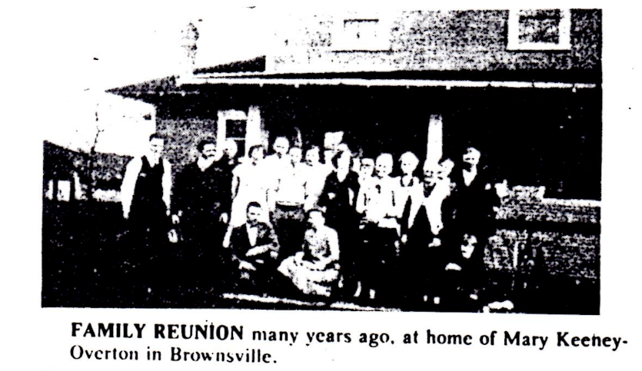
CALIFORNIA UPDATE
IRIS CECIL KEENEY PRIDDY (b. 1912 in Gowen, OK, daughter of Oscar Douglas Keeney, has moved from her home in Bakersfield, CA to a retirement home in Garden Grove. She has recently lost 2 family members by death: a sister, Ruth Elizabeth Barnes on 18 October 1988, and a brother, Oscar Douglas, Junior, of Springfield, OR on 11 October 1993.

There are only 2 lasting bequests we can leave our children. One is roots; the other is wings.
The cheapest way to have your family tree traced is to run for public office.
From “The Sunny Side of Genealogy”
Compiled by Fonda D. Baselt

FAMILY RECORD

William Keeney
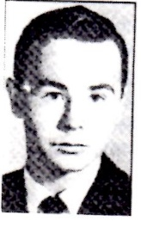
William “Bill” Keeney, 52, Charleston, died December 31, 1993, at home after a long illness.
Surviving: mother, Lillian Hammons Keeney of Charleston, brothers, John Wayne and Robert Norris, both of Charleston; sister, Betsy Elaine Jarrett of Charleston.
Service will be 11 AM Monday at Cunningham-Parker-Johnson Funeral Home with the Rev. Robert W. Burdette officiating. Burial will be in Legacy Memorial Gardens, Cross Lanes. Friends may call from 5 to 8 PM today at the funeral home.

James Morton
James W. Morton, 67, of 117 East Main St., Glenbeulah, died Tuesday, February 21, 1989, following a lengthy illness.
He was born September 8, 1921, in Waynesville, WV, a son of Frederick G. and Nona Keeney Morton. On September 28, 1945, he married Polly Enders in Fond du Lac.
Mr. Morton was a 1940 graduate of Clay County High School and served in the US Air Force from 1942 to 1946. He resided in Glenbeulah where he was employed with Mayhew’s garage until 1957 when he purchased his own garage that he operated until 1978. He was a member of St. Fridoloin Catholic Church, Glenbeulah, the Walter Gillis American Legion Post number 484, Glenbeulah, where he served this past commander, and the Green Glenn Lions Club.
Survivors include his wife; 2 sons, Leonard and his wife Mary of town of Plymouth, and Thomas and his wife Diane of Peoria, Arizona; one daughter, Ruth Reiss and her husband John of Elkhart Lake; 6 grandchildren; stepmother, Evelyn Morton of Lizemore, WV; 3 sisters, Geraldine Ratliff and her husband Howard of Parkersburg, WV, Emogene Stone and her husband Wilson of Lizemore, WV, and Helen Le Mieux and her husband Kenneth of Fond du Lac; 3 brothers, Milford and his wife Mamie of Tallmadage, Ohio, Homer and his wife Phyllis of Lizemore, WV, and Charles of Montgomery, WV. His parents and one sister preceded him in death.
Funeral services will be held Saturday at 11 AM at St. Fridolin Catholic Church, Glenbeulah. The Rev. James Sera will officiate. Interment will follow in Garden of Peace Mausoleum, Sheboygan.
Friends may call Friday after 4 PM to 10:30 AM Saturday at Wittkopp Funeral Home, Plymouth. A visual service will be held Friday at 7 PM. Glenbeulah Legion Post will conduct military services.

Robert L. Keeney Sr.
OAK HILL- Robert L. Keeney Sr., 68, of Oak Hill, died January 4, 1994, at Raleigh General Hospital, Beckley, after a long illness.
He was a native of Powellton, a retired truck driver, and a Navy veteran of World War II. He was a member of the Church of God.
Surviving: wife, Geraldine Keeney; sons, Robert Lee Junior of Harvey, Sammy Joe of Fayetteville, James Douglas of Prudence, Chad of Oak Hill; daughter, Bobbie Woods of Winston-Salem, and the; brother, J. D. Of Deepwater; sister, Mary Davis of Kimberly; 12 grandchildren.
Service will be 2 PM Friday at Gatewood Church of God, with the Rev. Morris Nutter officiating. Burial will be in the Huse Memorial Park, Fayetteville. Friends may call from 7 to 9 PM today at Dodd-Payne-Hess Funeral Home, Fayetteville.

Mrs. LeMieux
Mrs. Helen B. Lemieux, 61, of 479 Marshall Ave., died Tuesday, April 16, 1991, at her home.
She was born January 28, 1930, in Lizemore, WV, A, daughter of Fred and Nona Keeney Morton. On May 28, 1949, she married Kenneth Lemieux in Fond du Lac.
Mrs. Lemieux was employed by Fond du Lac County from 1978 the 1984, and Murray’s Disposal from 1985 to 1989. She was a member of Community Church.
Survivors include 7 daughters, Monica Newton and her husband Dale, Debbie, Kelly and her husband Robert, Connie Schmidt and her husband David, Rebecca Fenner and her husband Thomas, and Lauren Hernandez and her husband Randy, all of Fond du Lac, Jennifer Sturtz and her husband Robert of Van Dyne, and Jodi Ziesmer and her husband Paul of Rosendale; one son, Bill and his wife Dawn of Oakfield; 17 grandchildren; 2 sisters, Jerry Ratliff and her husband Howard of Parkersburg, WV, and Jean Stone and her husband Wilson of Lizemore, WV; and 3 brothers, Milford Morton and his wife Mamie of Tallmadge, Ohio, Homer Morton and his wife Phyllis of Lizemore, WV, and Charles Morton of Kimberly, WV.
She was preceded in death by her husband in 1989, one sister, one brother, her parents and her stepmother.
Memorial services will be held Friday at 4 PM at Community Church. The Rev. William Crawford will officiate. Entombment will be at Shrine of Rest Mausoleum.
There will be no visitation.
A memorial in her name has been established.
Uecker-Witt Funeral Home is handling arrangements.

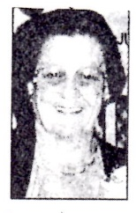
SCRUGGS, Francis-service will be 1 PM Monday at East Nitro Baptist Church with the Rev. Phil Sutter and the Rev. David Wilkinson officiating. Burial will be in Montgomery Memorial Park, London. Friends may call from 2 to 4 PM and 70 9 PM today at Fiddler-Frame Funeral Home, Belle. In lieu of flowers, donations may be made to East Nitro Baptist Church building fund, care of the Rev. David Wilkinson, 605 Sixth St, Nitro, WV, 25143. Mrs. Scruggs, 75, of Nitro, died March 31, 1994, at her home after a long illness.

William T. Wilson
SHERIDAN, Wyoming-William T. Wilson, 83, died after a long illness on Thursday, December 16, 1993, at Memorial Hospital of Sheridan County.
He was born on August 8, 1910, in Newell, SD, the son of William C. and Hannah C. (Milberg) Wilson. He was educated at South Dakota State University in Brookings, SD.
Bill married Mary Helen Miller on November 26, 1933, in Sturgis, SD. Bill spent most of his career in the construction business with Peter Kiewit Sons, Inc. in Rapid City, SD. In 1965, Bill was transferred to Sheridan, Wyoming, where he retired as the vice president of the Kiewit Company.
Bill was a member of St. Peter’s Episcopal Church and the B.P.O. Elks Lodge No. 520 of Sheridan, the Kalif Shrine in Deadwood, SD, and the Masonic Lodge No.25 in Rapid City, SD.
Bill is survived by his wife, Helen; a daughter, Carol Orr and her husband, Charles of Big Horn, Wyoming; a son, Bill Wilson and his wife, Joan of Billings; and a son, Tom Wilson and his wife, Nadine of Cheyenne, Wyoming; a brother, Leonard Wilson of Newell, SD; a sister, Evelyn Aschenbrenner of Spearfish, SD; 8 grandchildren; and numerous nieces and nephews.
He was preceded in death by his parents; his brother, Harold; and his sister, Lillian.
Funeral services will be 9 AM Saturday, December 18, at St. Peter’s, Episcopal Church in Sheridan with Father David Dupree and Rev. Canon Raymond Clark officiating. Interment will follow later in the day at the Pineslope Cemetery in Belle Fourche, SD, with Champion Funeral Home in charge of arrangements.
Memorials in memory of Bill may be designated for the charity of doner’s choice, and care of Delphine Toner, First Interstate Bank, Sheridan, WY 82801.

WILLIAM KEENEY was a son of Norris Clark Keeney (1917-1972) and the family line extends back to Noyes M. (1869-1940), Moses M. (B. 1837) & DAVID (b. 1794) & CATHERINE JARRETT KEENEY; JAMES MORTON & HELEN D. LEMIEUX were children of Nona Keeney & Frederick Morton, grandchildren of Harrison C. Keeney at great-grandchildren of Moses Walls Keeney; WILLIAM T. WILSON was the husband of Helen M. Wilson, a descendent of Thomas & Nancy Fugate Keeney, of Tennessee & Missouri (see p. 1-2); ROBERT L. KEENEY, JR. In the descendent of James Keeney, b. 1810) of the Lawrence County, Ohio, and son of Benjamin F. Keeney; FRANCIS HILL SCRUGGS was a granddaughter of John S. & Hannah C. Keeney and daughter of Charles C. & Fanny Hill; HEWITT CABELL KEENEY's family line is Harry Leslie Keeney (father) Andrew Jackson Keeney (1867-1899), Robert G. Keeney (1833-1909) and Michael R./Elizabeth Gatewood Keeney (1804-1875)

DAVID J. KEENEY SERVES AS DELEGATE FROM JACKSON TO WEST VIRGINIA HOUSE OF DELEGATES
The JOURNAL of the House of Delegates of the Commonwealth of Virginia extra session held in the city of Wheeling on Thursday, December 4, 1862, includes the following:
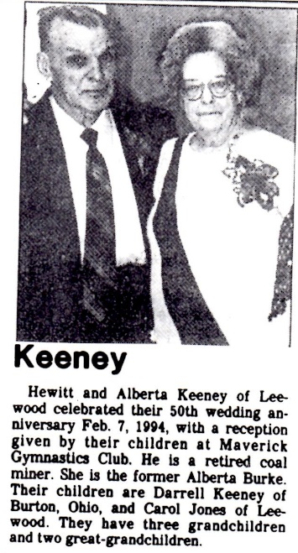
"The committee on privileges and election which was referred to them of D. J. Keeney, Esq., the member elects from the County of Jackson and part of Roane County; the certificate of said D. J. Keeney is in due form of law, and he is now in his seat and is duly qualified, as has traveled 136 miles from the place of his residence to the city of Wheeling. Charles Hooton, Chairman
December 12, 1862
(David J. Keeney was son of John B. and Rachel Burdett Keeney and Linda Ravenswood, WV; as a result of the Wheeling meeting, West Virginia became a state on June 20, 1863.)

These KEENEY KIN have donated enough to cover expenses from January 1994 and this issue as well: $50 Mary Ann Keeney, Raleigh, NC
$25 Ida Keeney Mehlman, Summit, NJ; Pat B. Austin, Laceyville, PA; Helen M. Wilson, Sheridan, WY; Joyce Hoffman, Sugar Grove, WV; Frederick Keeney, Hixson, TN.
Others: Bob & Jane Massey, Bloomington, CA; Anita Keeney, Sandy, UT; Amelia Palmer, Dunbar, WV; Joseph W. Foulke, Wilston, CT; Elaine R. Bristow, Newman, CA; Doris Keeney Hall, Belle, WV; Karla Keeney Yates, Santa Fe, NM; Sharon H. Galitz, Frogmore, NC; David R. Raese, Kent, WA; Emma C. Johnson, Staunton, VA; Blanche Keeney Stevens, Newington, CT

G.W. wrestler sets precedent
PITTSBURGH-Mark Samples did something no other wrestler from West Virginia has accomplished when he reached the finals in the 140-pound division at the National High School Wrestling Championships at Duquesne University.
Samples, the 140-pound state champion from George Washington High School, beat four state champions before losing in the championship match to Clint Musser of Jesuit High in Walsh, Ohio, 11-3. Musser is a two-time defending Ohio state champion.
Samples pinned Mike Lieberman of Arizona at 2:19 in his first match. He then defeated Seth Septer, the Iowa state champion by a major decision score of 16-5. Mike Garcia of Mount caramel, PA High School was his next victim. Samples defeated the three-time state champion, 2-1, in overtime. Samples reached the final round after routing Moises Perez, the California state champion, 15-0.
Samples haven’t decided where he will attend college.
Mark Samples is the son of Amon & Rebecca Louise Keeney Samples, grandson of Albert M. (Bus) Keeney and great-grandson of McDonald & Mamie Stanley Keeney; CRAIG KEENEY is the son of Kent Dwaine Keeney & Sherry Ann Payne Keeney and a great grandson of James T. Keeney, of Elkdale.

INVITATION
KEENEY GENEALOGISTS
Are you a died in the wool unrepentant obsessive KEENEY GENEALOGIST?
What will you be doing the first week of August 1994?
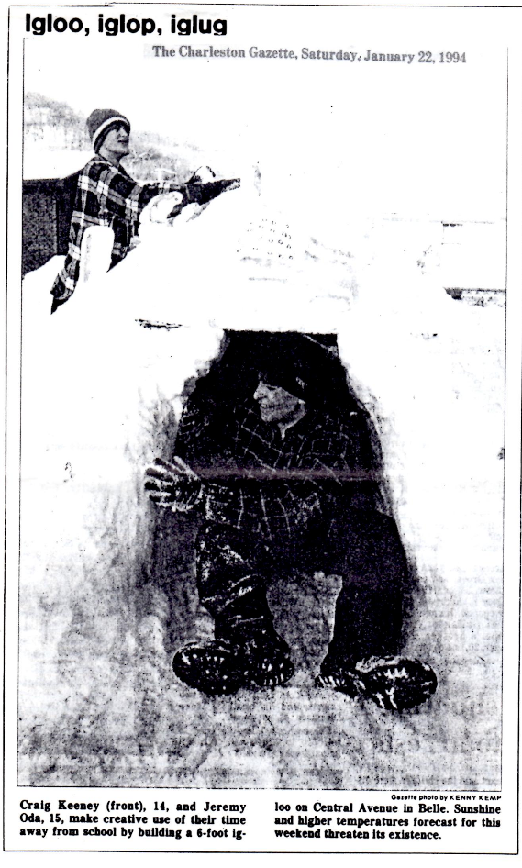
So many have written KEENEY UPDATE in the past 10 years expressing a desire to see the KEENEY MOUNTAIN, THE MICHAEL KEENEY CABIN and other Greenbrier County, WV spots of Keeney history. Maybe several could travel to Lewisburg (or nearby) for a day or 2 and Yours truly could arrange:
-A guided tour to the Keeney cabin and nearby Cemetery;
-A visit to OLD GREENBRIER CHURCH in Alderson, where their archives include records back to 1780;
-A meeting with Greenbrier Historical Society Members (they meet on Thursdays);
-A get together to compare notes and trade KEENEY stories.
If this “turns you on”, let me know and I’ll send you a map of the region, a list of nearby motels, and information about other attractions in the Greenbrier area.
Let me know of your interest by the end of May. By June 15, I’ll have the above materials for you or will notify you that the interest is nil.
This invitation is open to anyone on the KEENEY UPDATE mailing list.
Roscoe Keeney, JR.
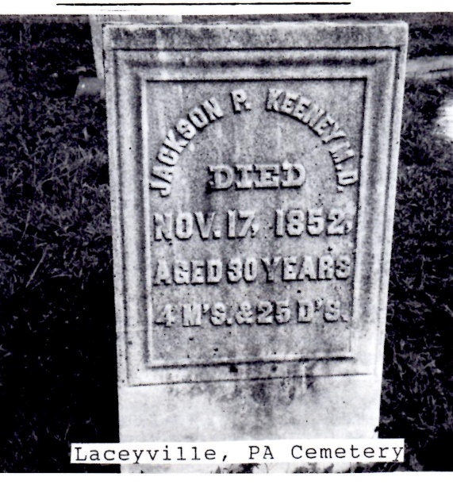

STORK ARRIVES IN SOUTH DAKOTA
SHAWN KEENEY HARMON, weight 8 pounds, was born January 3, 1994; son of Heather Keeney Harmon & Tim, Mitchell, SD; grandson of John D. & Rebecca Voll Keeney first child.

FAMILY GROUP RECORD – 30
DOCUMENTATION
HELP: if you can identify with any of the persons in this family line, please contact KEENEY UPDATE

HUSBAND William KEENEY-146.
WIFE Clarissa D. DAVIS-147

HUSBAND-William KEENEY-146
BIRTH-SPOUSE-DEATH: tombstone data gives death date and age (birthdate calculate from tombstone). Crete Cemetery, corner of Exchange Street and Vincennes Ave., Creek, Will County, IL. Also listed in reading of Crete Cemetery (1978), p. 6, South Suburban Gen. & Historical Society Early Will County history states he moved to the area in 1836 (SSG & HS Quarterly), from Ohio, appears in 1840 Will Co., IL federal census. 1850 mortality schedule for IL says born in NY; probate papers give no clue to birthplace.

FHL file 1,312,794 shows a list of Freemen admitted to East Hartford in 1820, where a William Keeney appears on the first Monday of April. To qualify as a Freeman, you have to be 21, own land, or both.

WIFE-Clarissa D. DAVIS-147
NOTE: Found in IGI (6 June 1991) a Clarissa Davis, baptism, date of 15 November 1802, parents William Davis and Sally W. Born in Rutland, Worcester County, Massachusetts. Could this be the right info? Bearish info says she is from Vernon, Tolland County, CT.
Is Betsy Davis who received $500 from the estate of William Keeney be her sister? Evidence below seems to point in this direction.
BIRTH-SPOUSE-DEATH: Tombstone data gives death date and age (birthdate calculated from tombstone). Crete Cemetery, corner of Exchange Street and Vincennes Ave., Crete, Will County, IL. Also listed in reading of Crete Cemetery (1978), p. 6.
NAME/MARRIAGE: from Keeney update edited by Roscoe Keeney, Junior January 1991. Accompanying letter (February 1994) that she is from Vernon, CT and married by Isaac D. Bolton.
MARRIAGE: found on FHL file # 2908, Barbara collection, East Hartford, Hartford County, CT Vital Records, Volume 1, p. 96, by Rev. Isaac Dwinel, pastor of the Baptist Church in East Hartford.

CHILD 1-Clarissa Elizabeth KEENEY-140
BIRTH-MARRIAGES: Will County, IL records; 1850 IL census, Crete, Will County, Joliet, IL Courthouse.
POSSIBLY DESERTED BY 2ND HUSBAND, WEBSTER A. CASTLE. SHE REVERTED TO FIRST MARRIAGE, NAME, AND REMARRIED FOR 3RD TIME 30 OCTOBER 1862 TO HIRAM MOULTON, ALSO IN WILL COUNTY. CANNOT FIND HER LOCATION IN ANY ILLINOIS CENSUS, 1860, 1870.
PER CORRESPONDENCE WITH TERRY MORGAN, DESCENDENT OF WEBSTER A. CASTLE, HE DESERTED HIS FIRST WIFE, ELIZABETH, AND 1857, MOVED TO ILLINOIS. SHE DIVORCED HIM IN BRIDGEPORT (DANBURY?), CT IN OCTOBER 1858.
Other marriages:
19 SEP 1859 Webster A CASTLE-644 MRIN: 148
30 OCT 1862 Hiram MOULTON-1793 MRIN: 524

CHILD 2-David K. KEENEY-148
DOCUMENTATION: IL CENSUS 1850 STATES BIRTHPLACE AS OHIO; 1860 SAYS MA. HE IS LIVING WITH 2 OTHER KEENEY MEN KNOWN TO BE CHILDREN OF WILLIAM AND CLARISSA KEENEY, BUT HE IS NOT MENTIONED IN WILL OF WILLIAM KEENEY. IS HE A NEPHEW? MIDDLE INITIAL COULD ALSO BE AN “H” WHEN HE SIGNED A STATEMENT IN PROBATE OF JOHN L. HASKIN ESTATE, 1858.

CHILD 3-William KEENEY-149
DOCUMENTATION: 1850 IL CENSUS LISTS HIM TWICE-CREATE WITH SISTER CLARISSA KEENEY HASKIN AND IN MONE WITH BROTHER GEORGE NELSON KEENEY, ET. AL. ONE ENTRY SAYS BORN IN OHIO, THE OTHER SAYS MASS.

CHILD 4-George Nelson KEENEY-150
BIRTH-PARENTS: CENSUS, IL. 1850; PROBATE RECORDS OF FATHER WILLIAM KEENEY (1799-1849), SOMETIMES LISTED AS GEORGE, OTHER TIMES NELSON.

SWITZERLAND COUNTY, INDIANA KEENEYS
GEORGE H. KEENEY, Rising Sun, County surveyor, undertaker and produce dealer, is a native of Switzerland County, Indiana, born in 1848. He is the son of Hiram B. And Delilah (Humphrey) Keeney, his father, a native of New York, his mother of Switzerland County, Indiana. His father, Hiram B. Keeney, born in New York in 1820, came to Switzerland County with his parents in 1835. He farmed with his brother, William, for several years and then purchased the farm, where his widow now lives, on which he resided until his death in 1866. He owned 170 acres of good land. Mr. Keeney married Delilah Humphrey in 1845. She was the daughter of Stephen Humphrey, of an old family in Switzerland County. Mr. Keeney was a member of the F. & A. M. and one of the most thrifty farmers and esteemed citizens of the county in which he lived. He had 4 children: Laura, wife of P. North; George H., hosier, who married Lena Cunningham; and Jacob, who married Molly Moore. At the time of his death, Mr. Keeney was holding the office of surveyor of Switzerland County. George H., Our subject, grew up on the farm, where he remained until his father’s death. He was educated in the public schools of the county and subsequently taught several terms. He acquired knowledge of surveying and civil engineering and has since done considerable work in that line. He served as Deputy surveyor of Switzerland County 1869 1880, when he located in Rising Sun. He was appointed surveyor of Ohio County in 1883 and has been served by election as regular surveyor. From 1873 to 1877 he was employed in the United States revenue service. In connection with his official work of surveyor and engineer, Mr. Keeney does undertaking an officiates as a funeral director, besides doing quite an extensive produce business, in partnership with Simon Beymer, president of the Rising Sun National Bank, under the firm name of Keeney & Beymer. Mr. Keeny was married in 1878 to Miss Mary Shafer, of Aurora, Indiana, daughter of Andrew Shafer, and they have five children: Burke, Bayard, Hale, Mable and Denver. Mr. Keeny is a member of the F. & A. M., Patriot, Indiana and of the Universalist church, clerk of the latter society.
JOHN KEENEY, a native of Connecticut, came from Delaware County, New York to this County in 1835. He was born in 1786, and as far as known was a resident of New York. He was a son of Jonathan and Esther (Beebe) Keeney. His parents died in Delaware County, NY, and there he grew to manhood and married Dorotha Harris, daughter of Robert Harris, and came in 1835, with his family of 9 children to this Township. He purchased 200 acres, which Mr. William Keeney still owns. He was a plain farmer, not connected with any other business. Was a surveyor and did considerable in this line. Was considered quite a thrifty farmers. He was accidentally drowned in the Ohio River near Vevay by being run over by a steamboat wall going down the river and a small flat boat loaded with scythe snaths. Their children were Fannie, John R., Salinda, William J., Harris, Ira, Alfred, Esther and Hiram B.
WILLIAM J. KEENEY, farmer, York Township, born in Delaware County, NY, 1816, son of John Keeney, came to this County with his parents in 1835. He remained with his parents still 1840, when he began farming for himself, making his annual trip to New Orleans and doing boat trading. This. He continued for 16 years, annually, but has since confined his work to the farm. He has kept good grades of stock and taken considerable interest in stock raising and agricultural affairs. He was one of the charter members of the Switzerland and Ohio County Agricultural Society, which is organized in 1851, and has since officiated as director, vice president and president. Is one of the thrifty farmers of the county, and a member of the Masonic fraternity. Mr. Keeney was married in 1843 to Mary R. Truesdell, daughter of James Truesdell, and born on Bryant Creek by the Ohio, in this County, 1815. Her parents were James and Nancy (Jones) Truesdell, the former of New York, the latter of Lexington, KY. They married in this County, the Jones is coming to this Township about 1800, Truesdells later. Her grandfather, Louis Jones, started to Kentucky in an earlier date with their parents. The father died on the way. The widow and children came on to Kentucky, where the brother of Louis was killed by Indians near Lexington, on which lands the town is situated. Lewis subsequently became homesick in Kentucky and returned to Virginia, and when a young man came West again and located in this county on Bryant Street near 1800, as stated above. Mr. and Mrs. Keeney have reared 6 children to maturity: Mary S., wife of Levi Sedam, Benjamin F., married Jenny M. Langwell; Martin G. married Louise Banta; James (died 1861); Emily; Eustatia, wife of Henry Torrence; Arletta, still at home.
The old double chair in which the Truesdells rode from New York to this county, is still in possession of Mrs. William Keeney, and is more than 100 years old. Mr. Keeny has patented a number of important inventions, chief among which was the universal pitman now in use by champion mowers and reapers.

